Delta Lake:

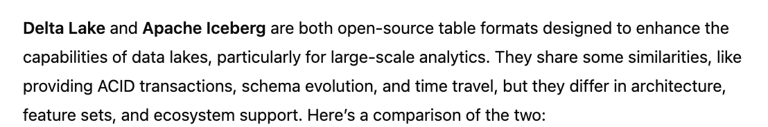

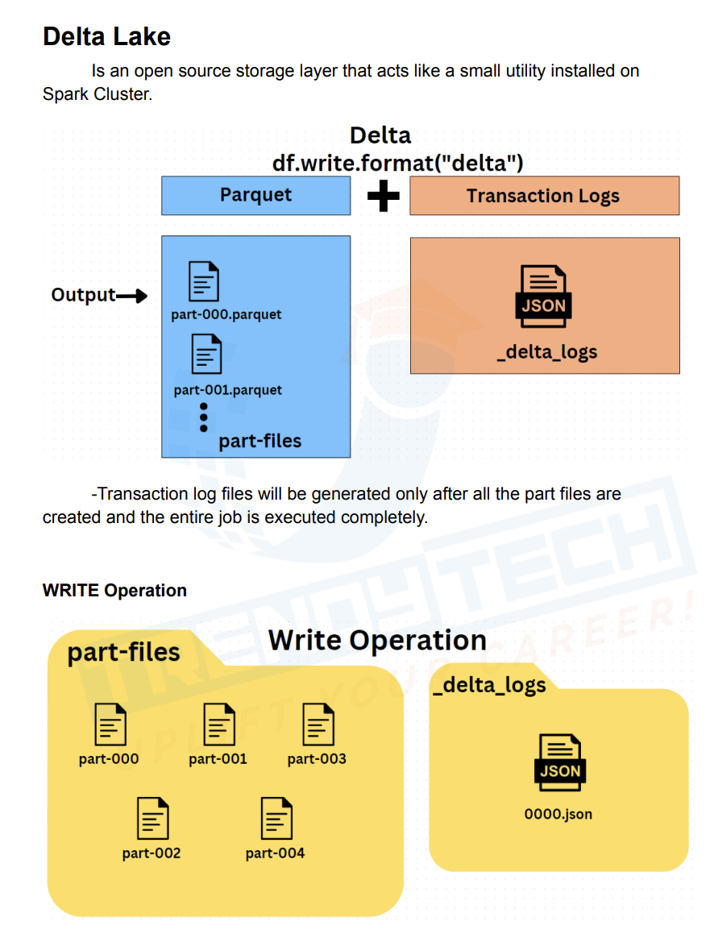

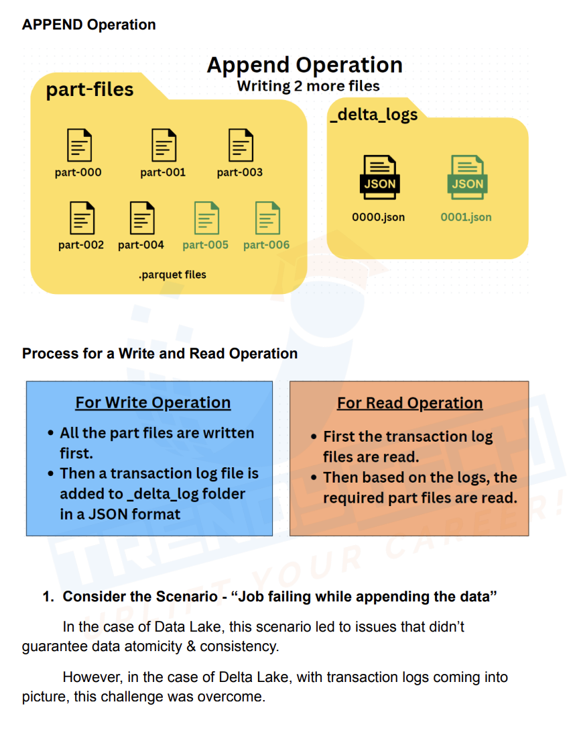

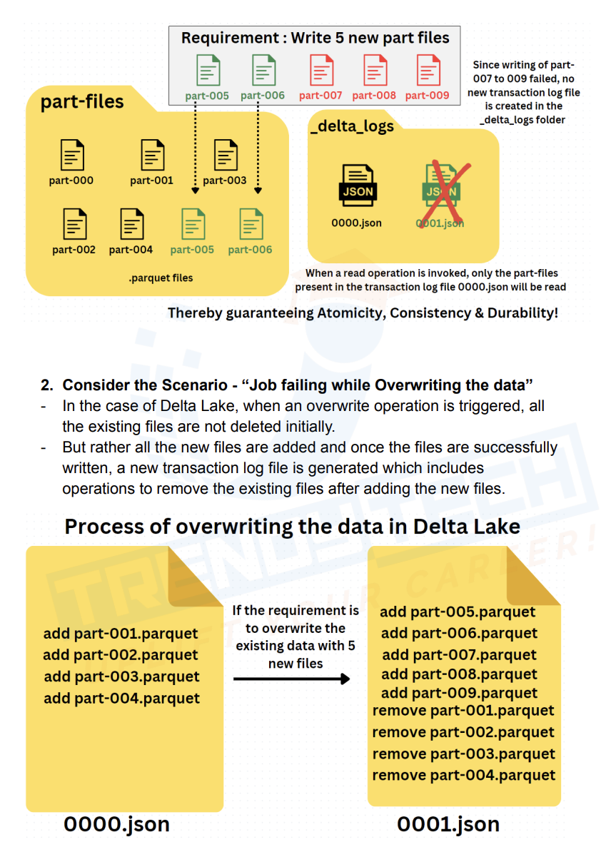

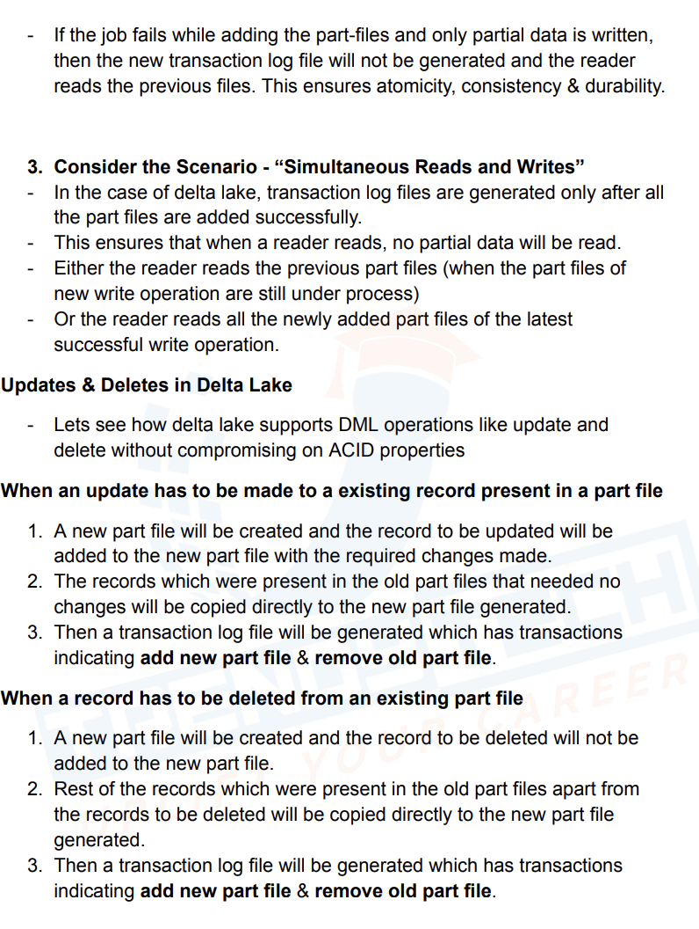

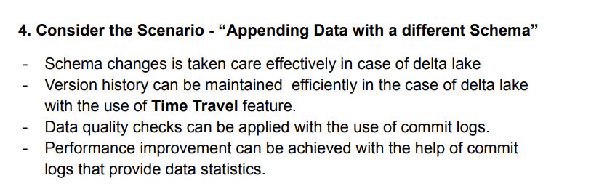

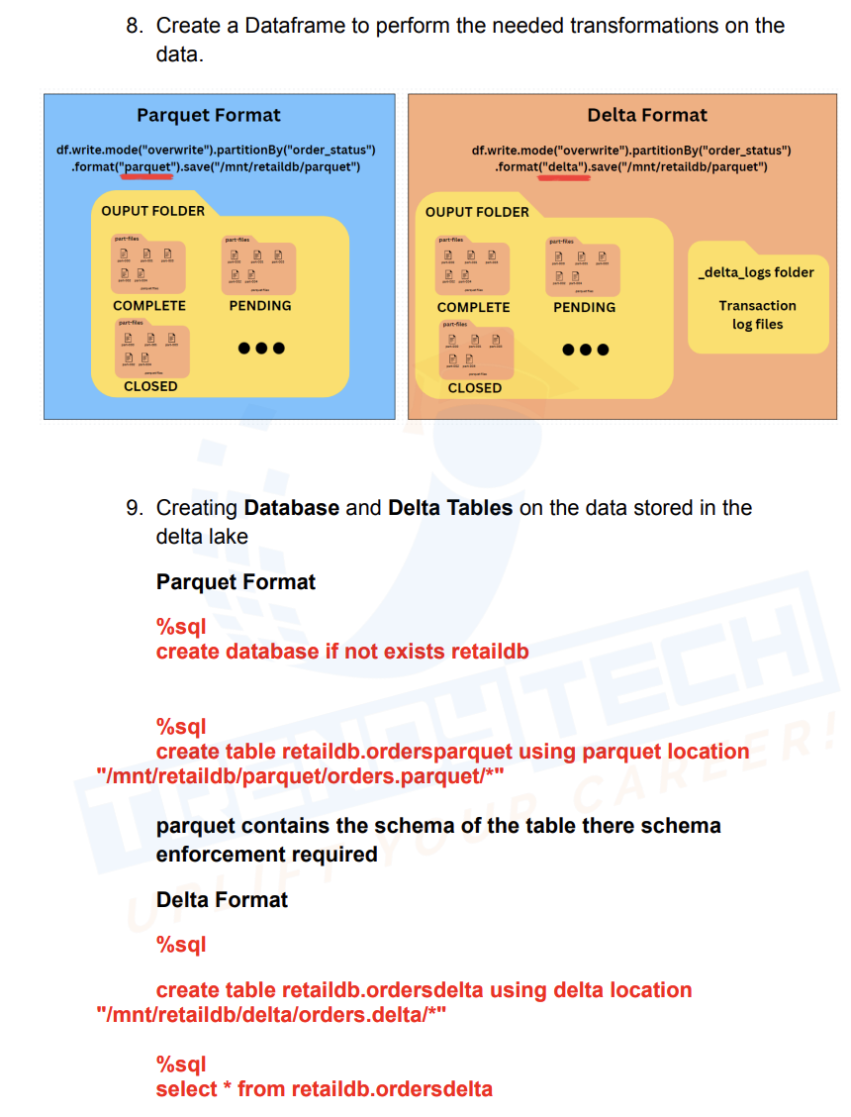

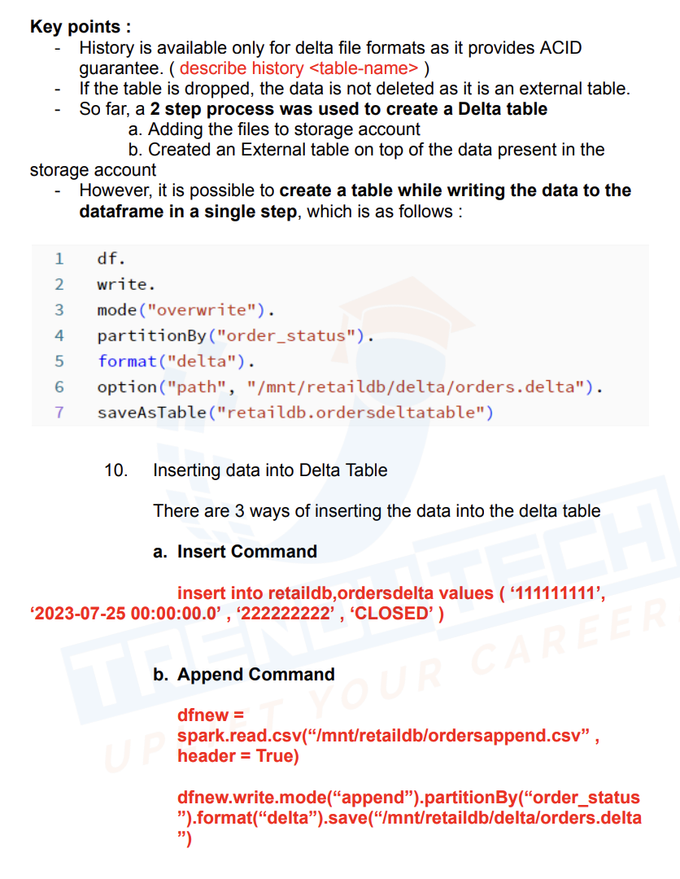

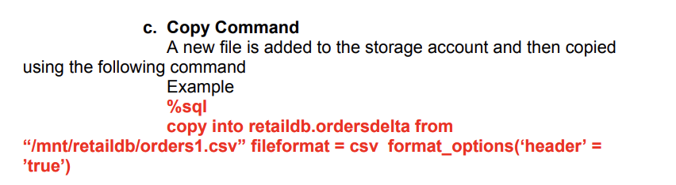

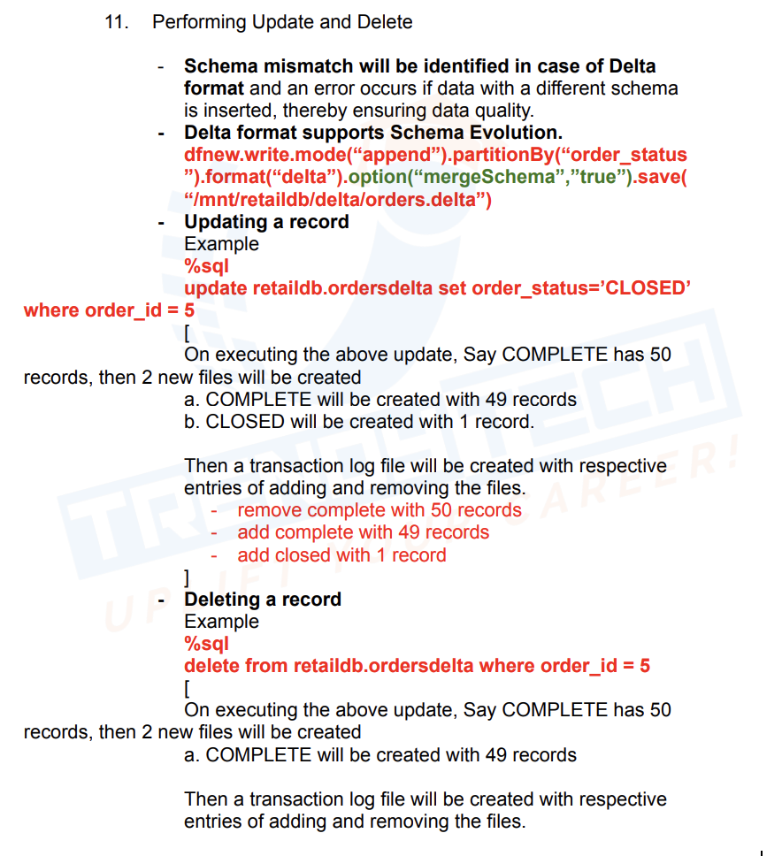



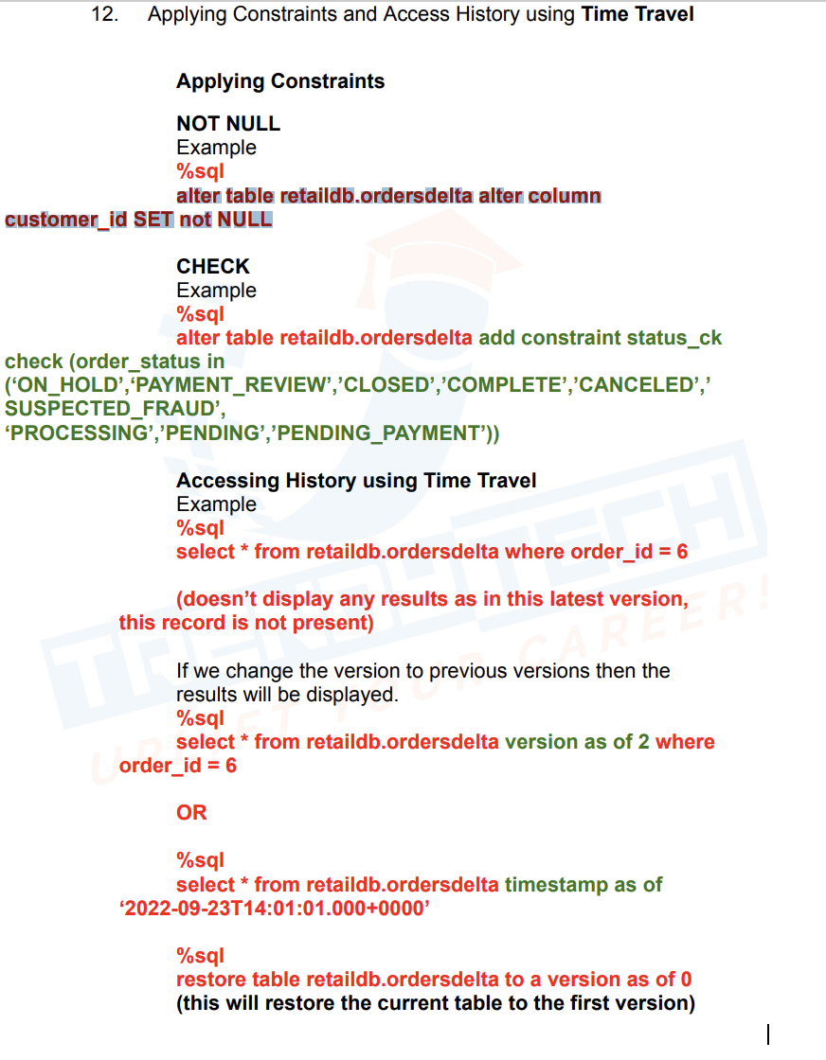

.

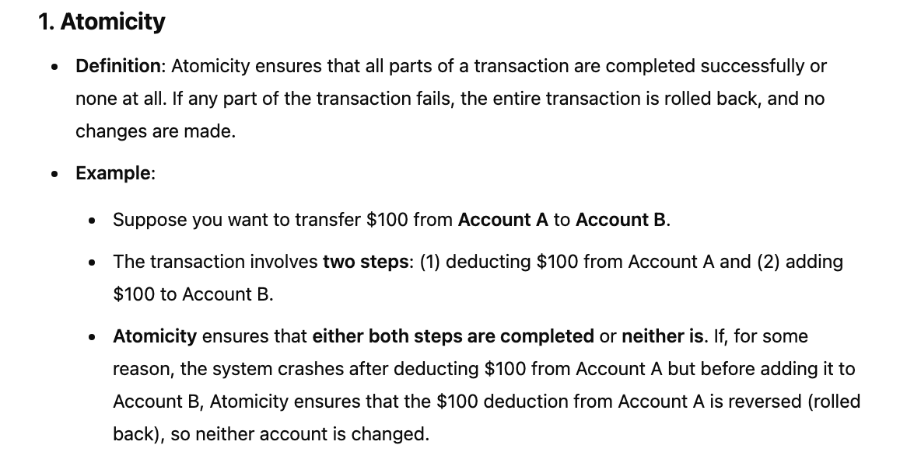

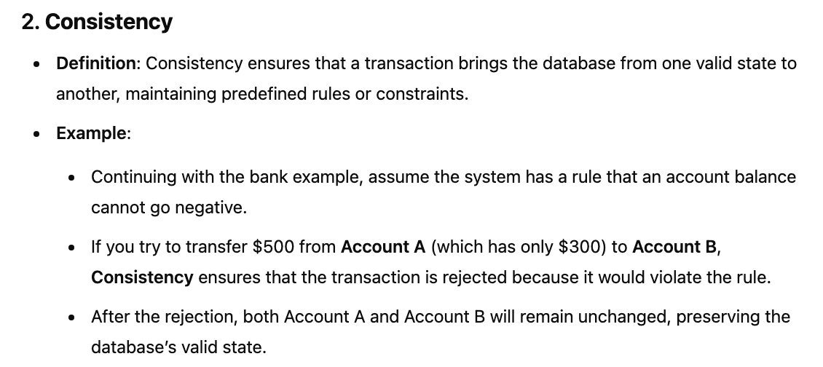

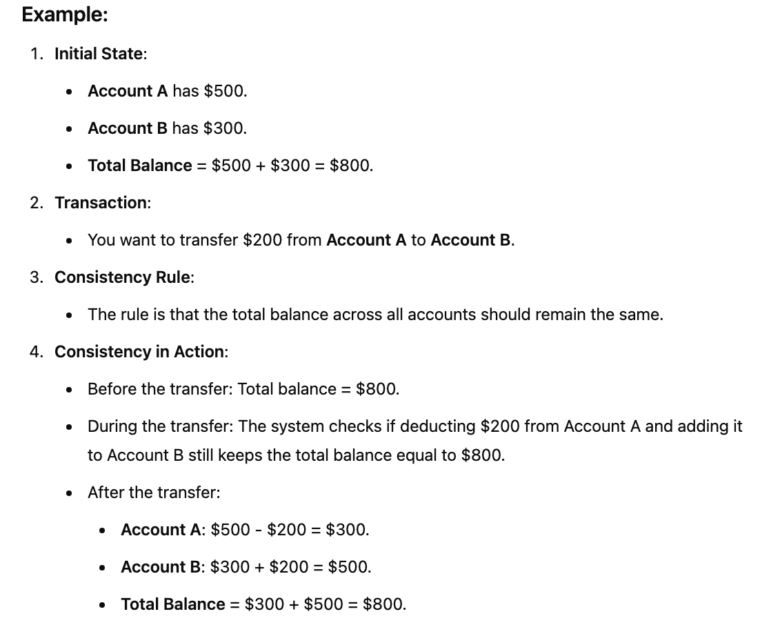

1. Isolation:

Example: Online Ticket Booking Two users try to book the last seat on a flight simultaneously. Isolation ensures that the transactions are processed separately, and only one user successfully books the seat while the other receives a "sold out" message.

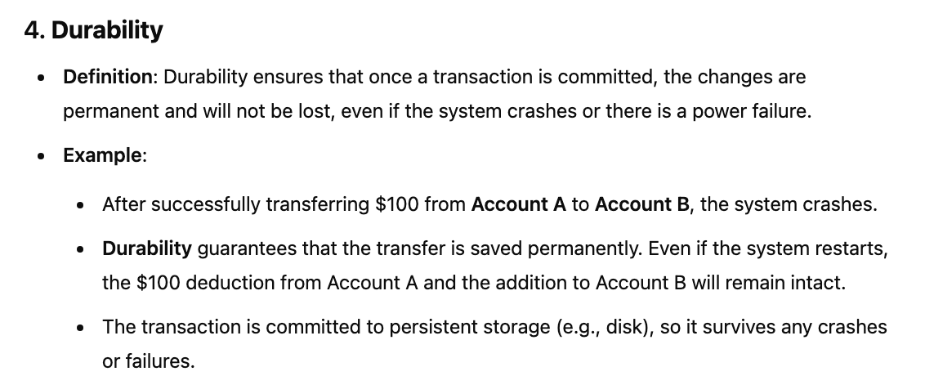

Lakehouse Architecture:

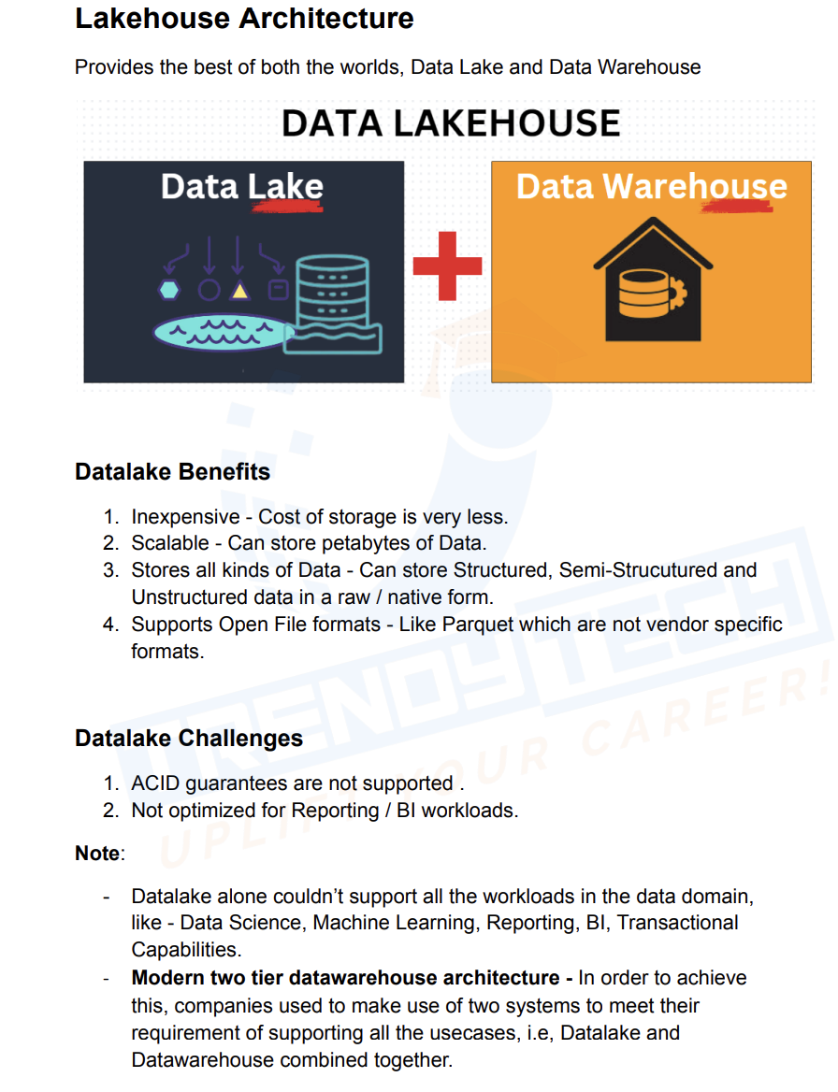

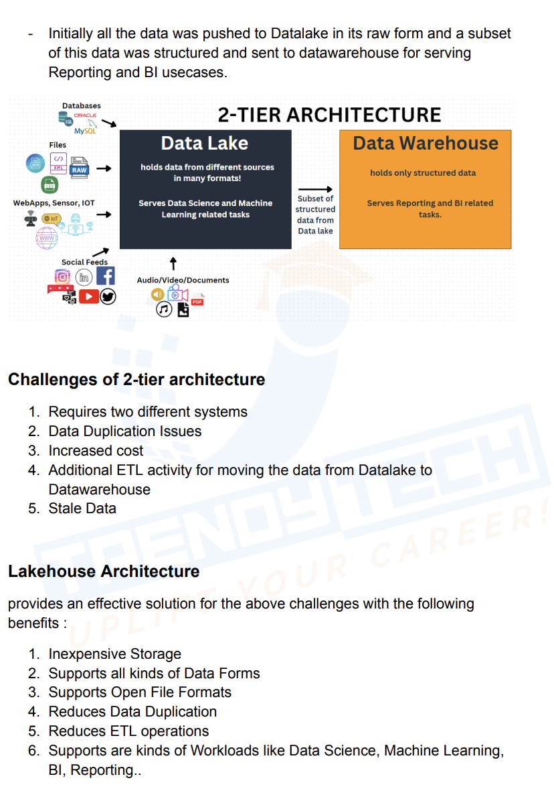

Databricks Lakehouse Architecture & Optimization Techniques:

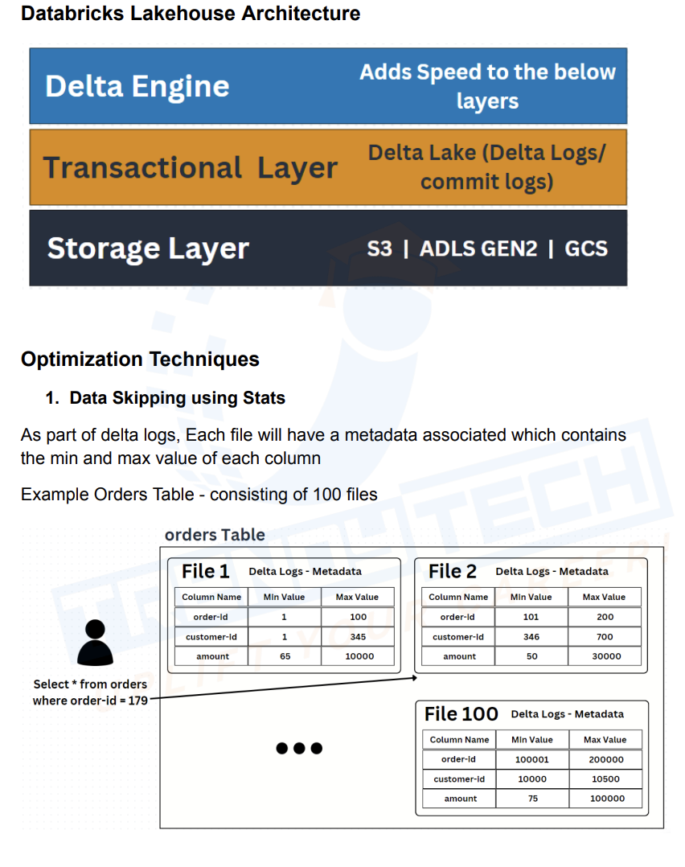

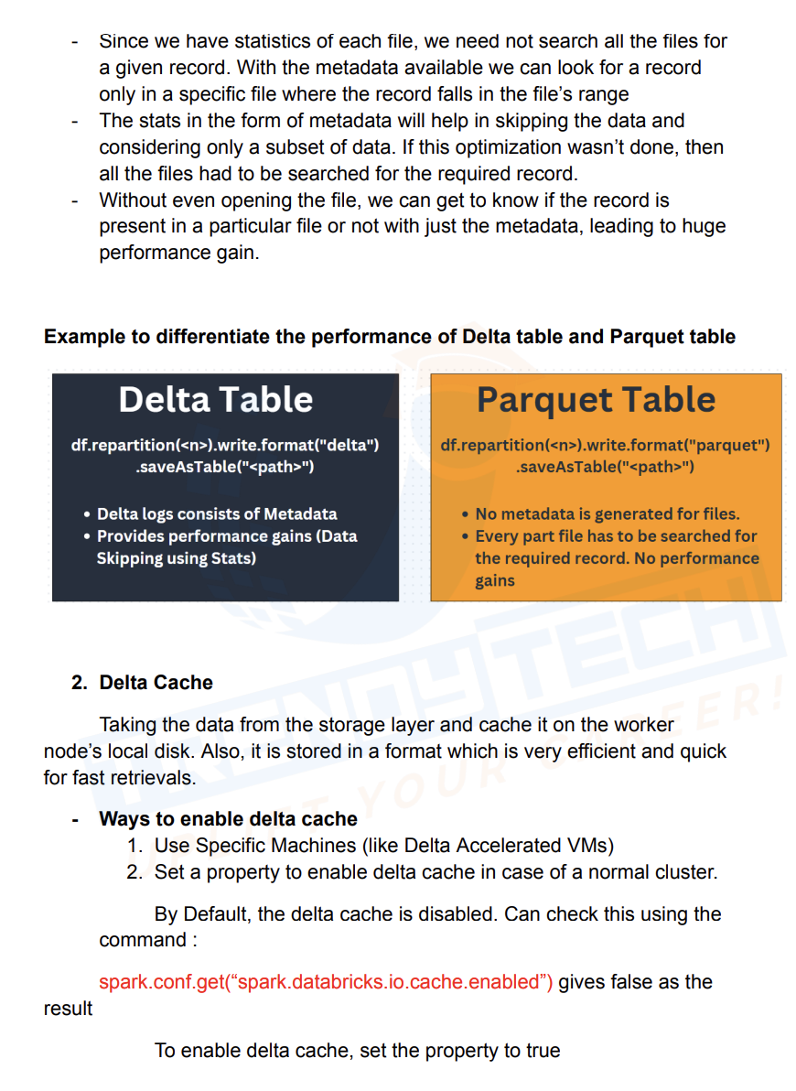

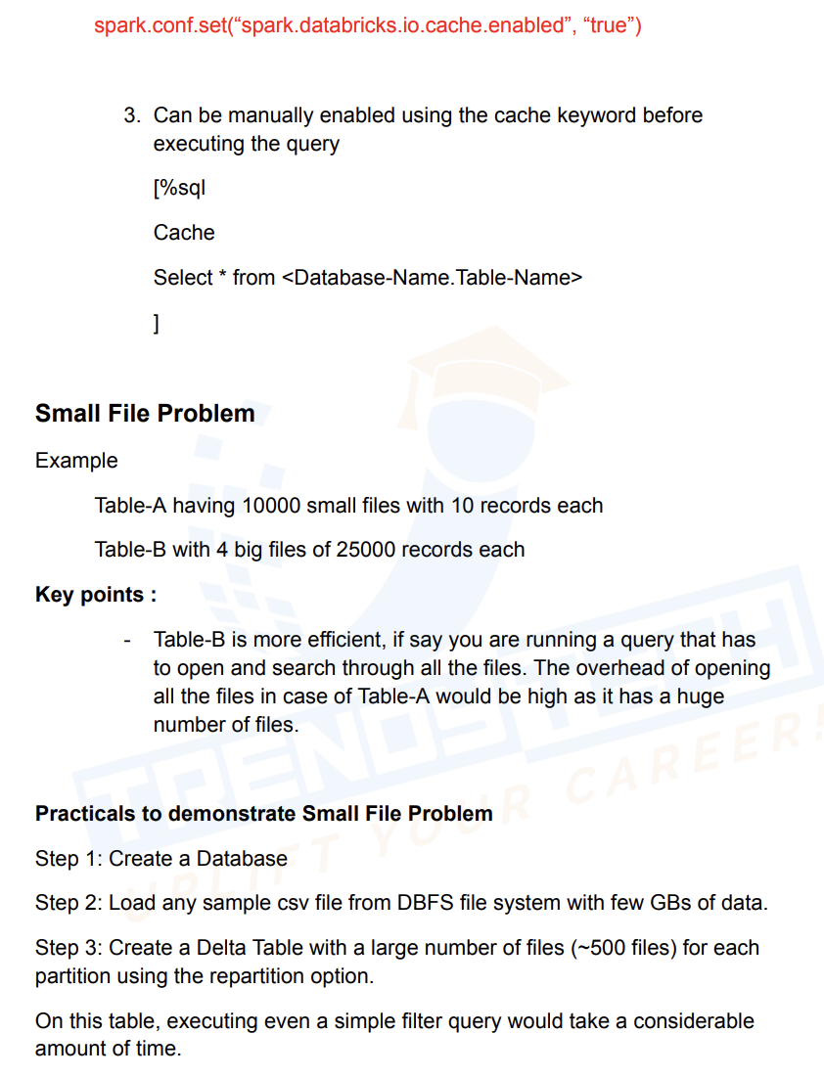

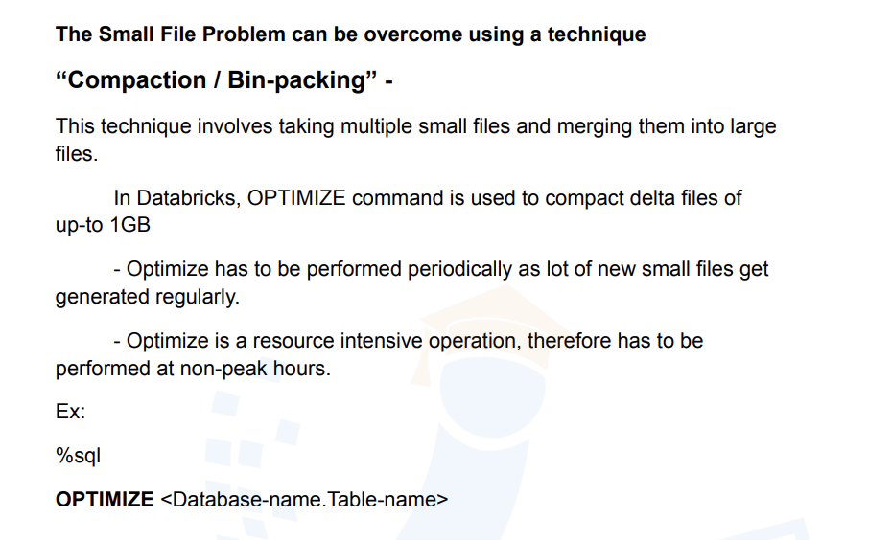

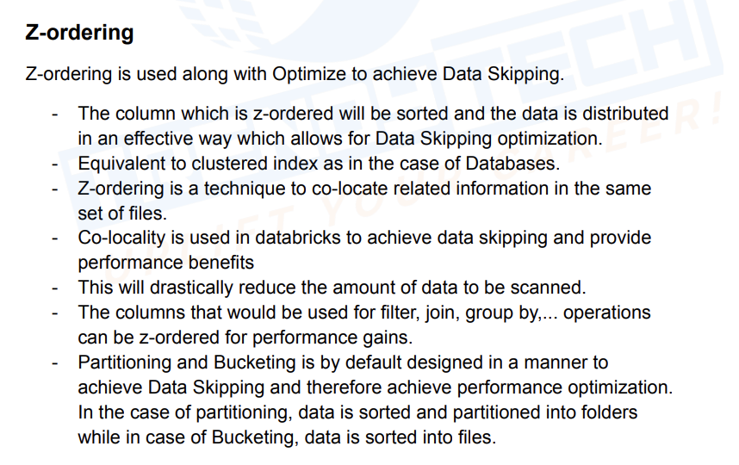

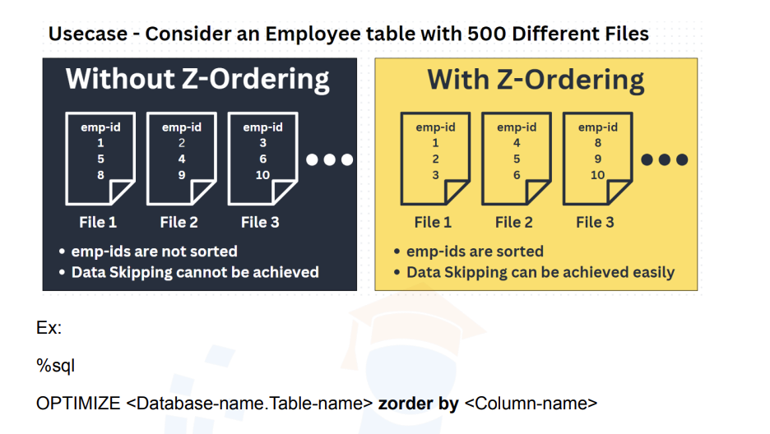

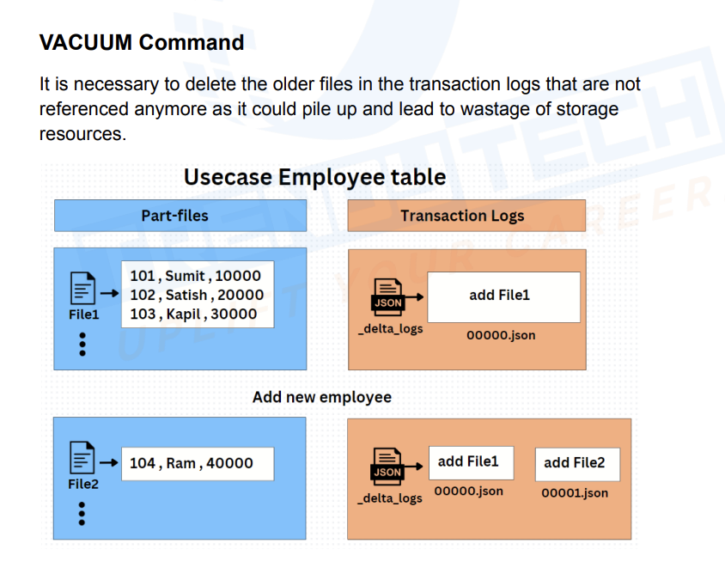

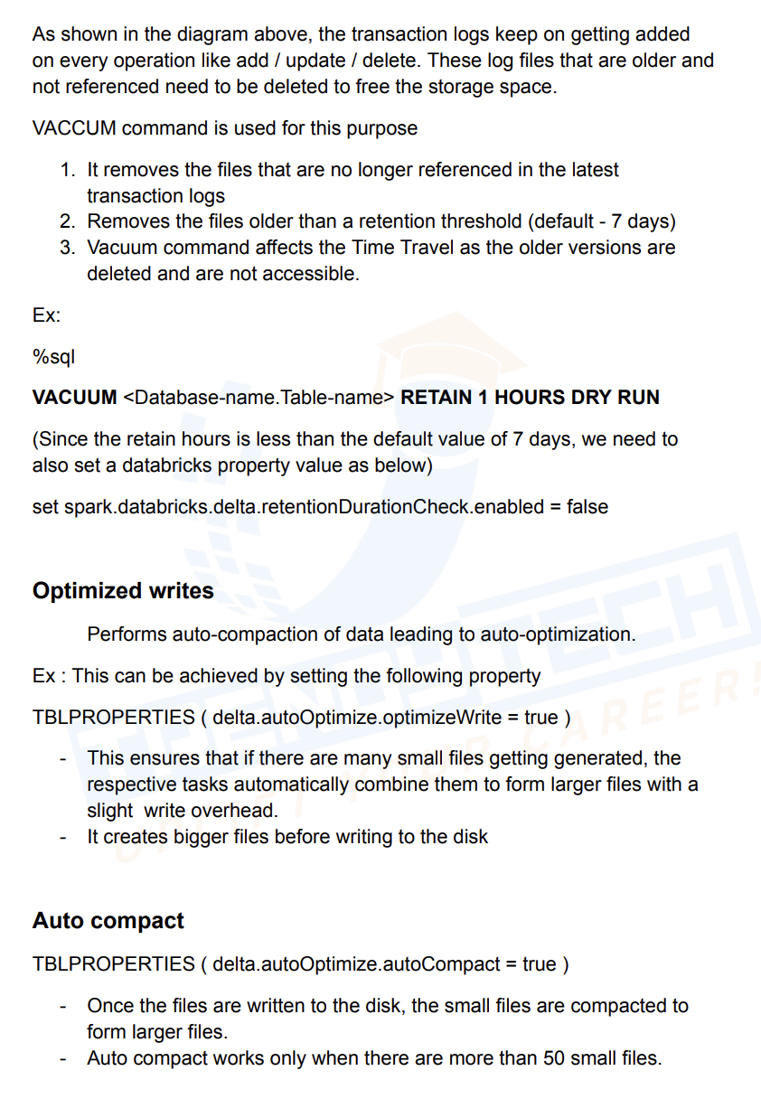

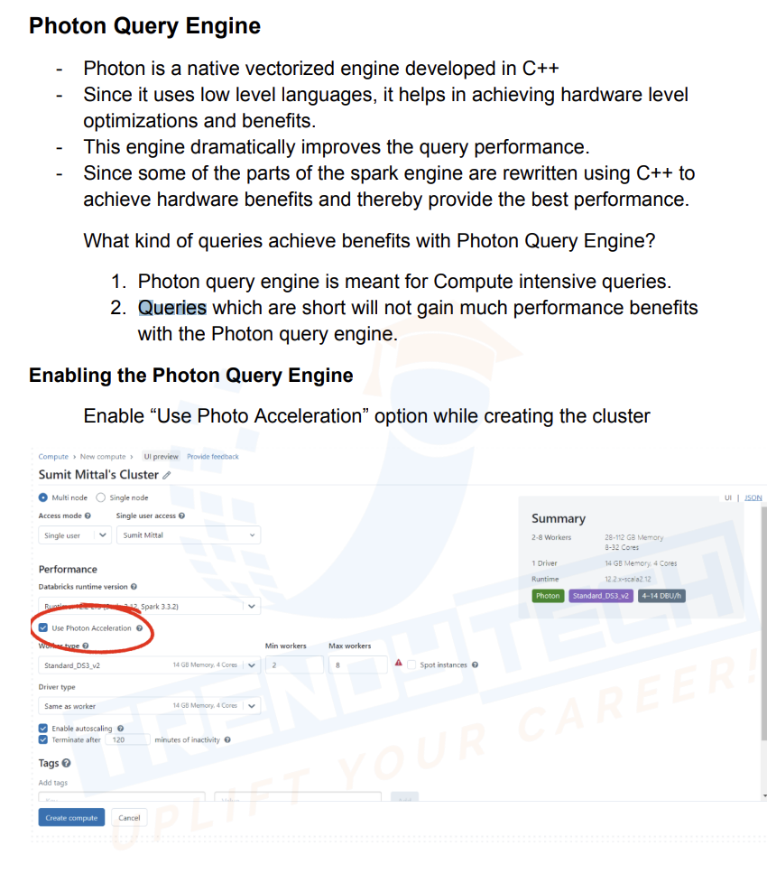

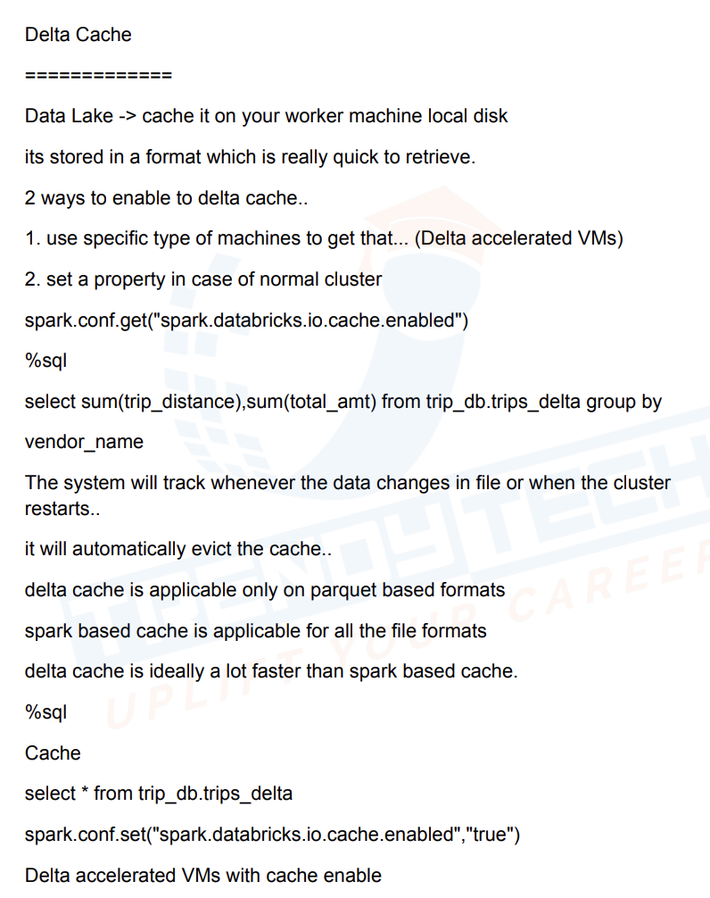

It saves the metadata in json format, so that it can provide ACID compliance and DML operations

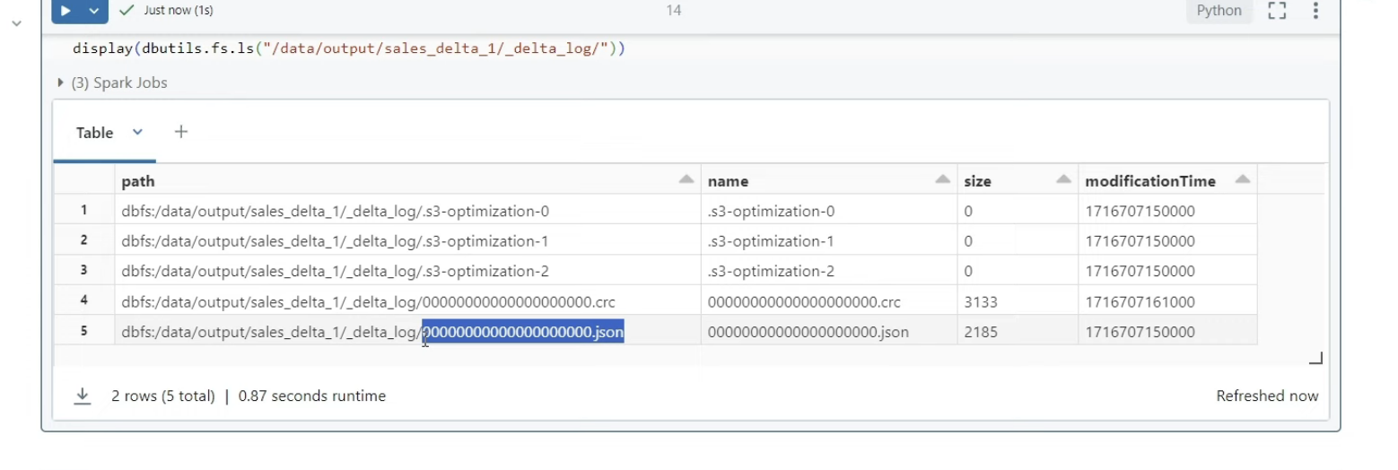

Read Delta table with file path:

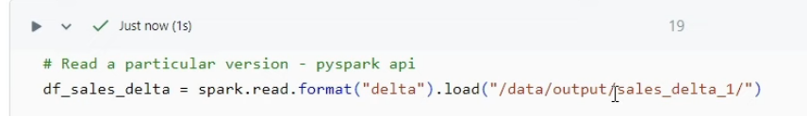

Read Delta table with table name:

df_delta = spark.read.table("sales_delta"

Read specific version:

df_delta = spark.read.table("sales_delta@v0")

display(df_delta)

Using Sql:

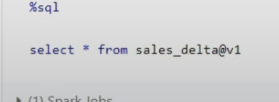

Schema Evolution:

df_new = spark.sql("select *,current_timestamp() as time_now from sales_delta")

df_new.write.format("delta").mode("append").option("mergeSchema",True).option("path","/Workspace/Users/atullutab@outlook.com/data/sales_delta").saveAsTable("sales_delta")

Access Delta tables using Delta API:

from delta import DeltaTable

dt = DeltaTable.forName(spark,"sales_delta")

display(dt.history())

DeltaTable.isDeltaTable(spark,"/Workspace/Users/atullutab@outlook.com/data")

DeltaTable.convertToDelta(spark,'parquet.`/Workspace/Users/atullutab@outlook.com/data`')

Restore Table:

%sql

restore table sales_delta to version as of 1

Vaccum History:

spark.conf.set("spark.databricks.delta.retentionDurationCheck.enabled", "false")

dt = DeltaTable.forName(spark, "sales_delta")

dt.vacuum(0)

Once vaccum is run, all old parquet files will be removed and timetravel option will be gone

Data Skipping (Z-ordering): If I z-order by order_id it will sort the order_id and store it in the file accordingly

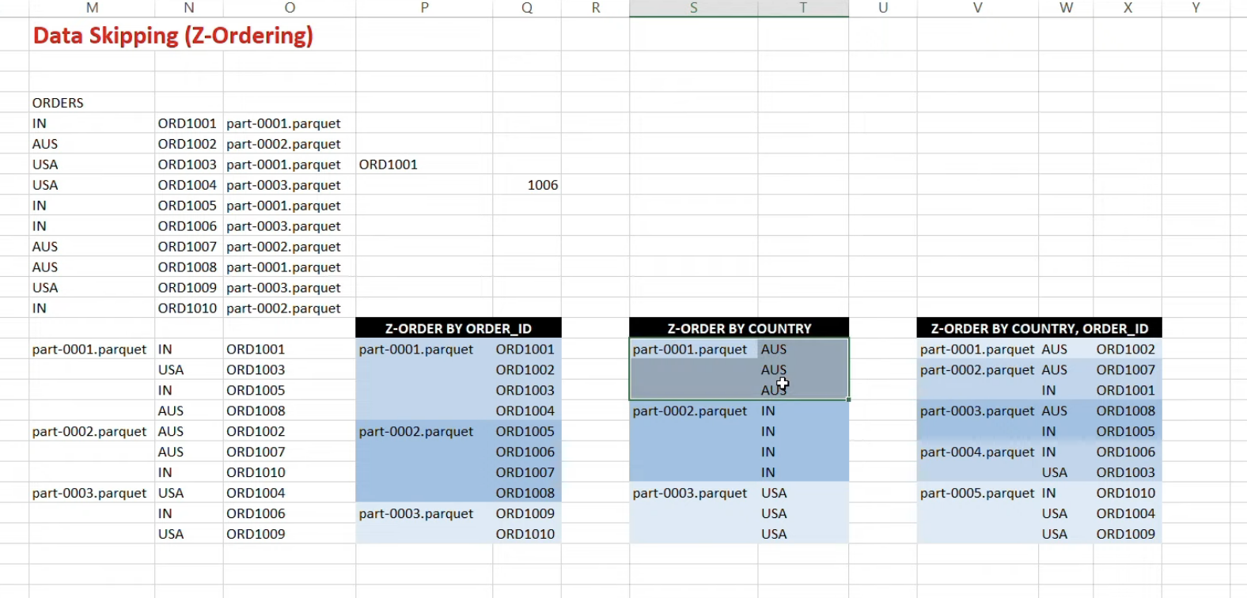

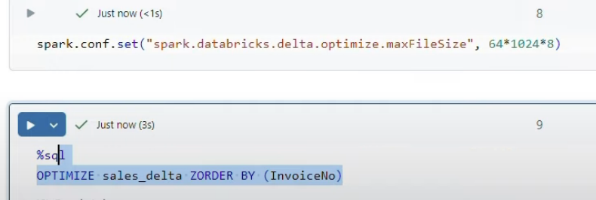

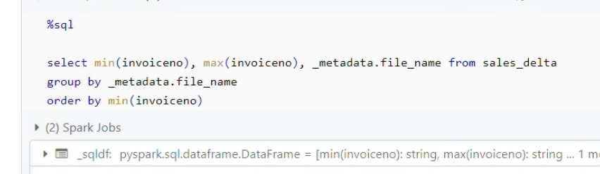

Partition with z-order:

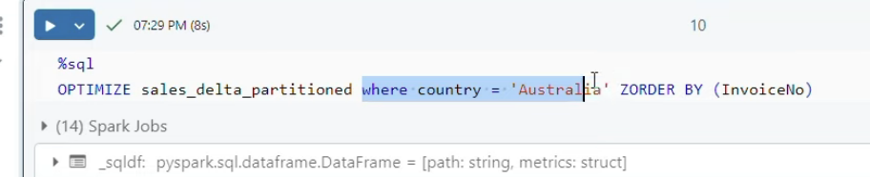

Deletion Vectors:

Whenever a parquet file is modified, whole parquet file is rewritten, suppose If we use deletion vector if a parquet file has 1M records in a file and I’m deleting just one record a flag will be added to that deleted record, so when reading rows will be skipped with delete flags, if we run optimize command then rows with delete flag will be removed

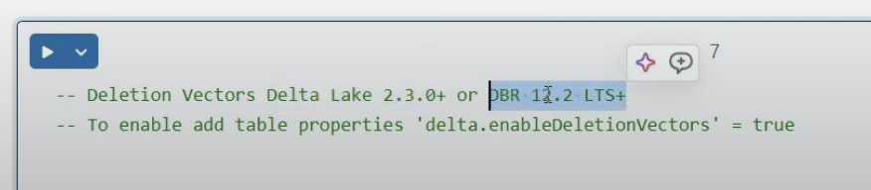

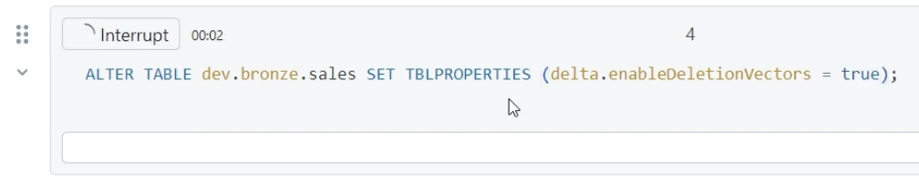

Liquid Clustering:

**Delta Lake** supports clustering via **Z-Ordering**, which is a technique for organizing data in a way that maximizes query performance by co-locating related data. By using liquid clustering in Databricks, we can effectively organize data in the table without requiring a manual refresh each time the dataset changes.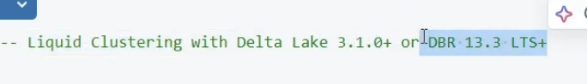

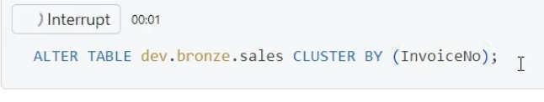

To remove clustering:

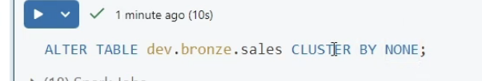

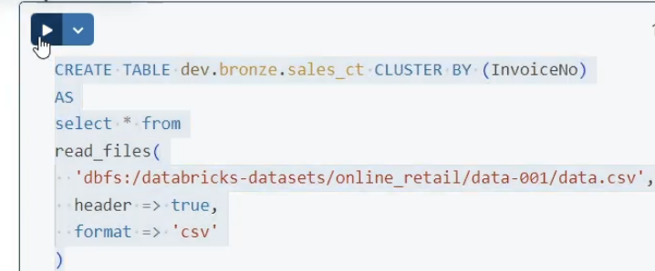

Clustering column should be in first 32 columns

Databricks:

**Databricks** is a unified data analytics platform that provides tools and services for **big data processing**, **data engineering**, **data science**, and **machine learning**. It is built around **Apache Spark**, an open-source distributed computing system, and is designed to simplify the process of working with large-scale data across various cloud environments.

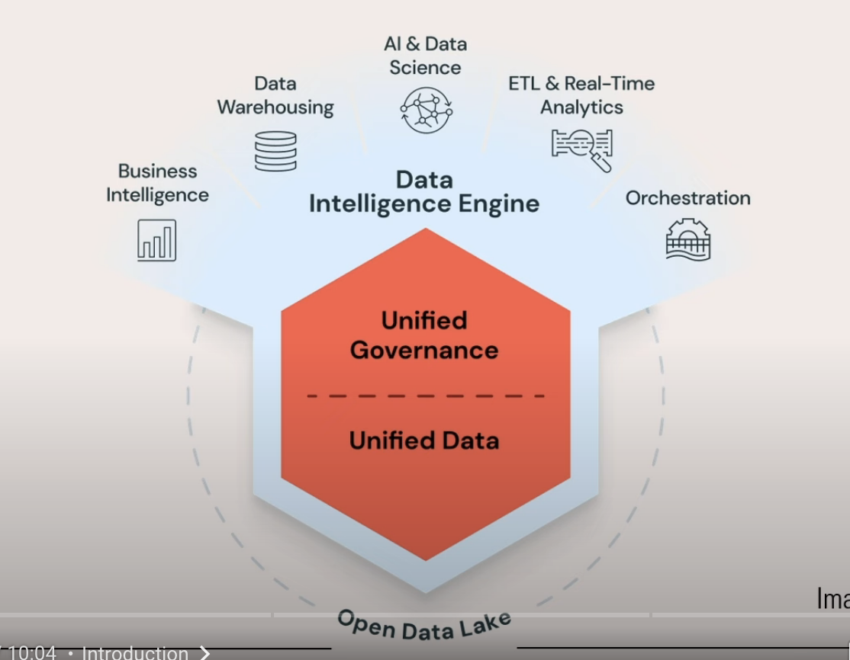

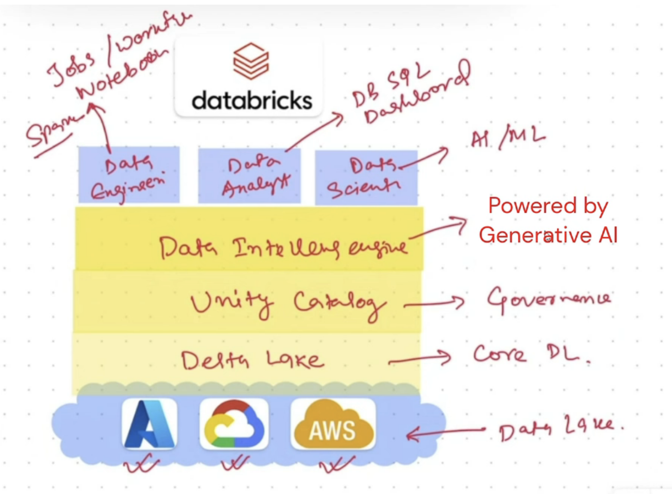

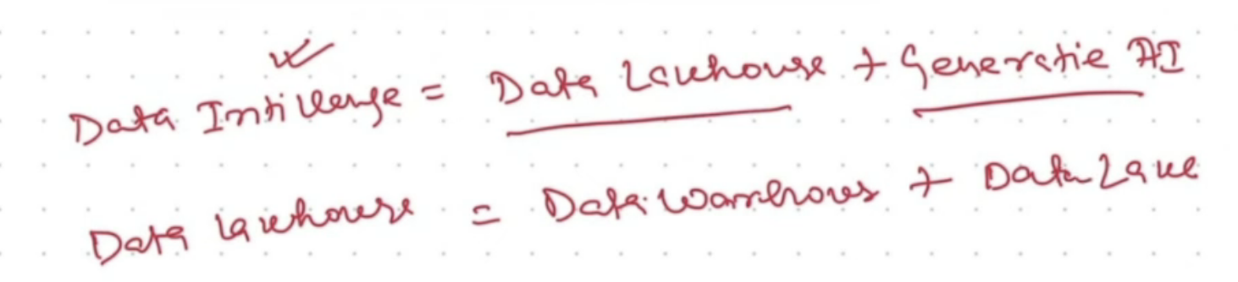

Databricks Architecture:

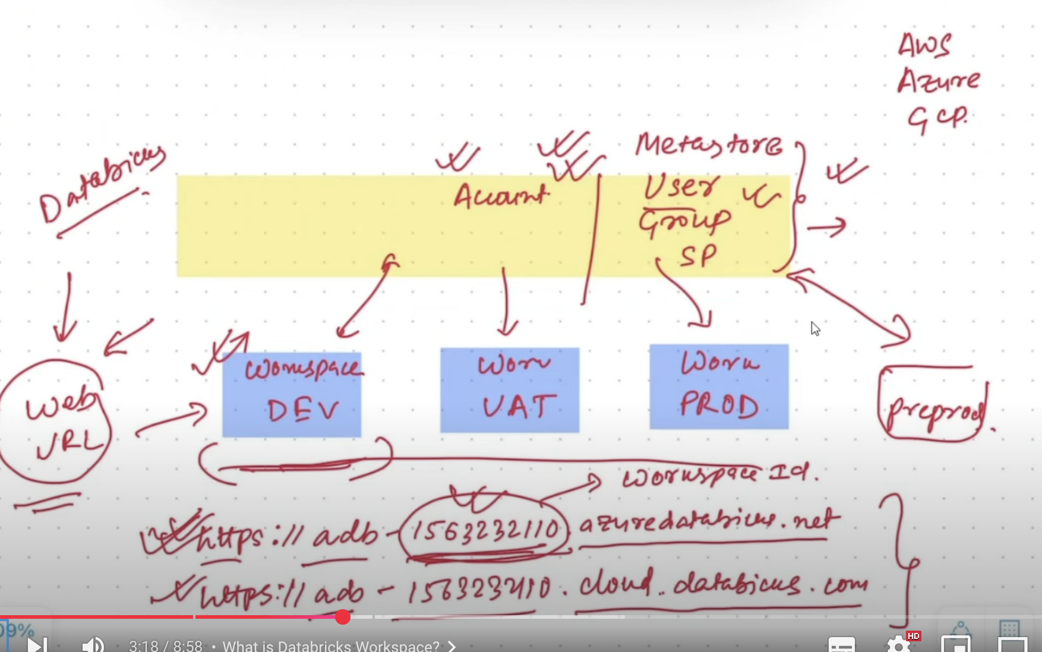

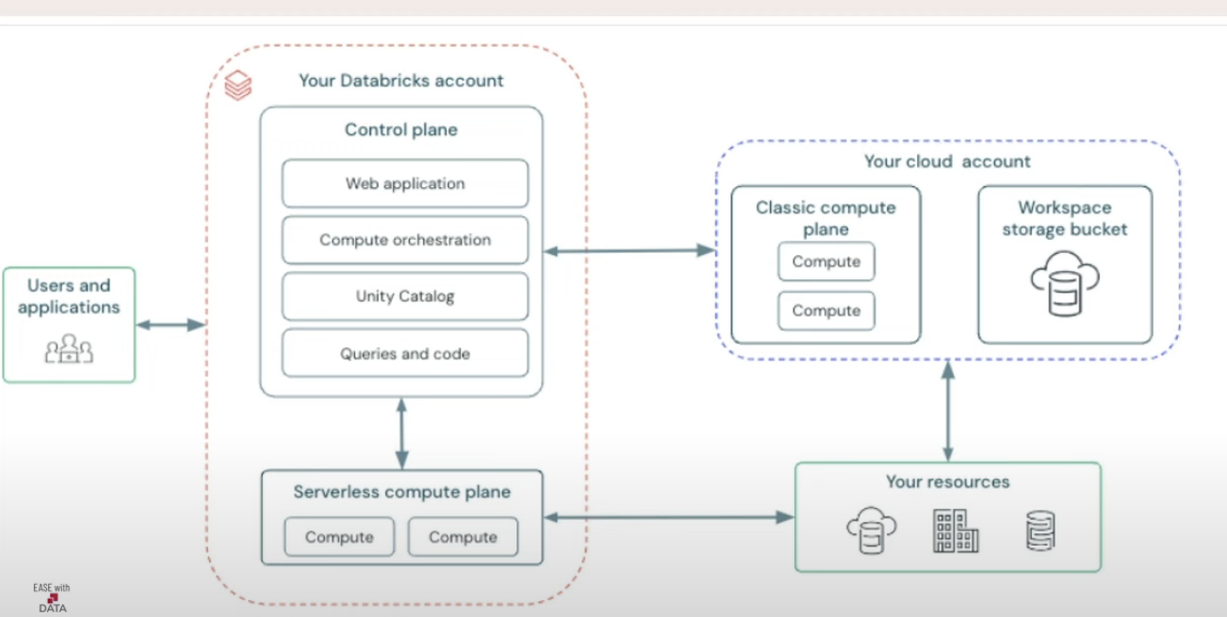

Control Plane: Is a place where databricks manages backend services

Data Plane is a place where data is processed

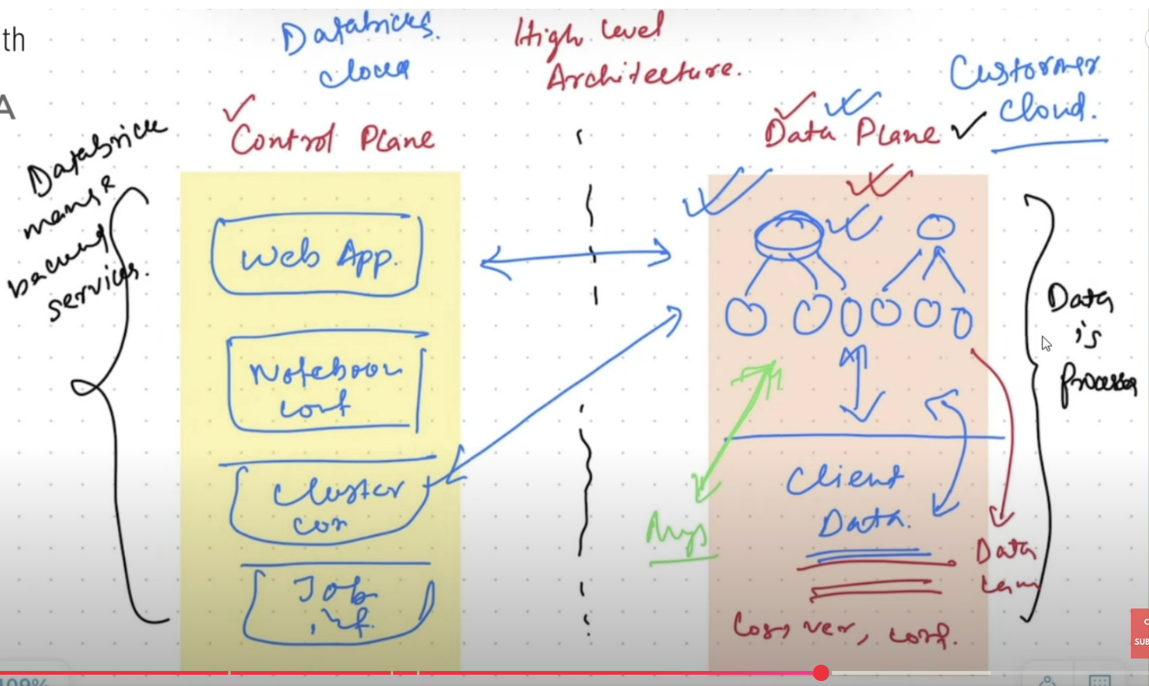

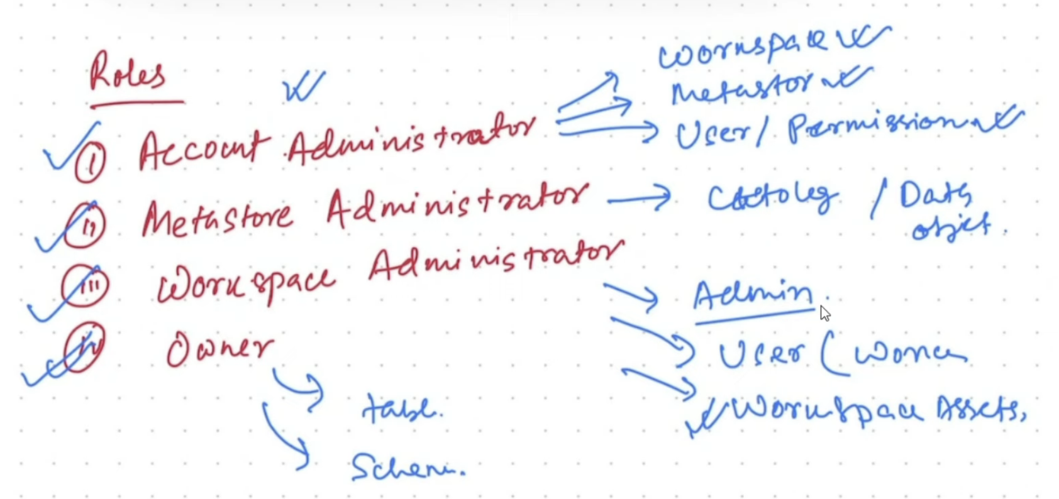

How Databricks works with Azure:

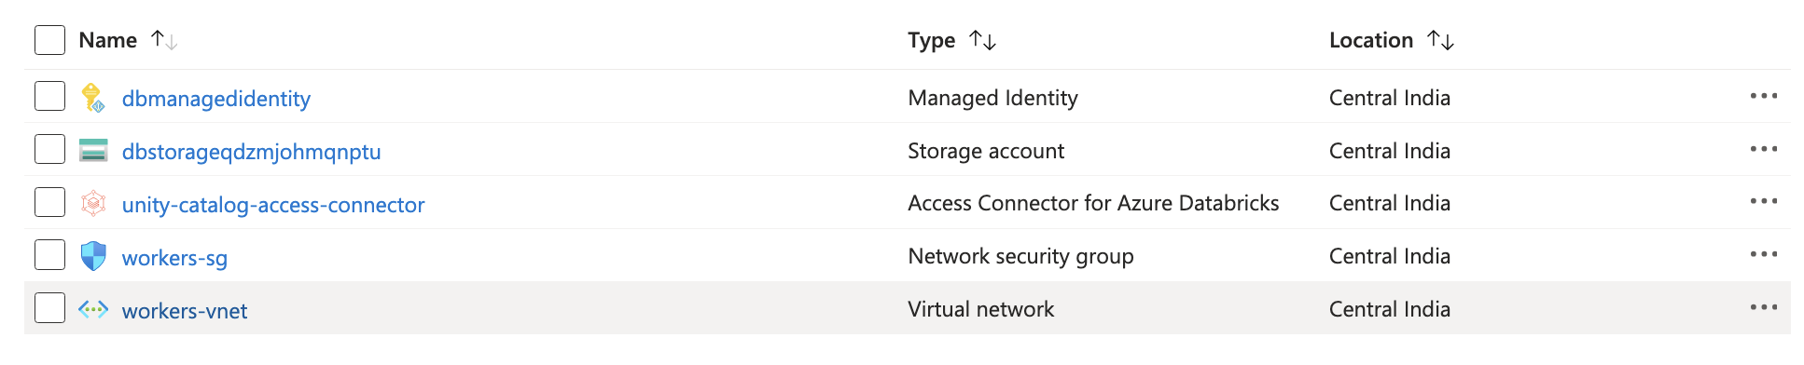

This is the storage account where data is stored in data plane, if we don’t specify any external stoage account, in the default storage account data is stored



To connect to storage account from data bricks

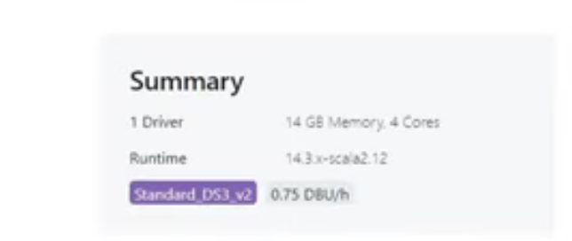

Whatever machine type you select, same machine will be created in azure virtual machines

Unity Catalog:

**Unity Catalog in Databricks is a unified governance solution for managing data and AI assets.**

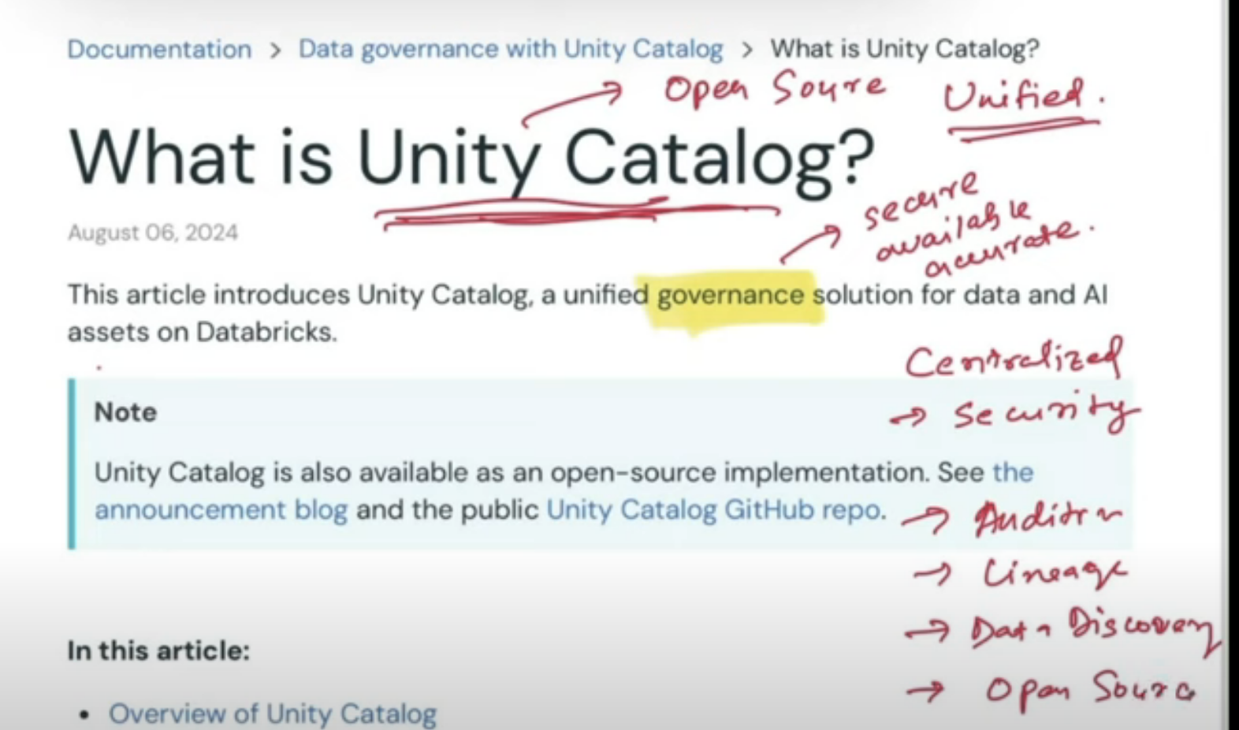

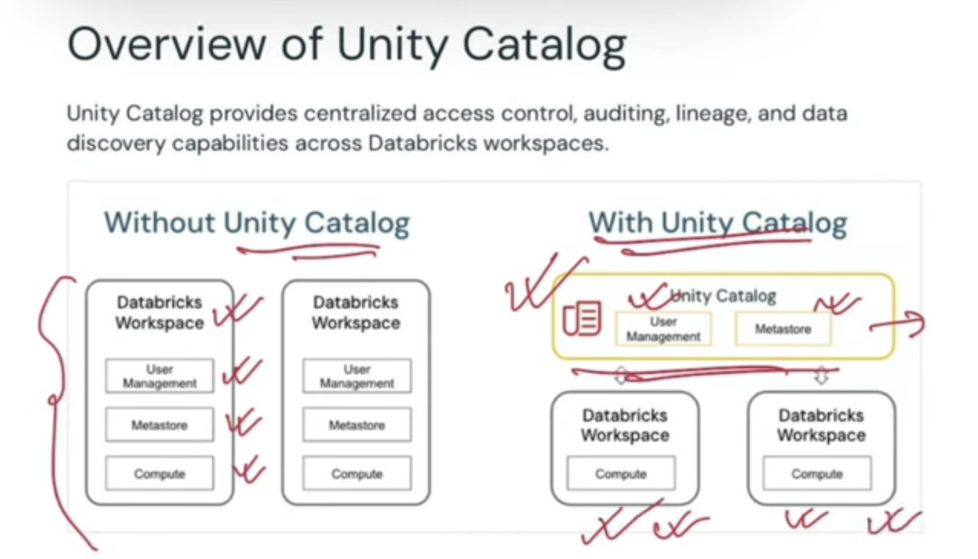

Catalog is used to maintain data assests

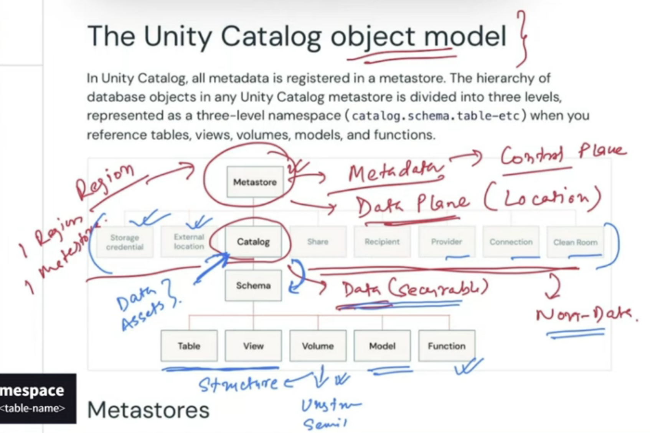

It is advisable to have 1 metastore per region

Below metastore we have lot of objects, catalog Is data securable where as others are non data securable

In the context of data governance and security, **"data securable"** refers to any object or asset in a data system (like databases, tables, views, or schemas) that can be protected through security policies, such as access control rules or permissions. Essentially, a "data securable" is any unit of data that can have specific security measures applied to it.

3 level namespace -> catalog.schema.table_name

Before Unity Catalog we used have legacy metastore that is hive metastore

Metastore Table Location for managed table

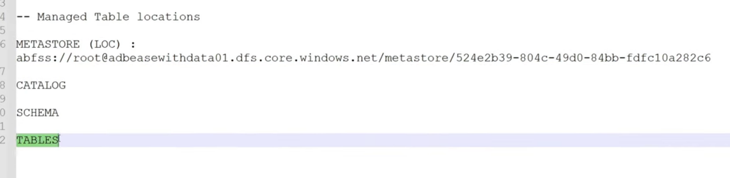

For managed table we can specify storage location at metatore level, catalog level, schema level or table level, if follows hirerachy. If at catalog level if table location is not passed then table will be at metastore location

To Create unity Catalog:

1. Create databricks workspace
2. Login to <https://accounts.azuredatabricks.net/> with ext user_id
3. Create storage account and databricks connector
4. Provide storage account path in databricks unity catalog store
5. For the storage account give storage blob contributor access to databricks connector so that databricks can store data in the blob

Create & Drop catalog with external location:

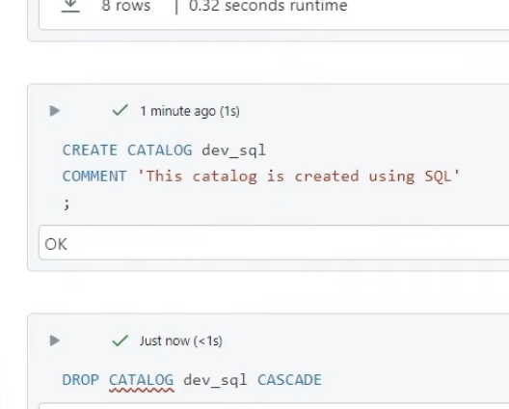

-- Create catalog with external location

create external location `ext_catalog`

URL 'abfss://data@atullutasa.dfs.core.windows.net/adb/catalog'

with (storage credential `sc_catalog_storage`)

Schema Creation:

create schema dev.bronze

-- Create schema with external location

create external location `ext_schema`

URL 'abfss://data@atullutasa.dfs.core.windows.net/adb/schema'

with (storage credential `sc_catalog_storage`)

create schema dev_ext.bronze_ext

managed location 'abfss://data@atullutasa.dfs.core.windows.net/adb/schema/bronze_ext'

create table dev_ext.bronze_ext.raw_sale(

invoice_id string,

cust_id string,

product_code string,

qty double,

price double

);

insert into dev_ext.bronze_ext.raw_sale values ('INV1001','CUST1001','PCODE1001',10,100);

All the table created under default schema and external schema are managed table, table created with external loction is only considered as external table

If we created new folder in storage account, for that path we need to create external location in databricks

Incase of unity catalog if I drop managed table data will not be removed immediately, but eventually after 7 days it will be removed, but within 7 days I can undrop table

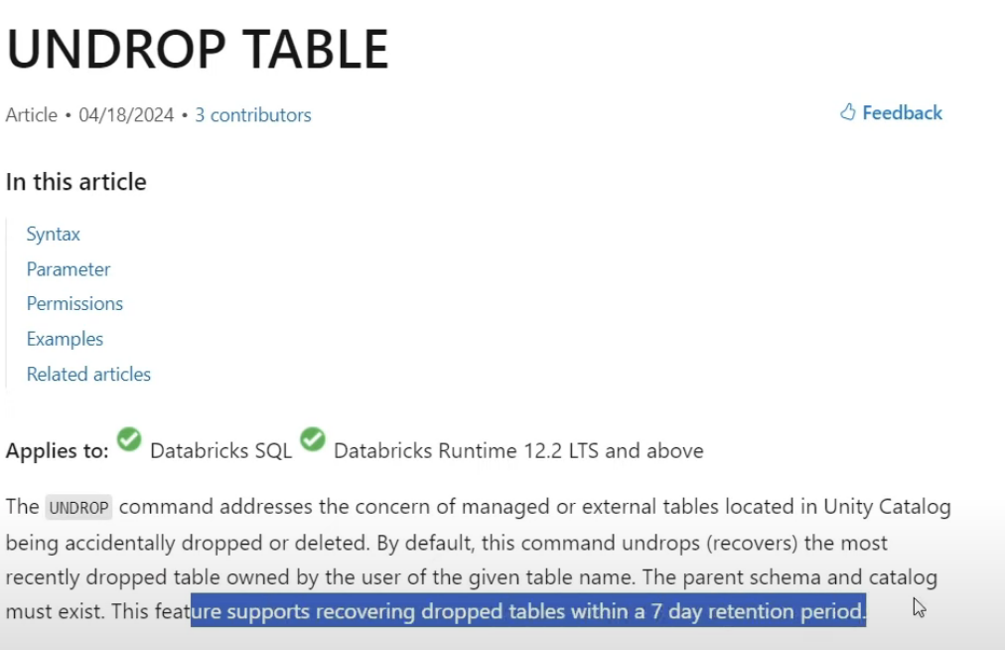

View all dropped table:

use catalog dev;

show tables dropped in bronze;

Undrop table <table_name>

Undrop table with table_id:

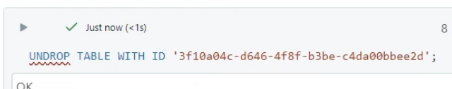

Delta Tables Utilities:

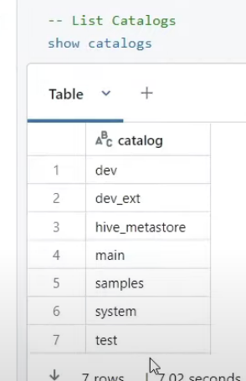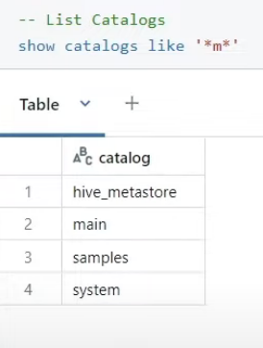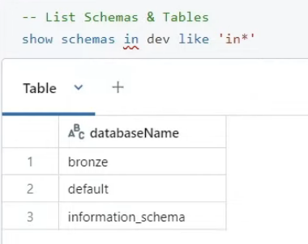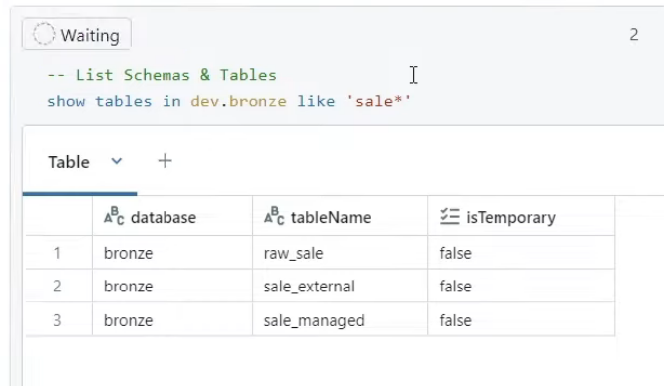

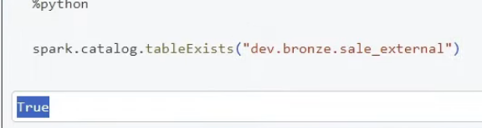

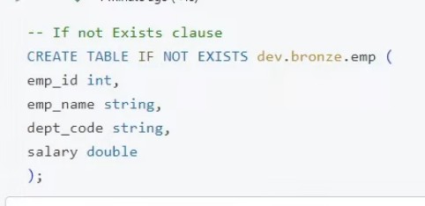

Temporary Views: Temporary tables which gets automatically removed once session is terminated

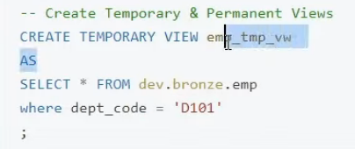

Permanent View:

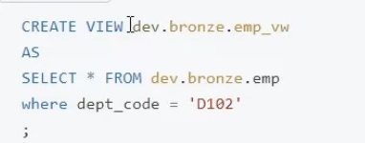

Refresh View:

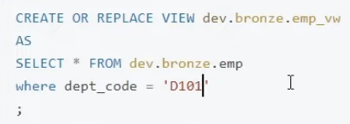

View will run query everytime, so if source table is updated, underlying view also gets updated automatically

Clone Tables:

1. CTAS will duplicate the table and will have new location and snapshot will start with 0, even though source table might have multiple versions
2. Deep Clone: We can copy both metadata and data
3. Shallow Clone: It will only copy metadata

Diff b/w CTAS and deep clone is there are in CTAS chances of missing metadata like partitioning, nullability where as in deep clone it’s an exact replica

Shallow Clone:

create table dev.bronze.raw_sale_dc deep clone dev.bronze.raw_sale;

create table dev.bronze.raw_sale_sc shallow clone dev.bronze.raw_sale;

Any changes in source table will not impact shallow or deep clone tables, but when u do vaccum on source table then shallow table will be impacted

Upsert: (update or Insert)

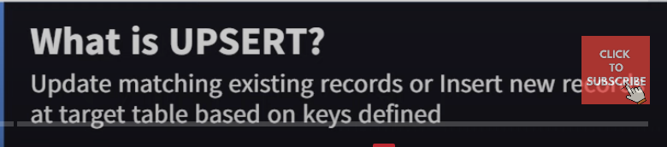

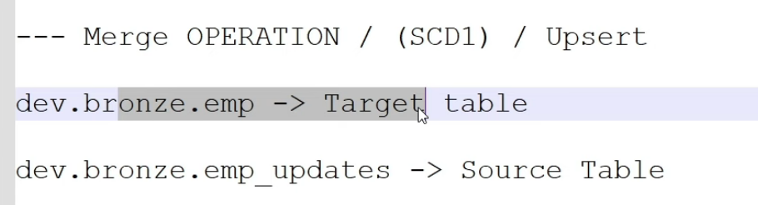

If source n destination has same keys then we update, if source key is not there we insert and if destination has a key which is not there in source then we can delete or mark inactive in dest table

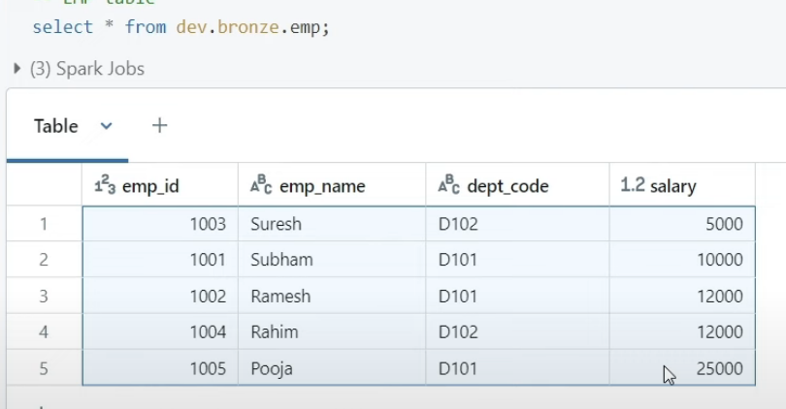

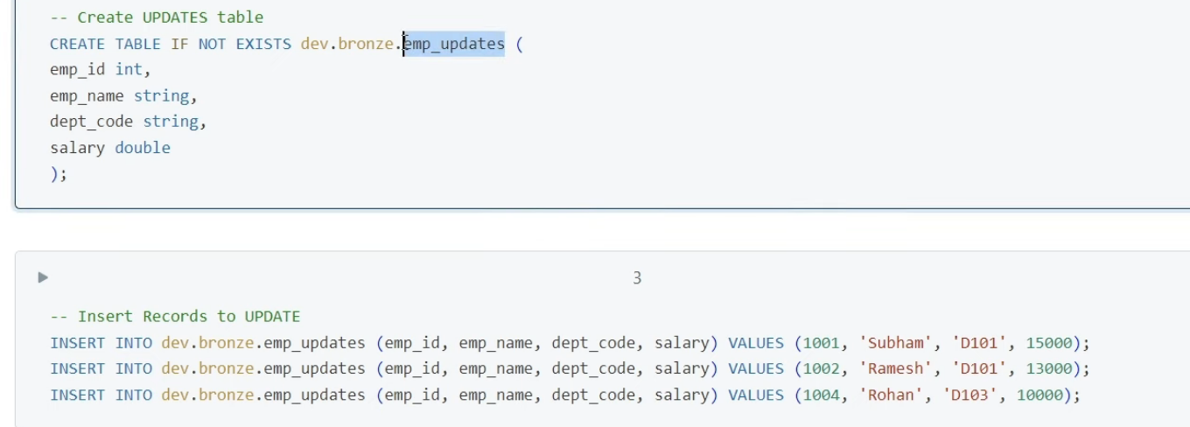



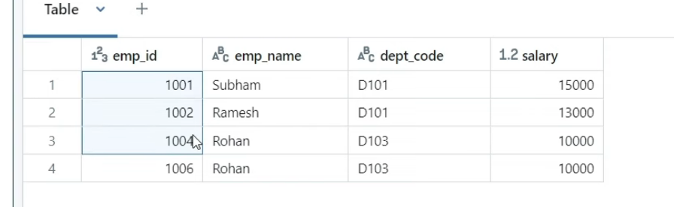

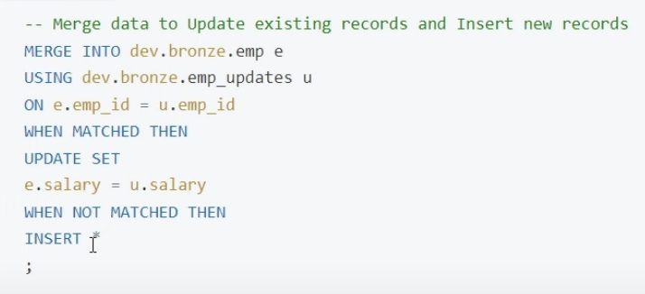

When target table has extra records then delete from target record

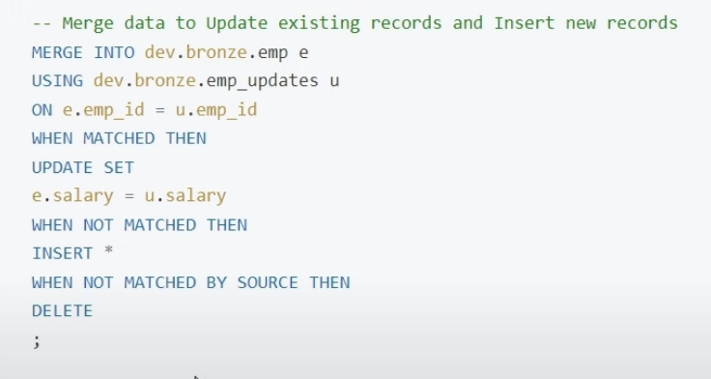

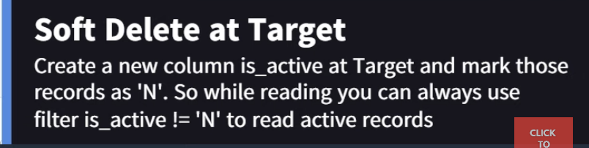

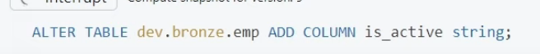

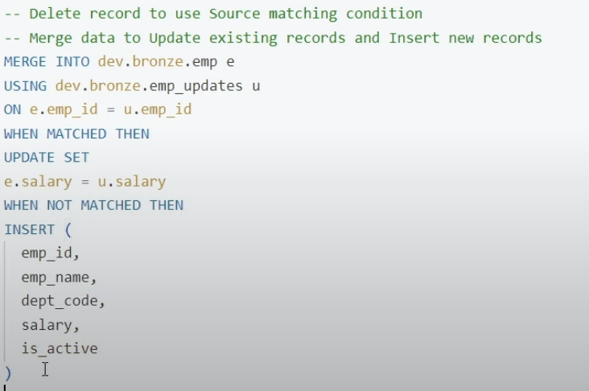

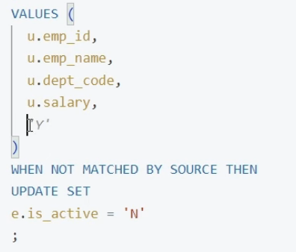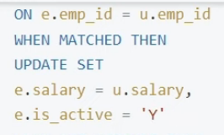

Volumes:

Volumes are siblings of table in unity catalog

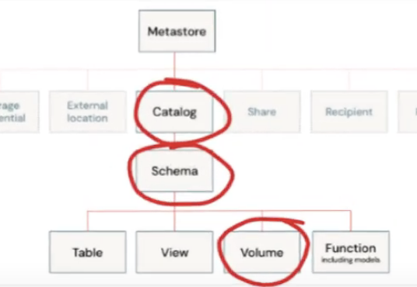

To create external volume first create a folder inside container in a blob, in databricks create external location

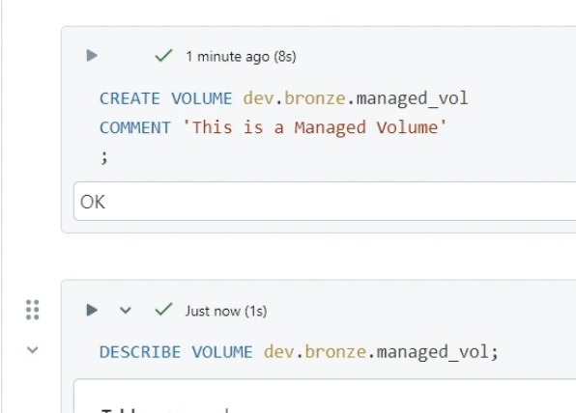

dbutils.fs.cp("file:/Workspace/Users/atullutab_outlook.com#ext#@atullutaboutlook.onmicrosoft.com/car_data_auto_no_header.csv","/Volumes/dev/bronze/managed_vol/tmp/")

%sql

create external volume dev.bronze.ext_vol

location 'abfss://data@atullutasa.dfs.core.windows.net/adb/ext_volume';

dbutils.fs.cp("file:/Workspace/Users/atullutab_outlook.com#ext#@atullutaboutlook.onmicrosoft.com/car_data_auto_no_header.csv","/Volumes/dev/bronze/ext_vol/")

If I delete managed volume all data and metadata will be lost, where as incase of external volume only metadata will be lost, data will be intact

DB Utils:

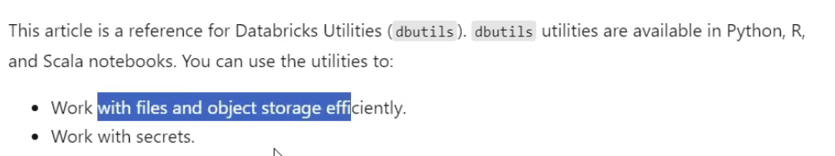

dbutils.help()

dbutils.fs.ls("abfss://data@atullutasa.dfs.core.windows.net/adb/catalog")

dbutils.fs.ls("file:/")

dbutils.fs.mkdirs("file:/Workspace/Users/atullutab_outlook.com#ext#@atullutaboutlook.onmicrosoft.com/tmp")

If folder is already there it will not throw error

Widgets are useful in paramterize query or code

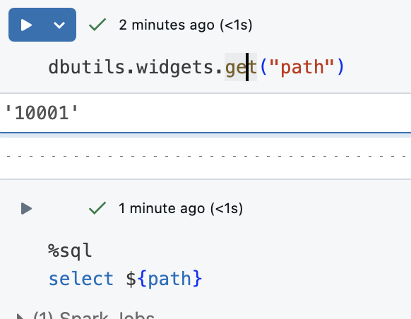

dbutils.widgets.text("path", "abfss://data@atullutasa.dfs.core.windows.net/adb/catalog", "Path")

%sql

select ${path}

Notebook Utils to run notebook from another notebook

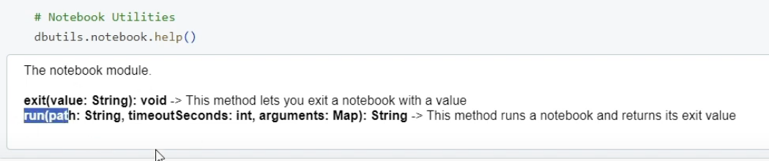

Orchestrating Notebook:

Create child notebook

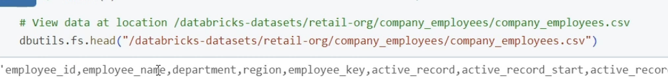

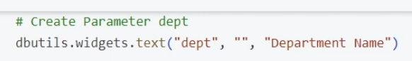

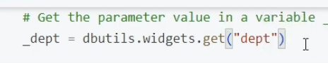

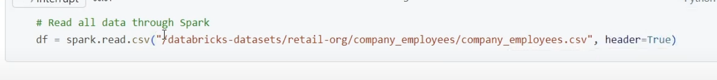

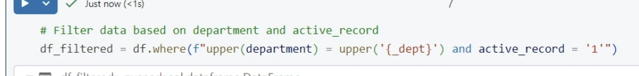

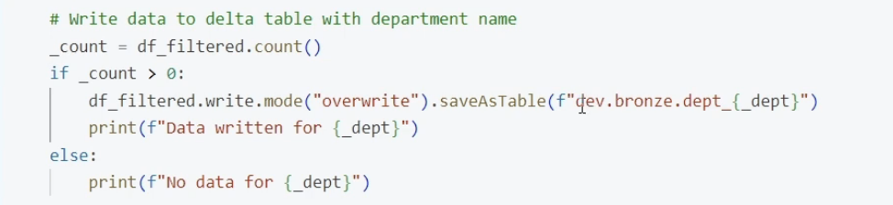

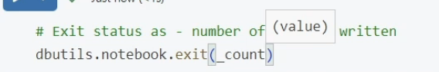

From Parent Notebook:

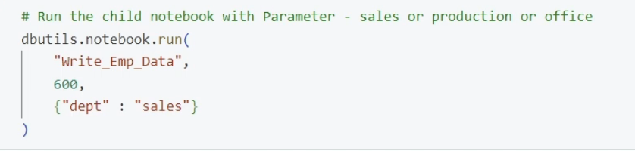

Different Types of Compute:

All Purpose Compute:

Access Modes:

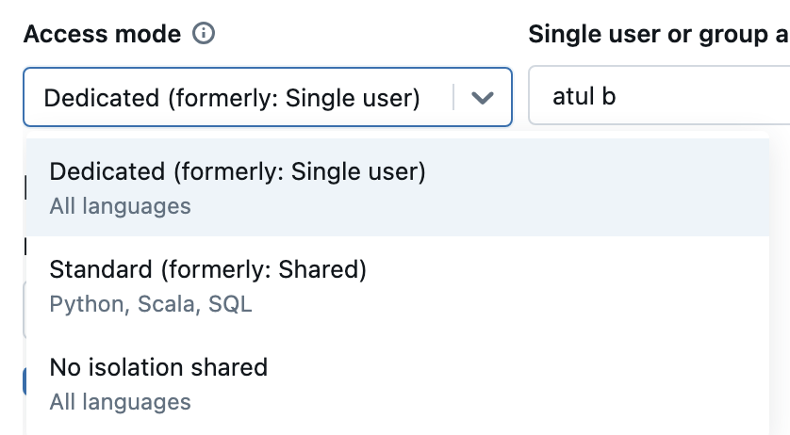

Databricks Runtime: Is a pre-packaged runtime image which has spark, python scala added

Photon Engine: Is a runtime engine which databricks has designed using c++, It gives faster execution for spark jobs

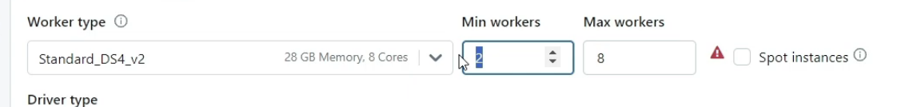

This is autoscaling

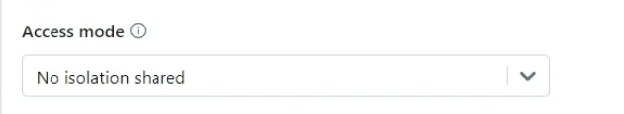

It is more of a legacy hive metastore system

Permission:

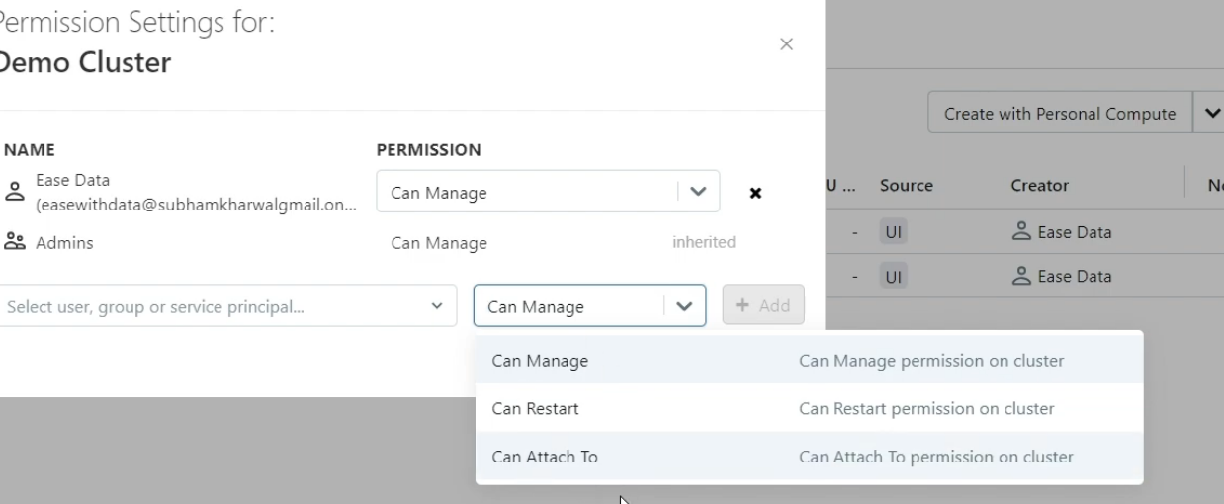

Policies:

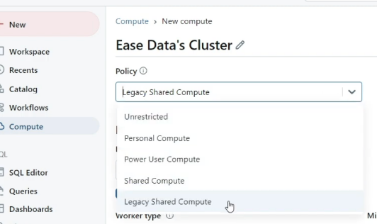

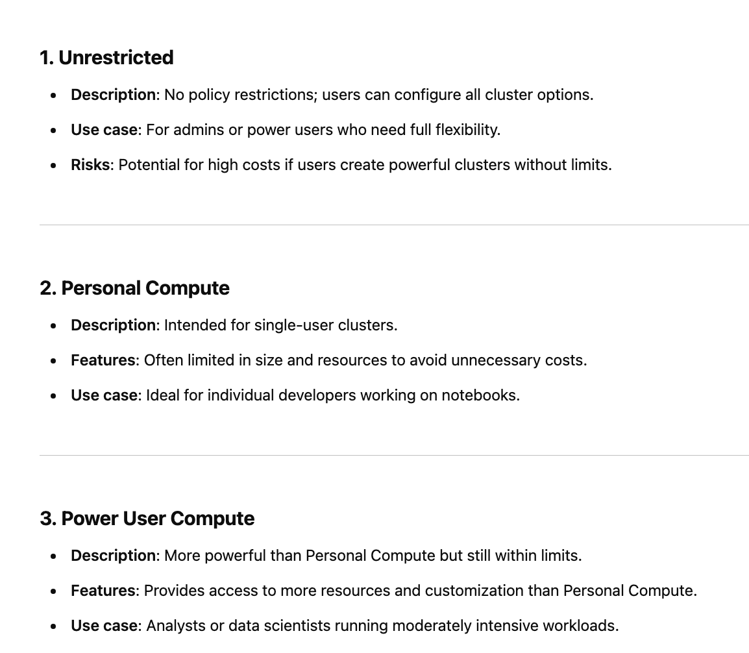

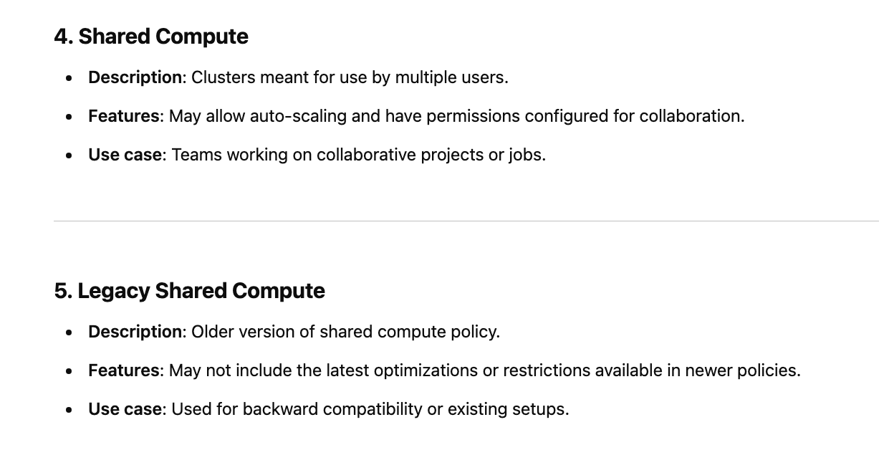



Allpurpose is used more for interactive or run jobs manually

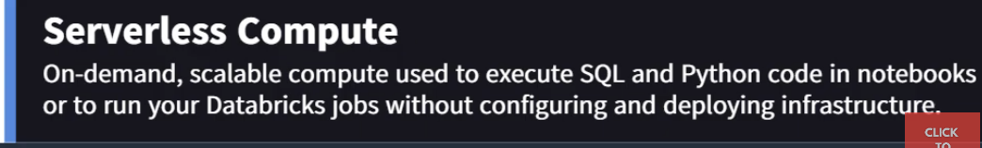

Policies:

Custom Policies:

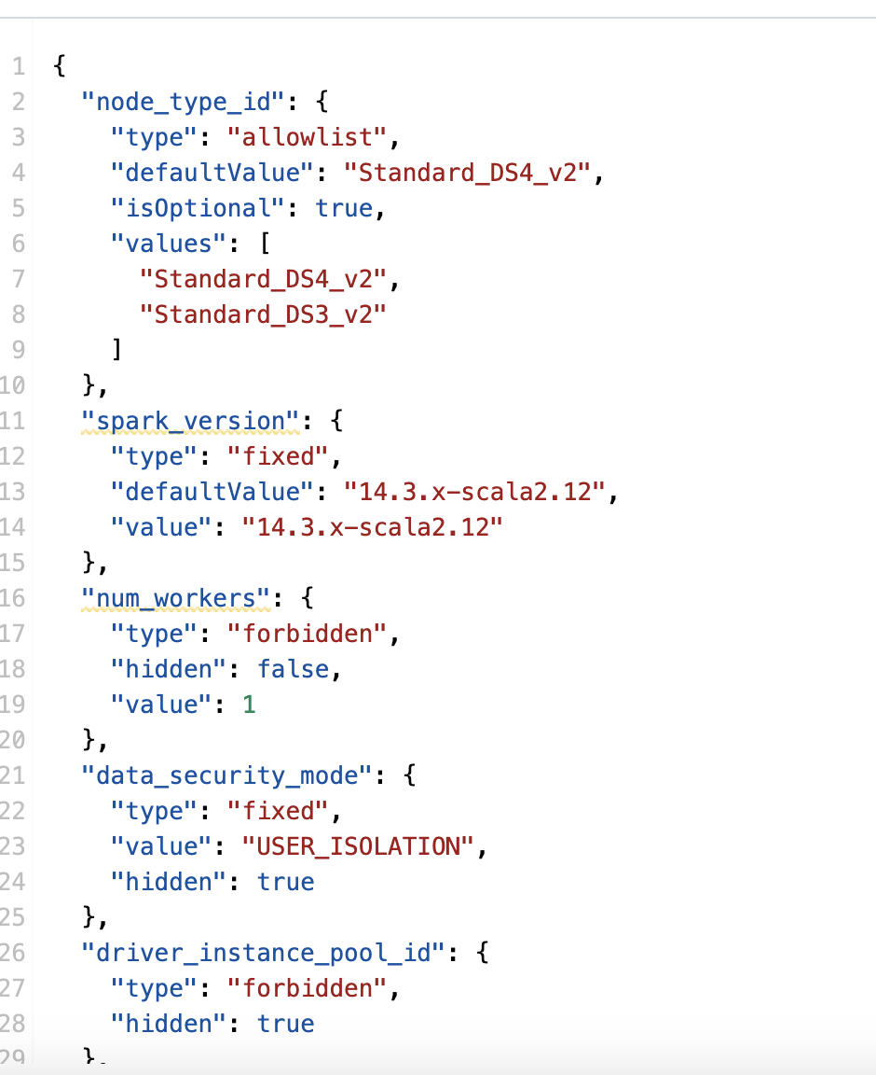

Clone from any policy and update values accordingly

Instance Pools: Pre-defined group of instances which are readily available which reduces compute start up time

Workflows:

Are used to orchestrate, schedule and trigger data processing jobs

Example 1: To run notebook if It’s Sunday else skip it:

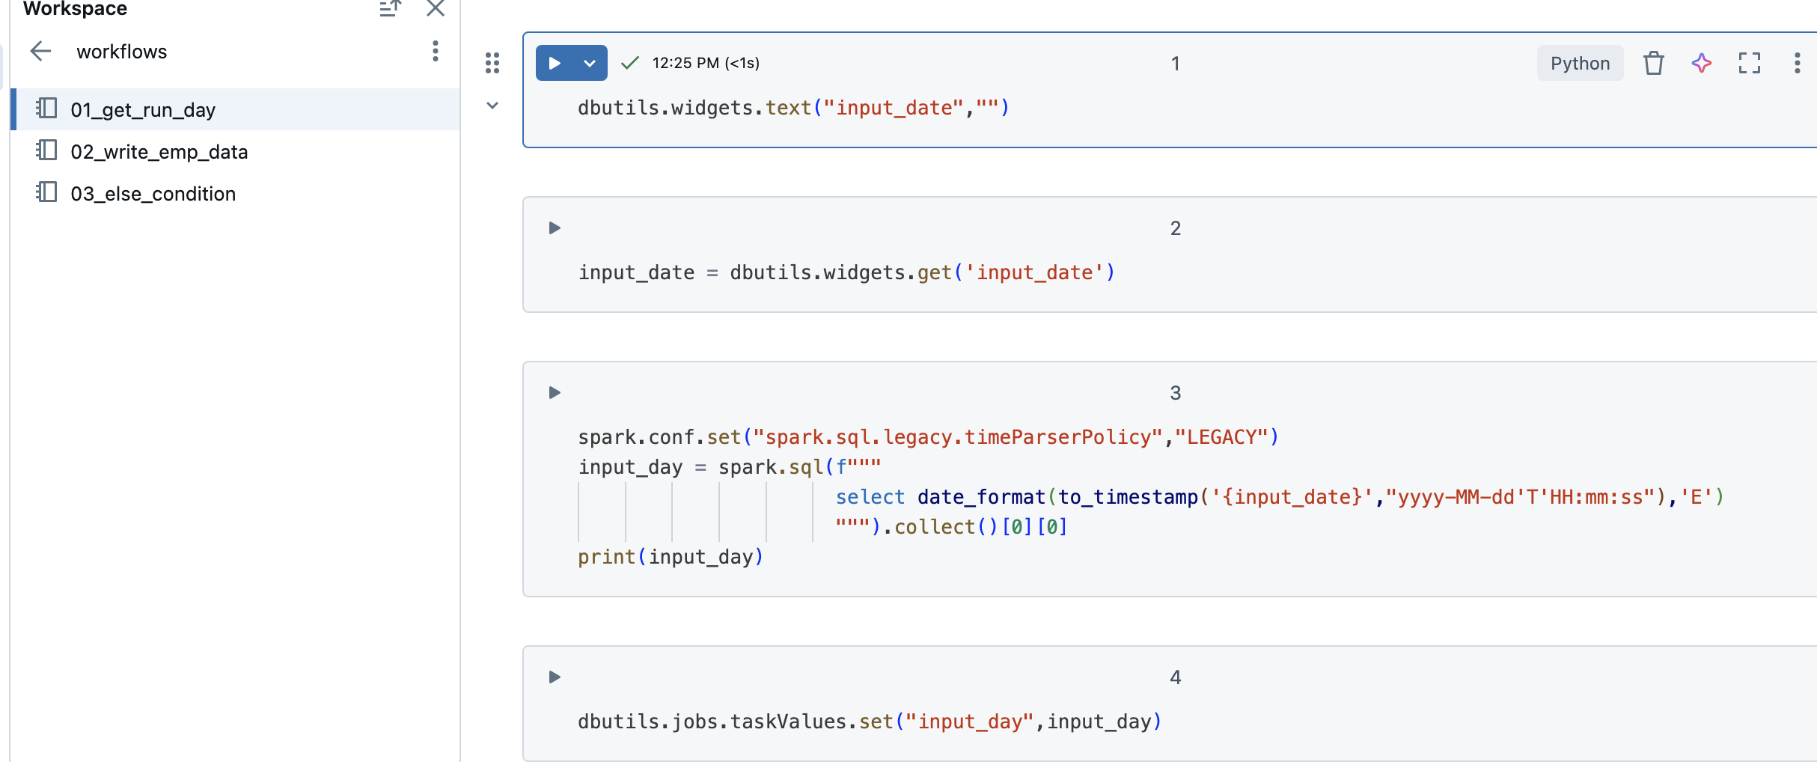

02_write_emp_data

df = spark.read.csv("/databricks-datasets/retail-org/company_employees/company_employees.csv",header=True)

dbutils.widgets.text("dept","")

_dept = dbutils.widgets.get("dept")

_dept

df_filtered = df.where(f"upper(department) = upper('{_dept}') and active_record='1' ")

_count = df_filtered.count()

if _count > 0:

df_filtered.write.mode("overwrite").format("delta").saveAsTable(f"dev.bronze.dept_{_dept}")

else:

print(f"No records found for department: {_dept}")

dbutils.notebook.exit(_count)

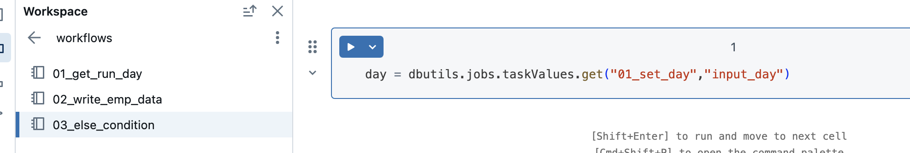

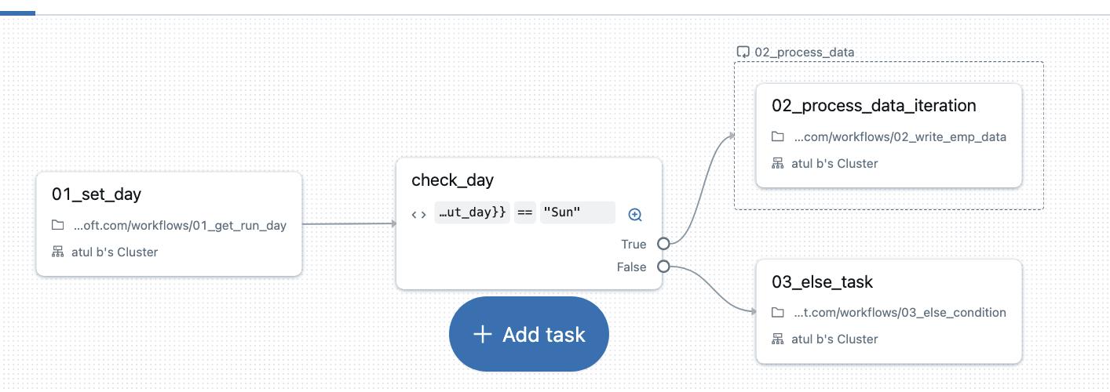

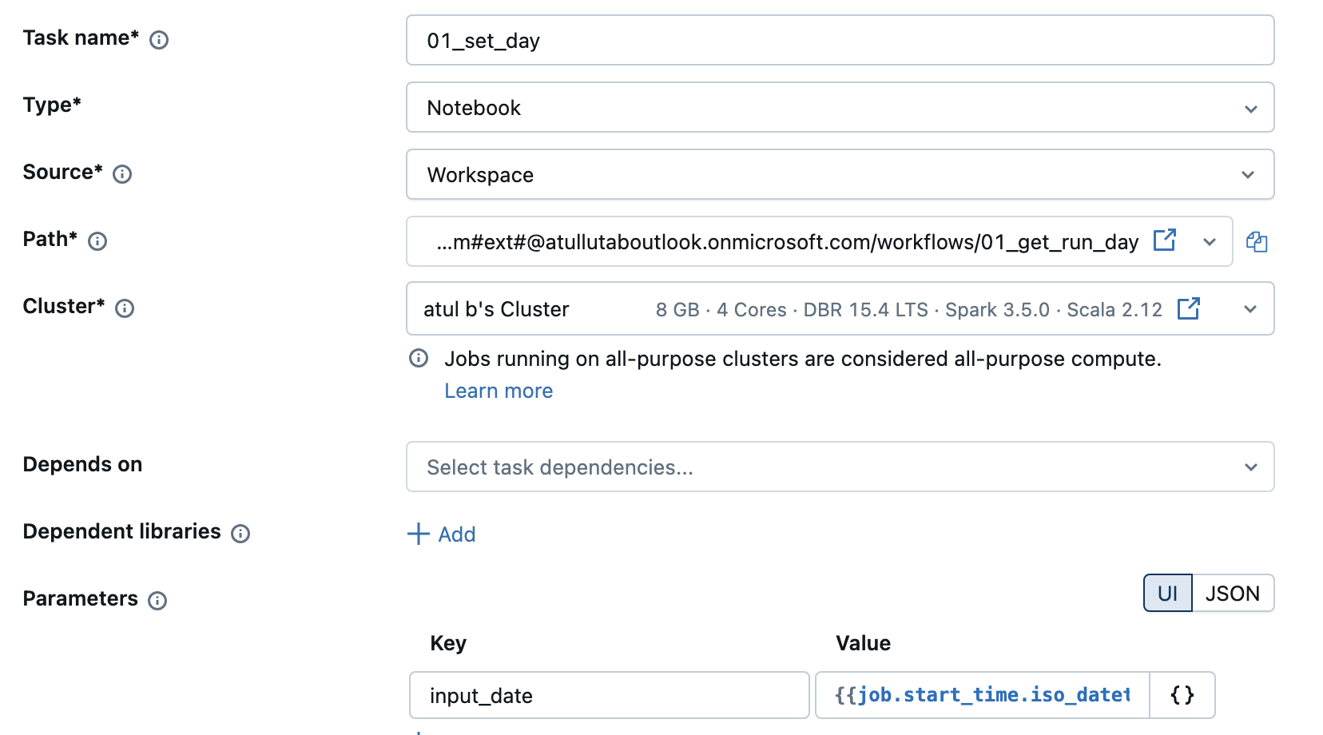

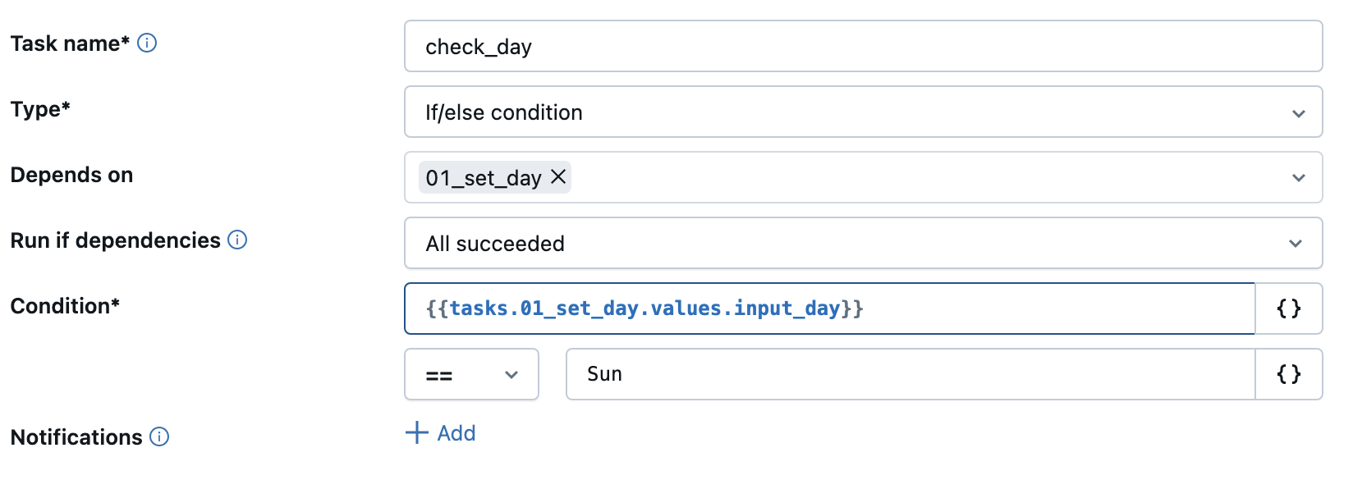

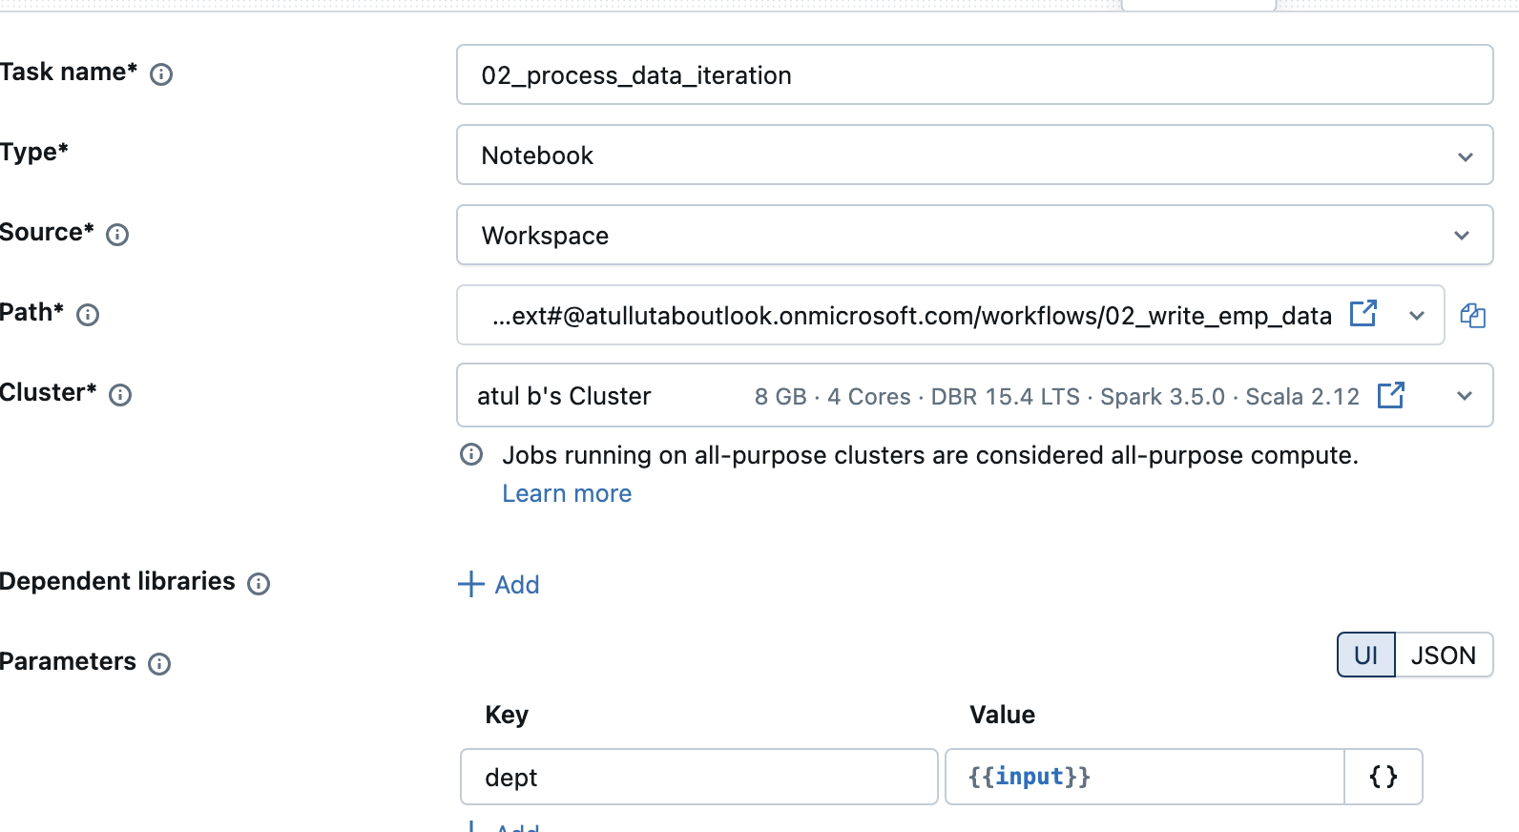

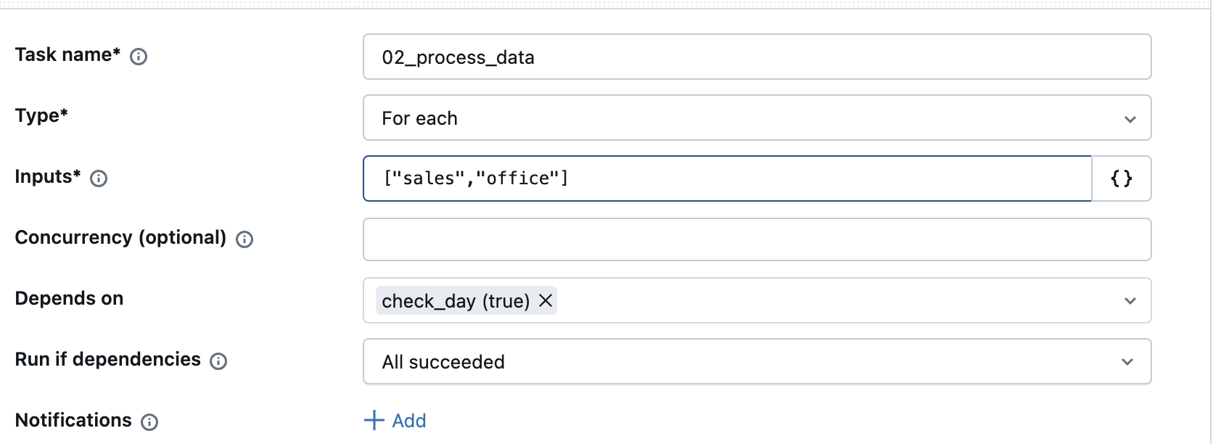

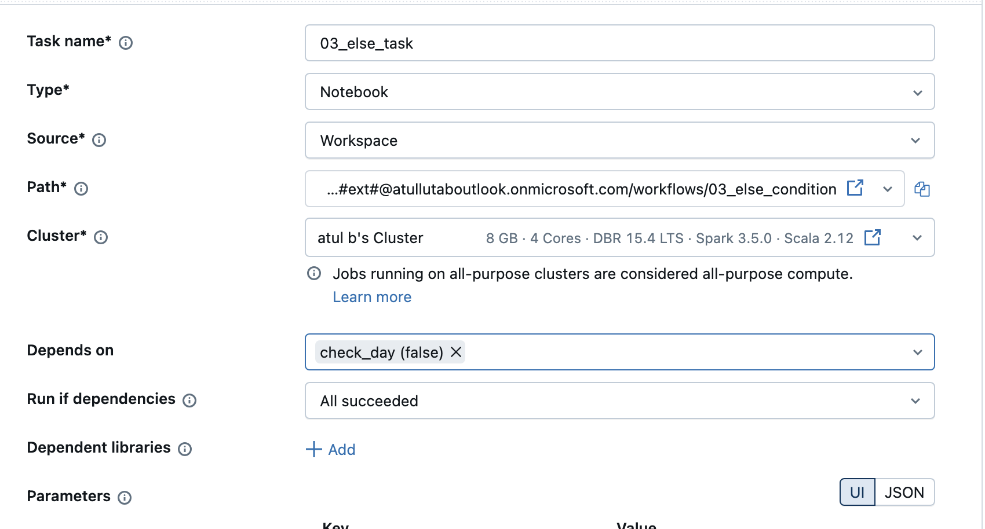

Copy Into:

The COPY INTO command in **Databricks** is used to efficiently **load data into Delta Lake tables** from external sources like cloud storage (e.g., AWS S3, Azure Blob, ADLS Gen2). It supports **schema evolution**, **data validation**, and **deduplication**, making it super useful for incremental data loading. 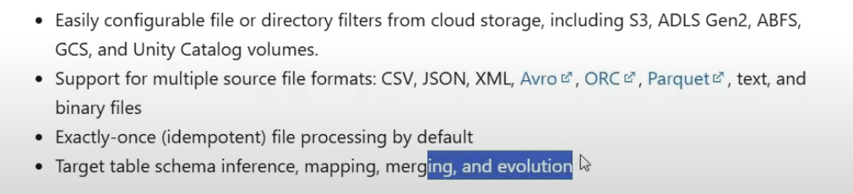

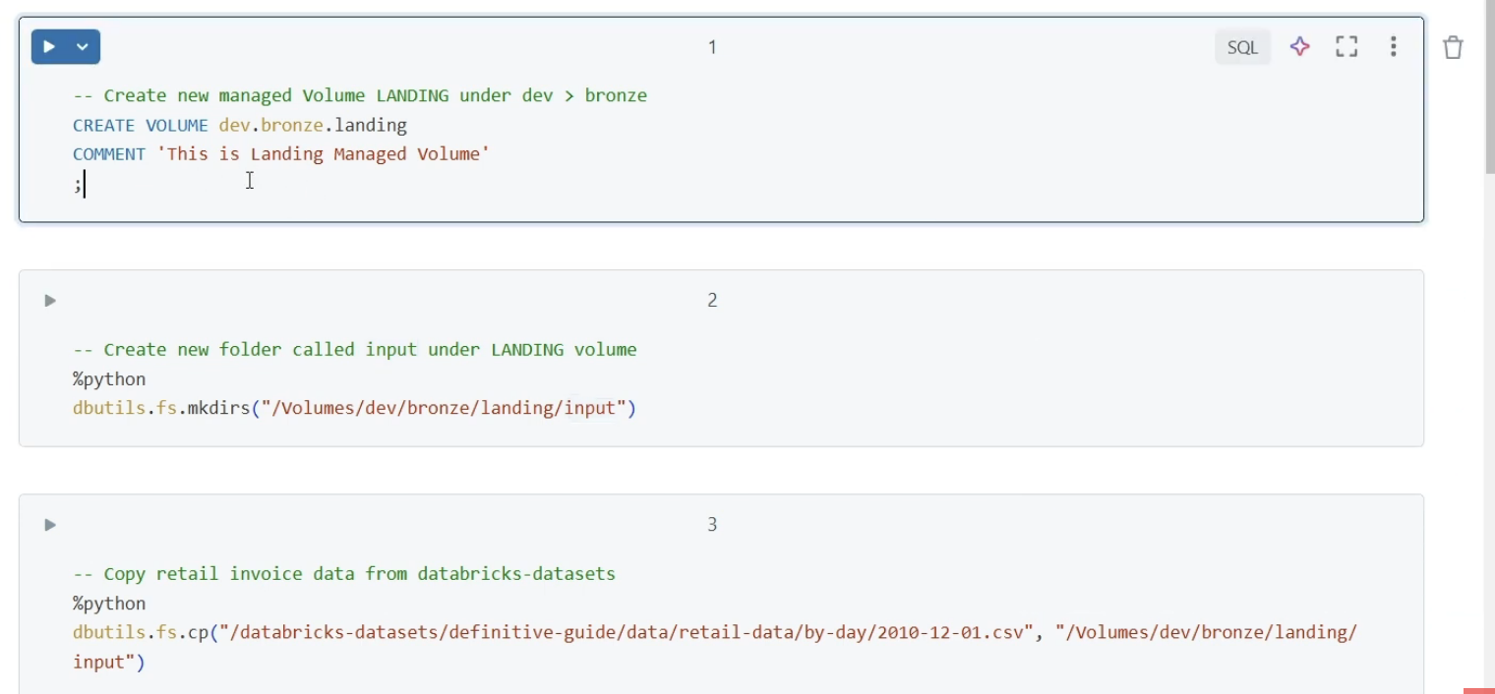



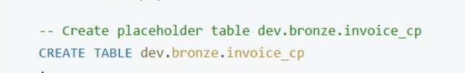



We just create tables without columns, we provide schema on the fly

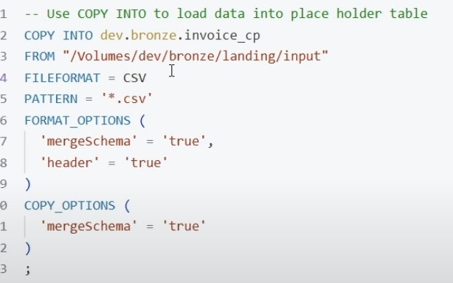

It is idempotent

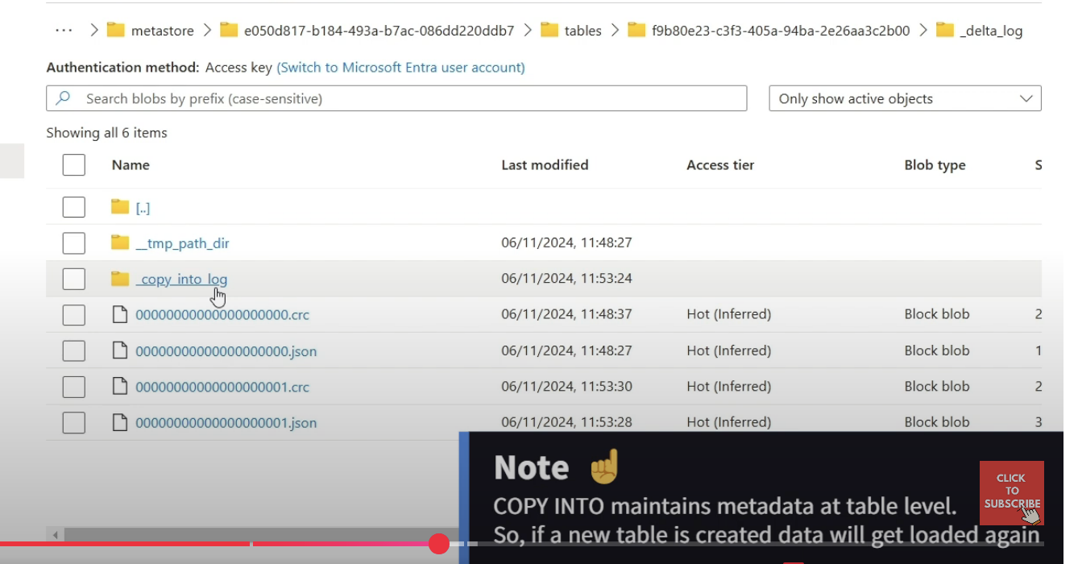

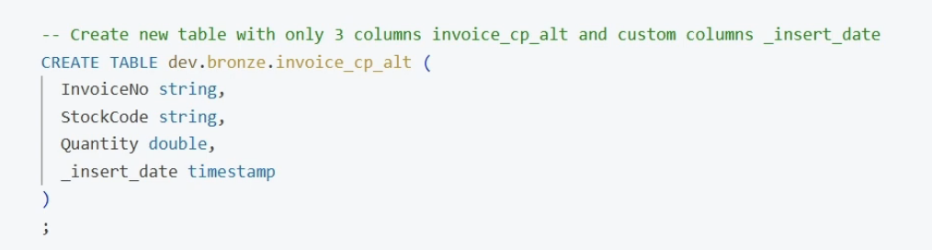

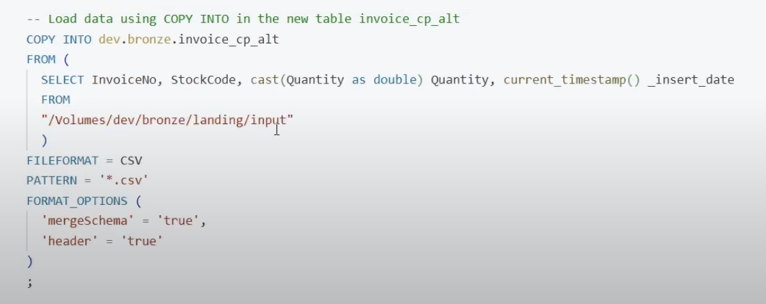

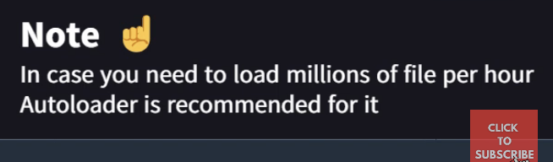

Autoloader:

It’s a utility to process files which are added incrementally to your cloud storage

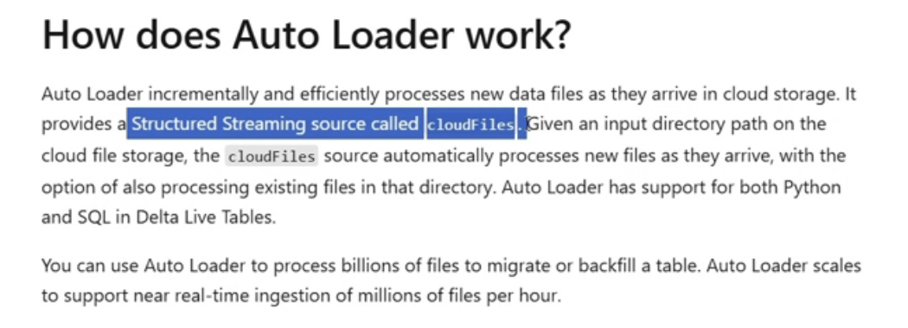

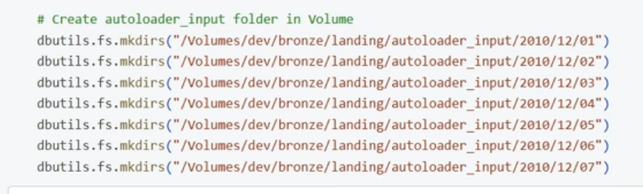

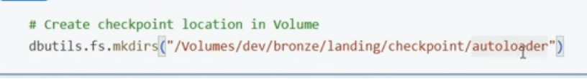

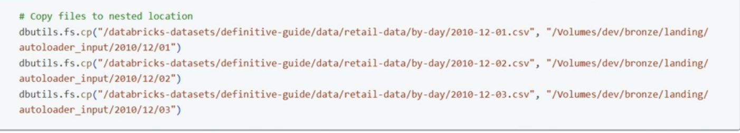

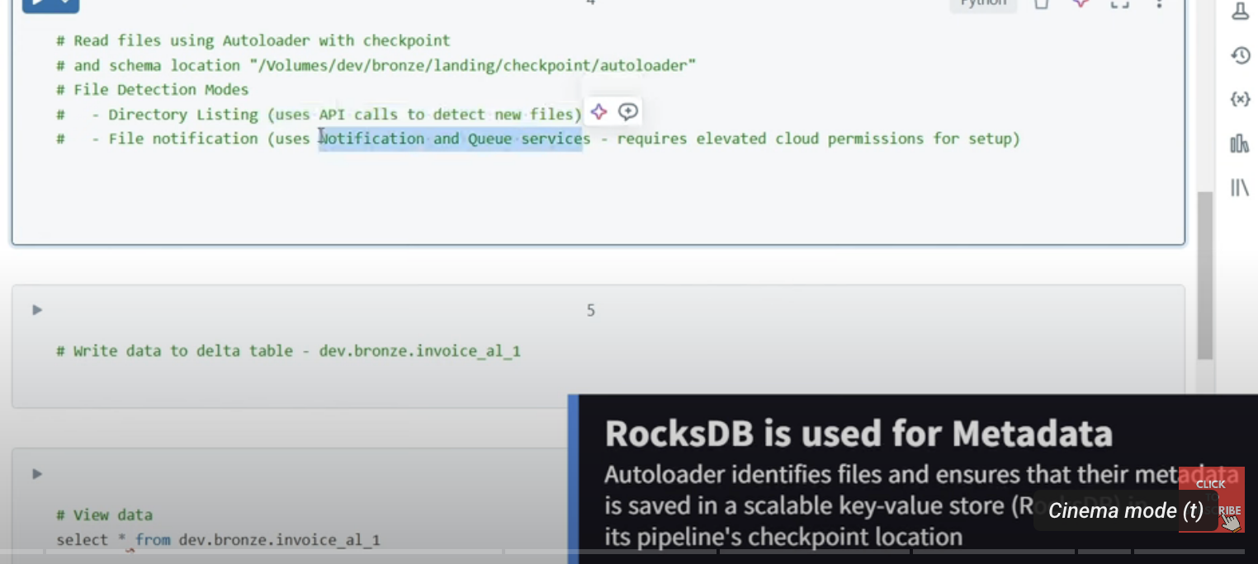

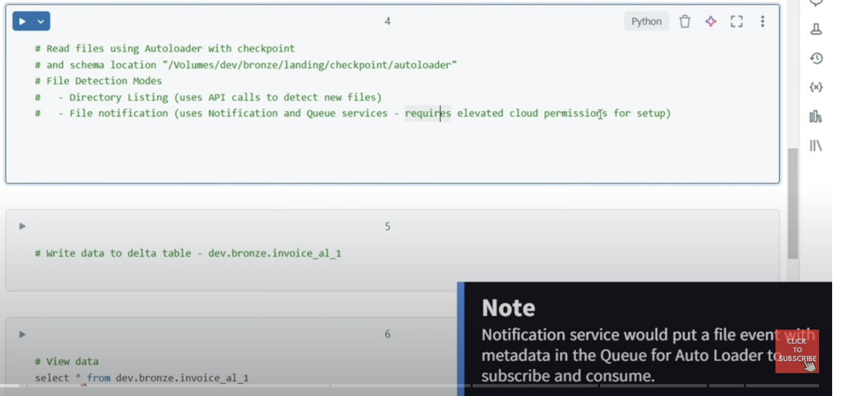

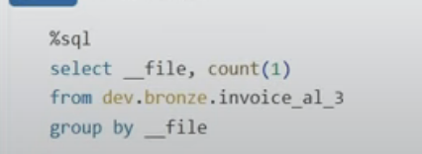

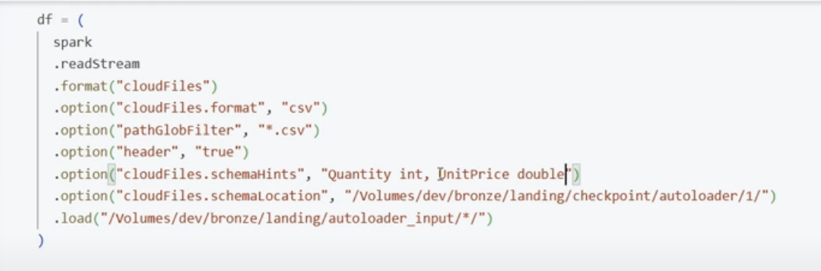

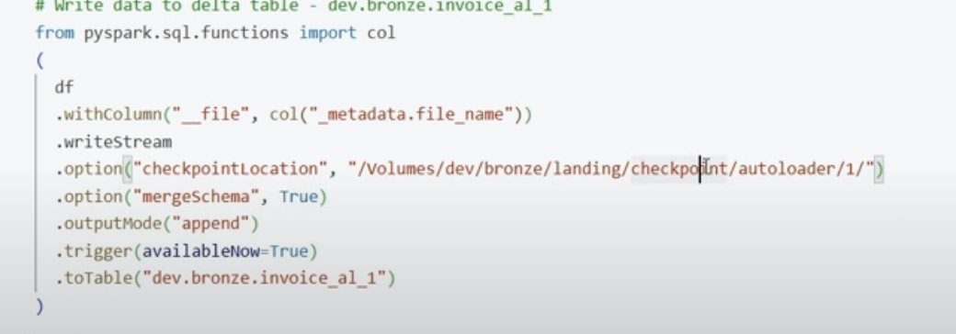

Schem Evolution in Auto Loader:

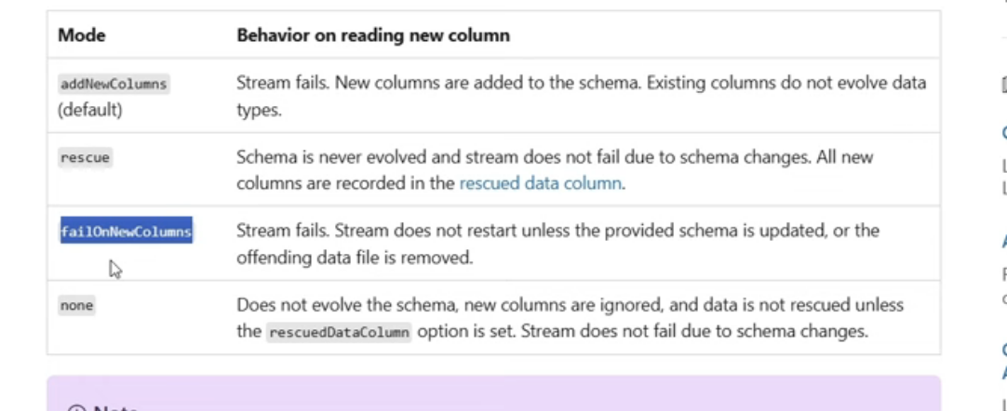

Suppose addNewColumns is set as schema and if we run pipeline

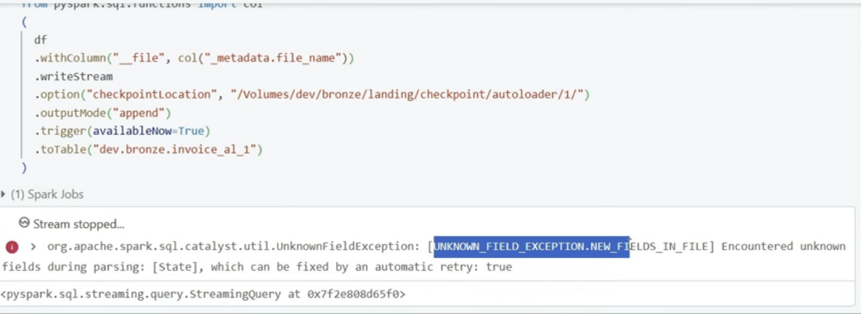

When it fails, it updates schema in checkpoint location and If I rerun, it will work

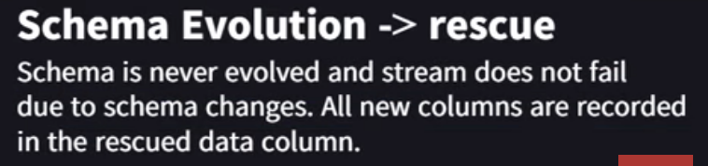

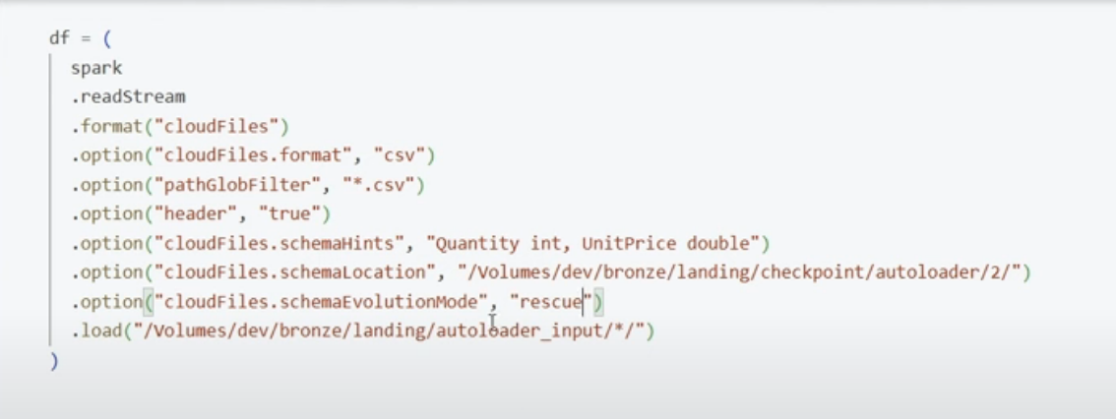

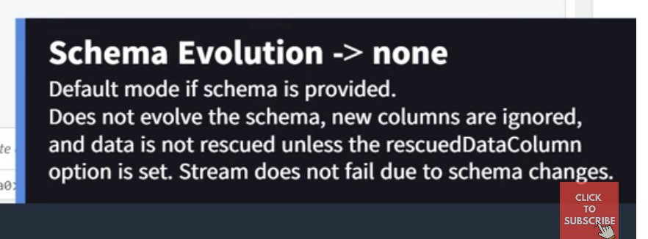

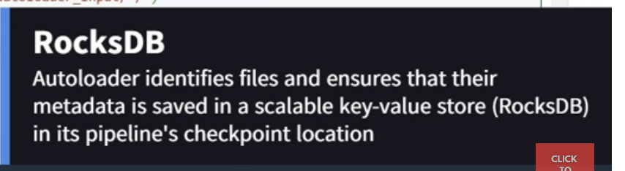

We can set file notification but databricks might need evelated previlages

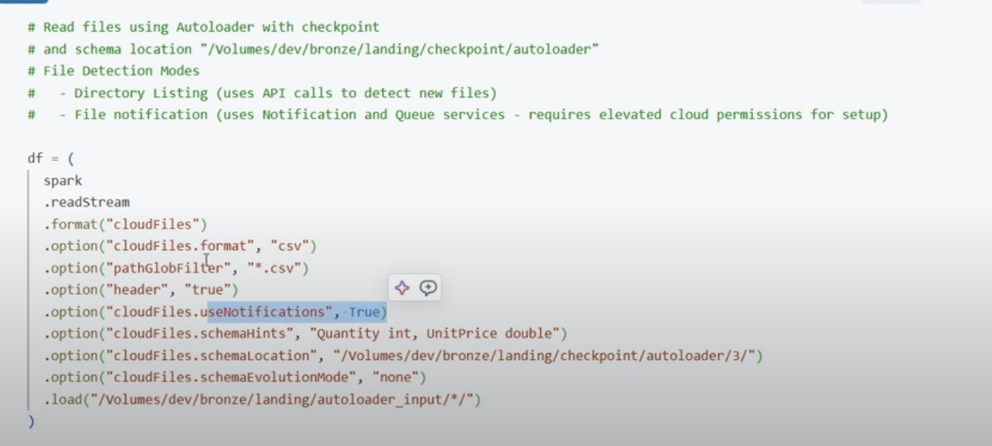

Medallion Architecture:

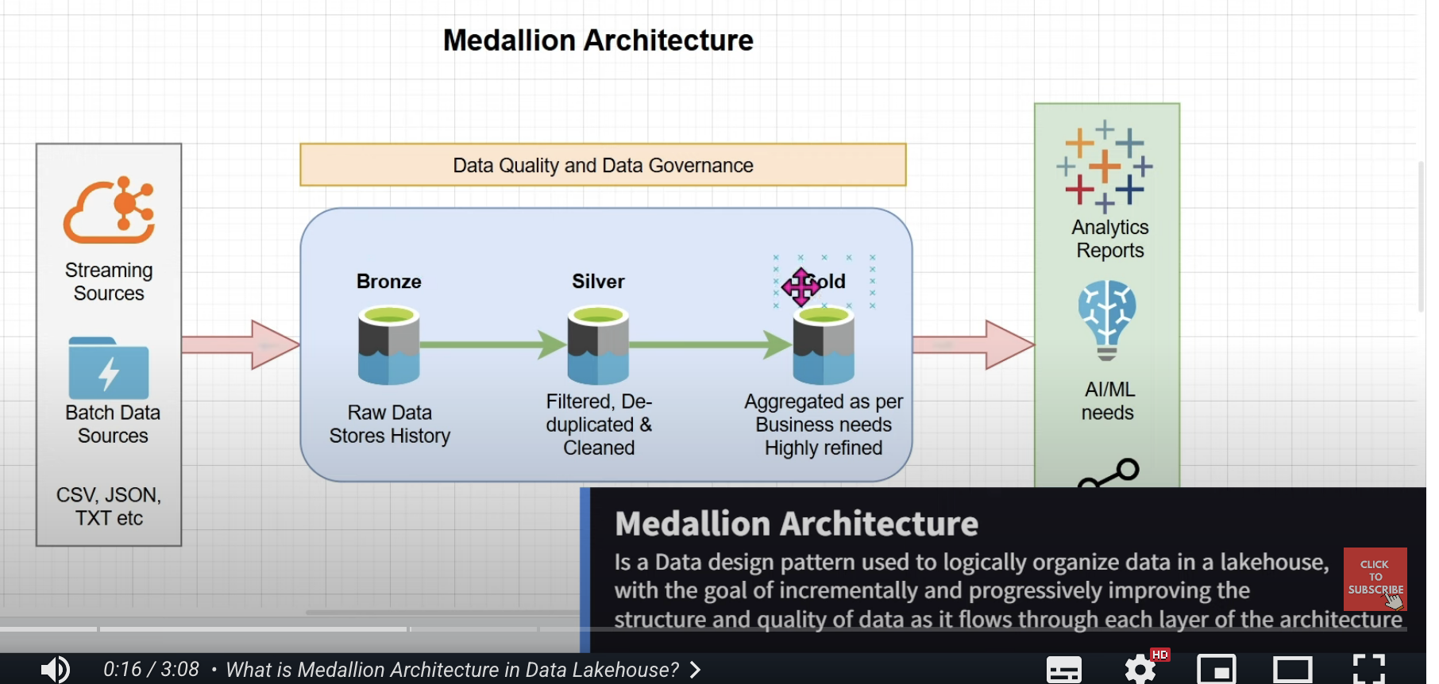

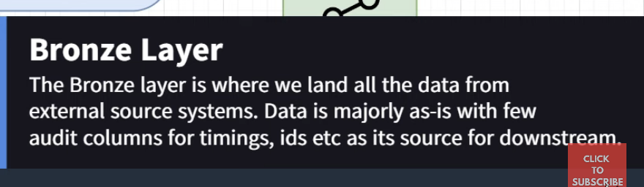

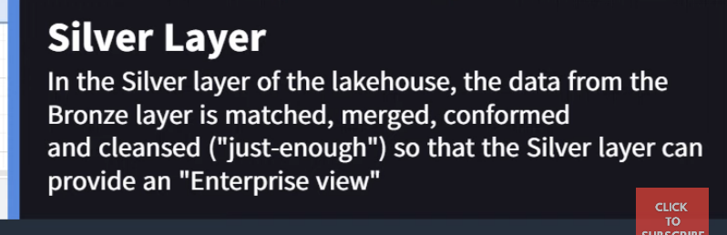

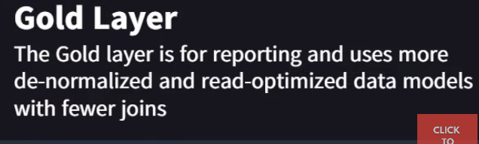

Delta Live Tables:

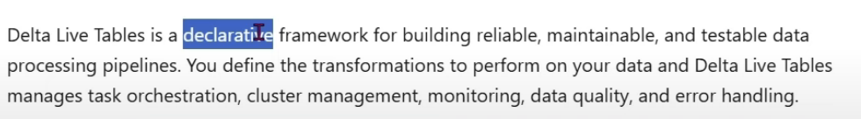

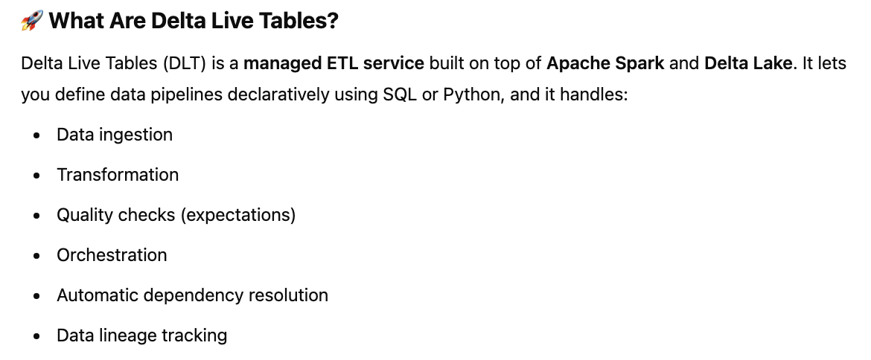

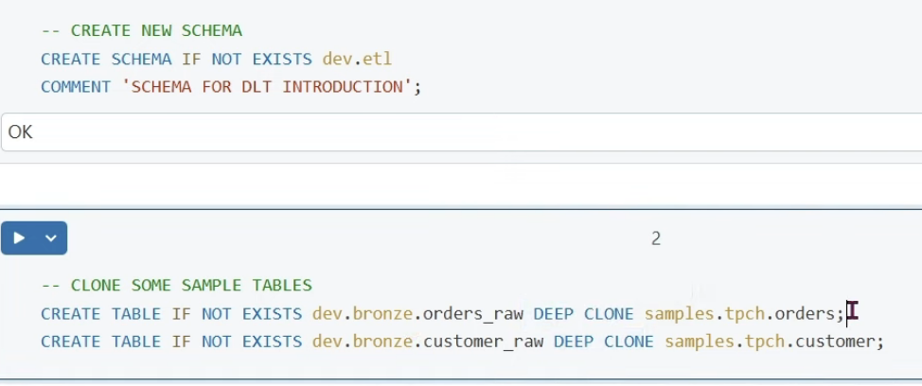

Types of Datasets:

It is powered by delta lake

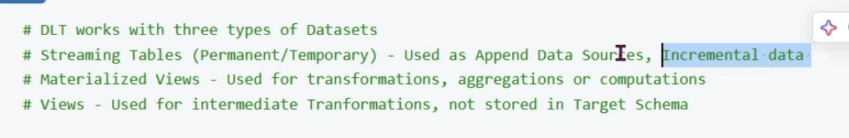

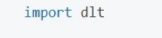

Streaming Table:

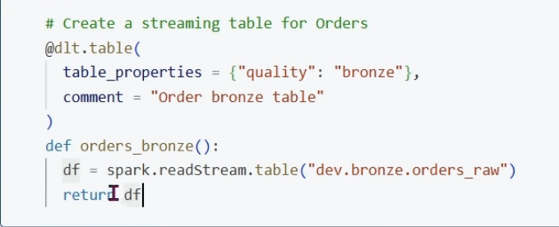

Materialized View:

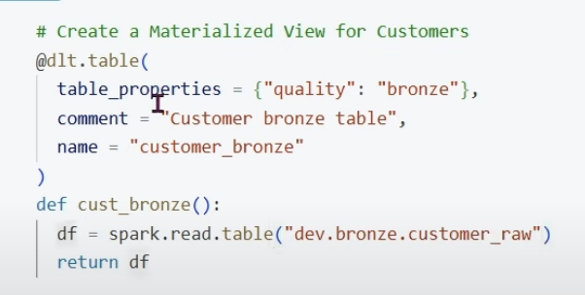

Create View:

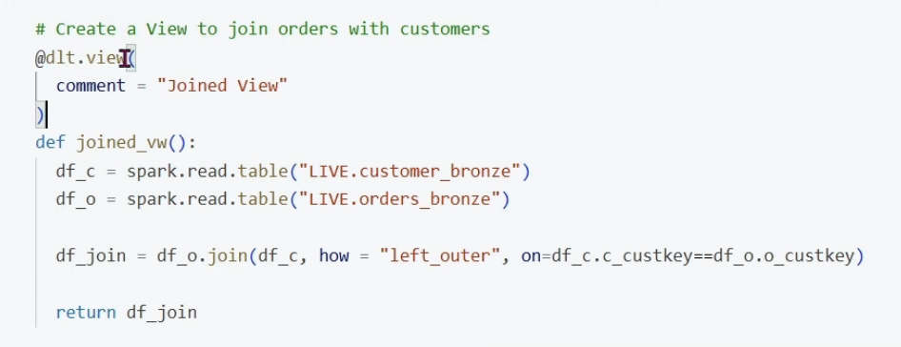

Joined View:

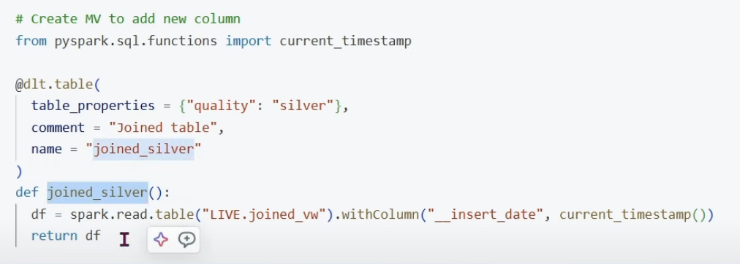

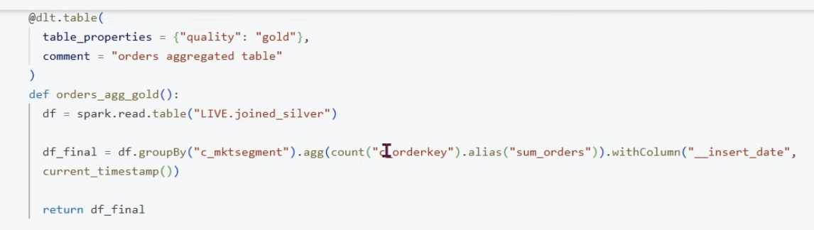

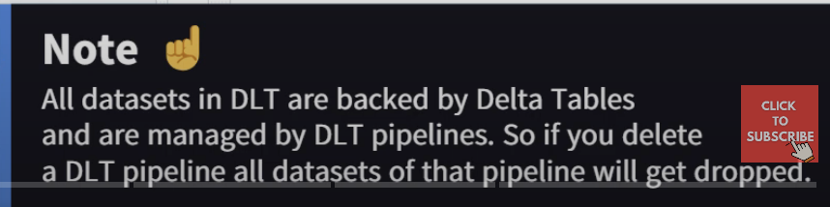

Incremental Ingestion:

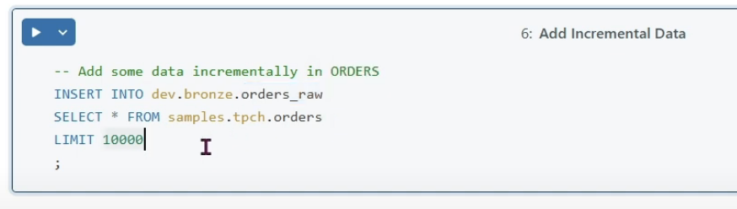

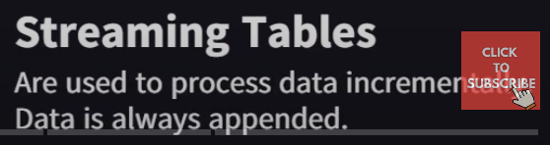

Add new column on final aggregated table:

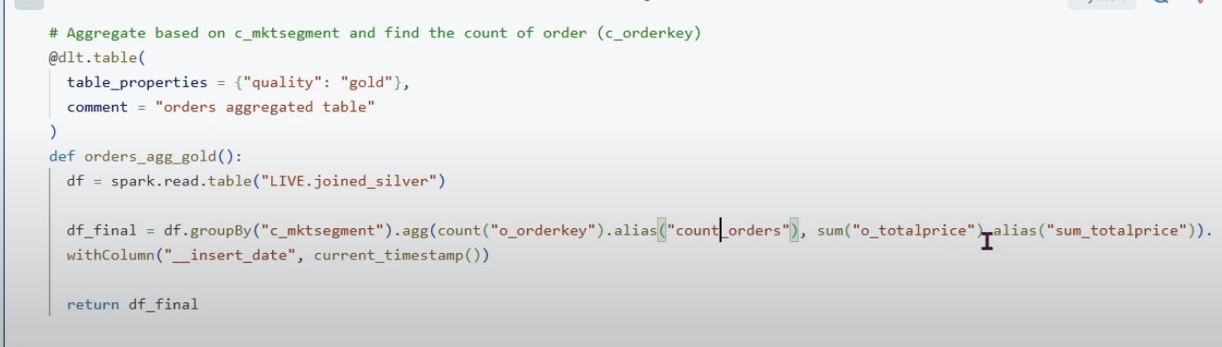

Here existing column is changed and new column is added

Even if we change table_name DLT handles it:

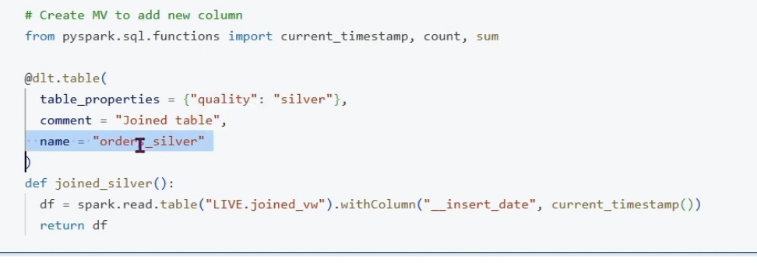

Meterizalied view and streaming tables are internally stored as delta tables under

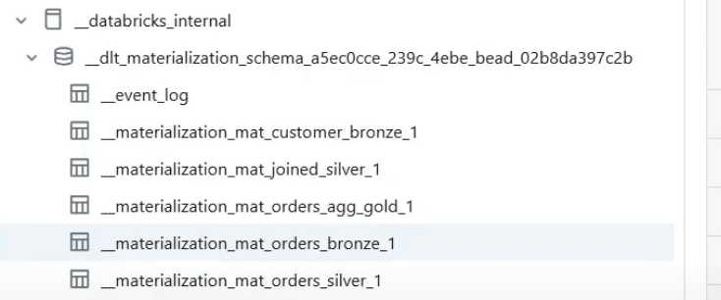

We can see lineage

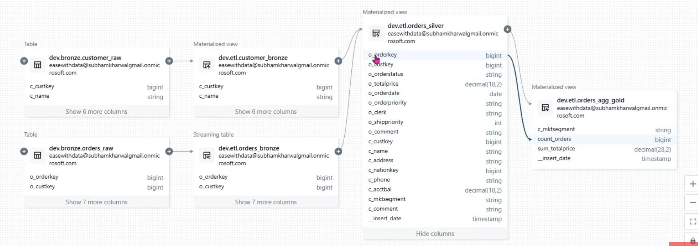

Auto Loader in DLT pipelines and Parameters:

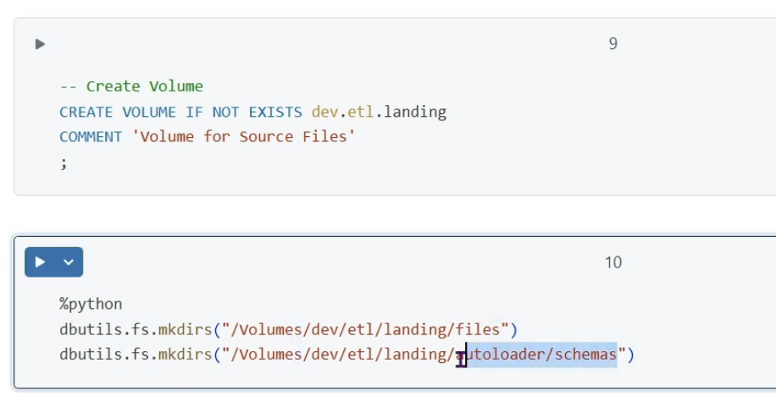

Place this code at the first cell block

For autoloader in delta live we don’t need to specify checkpoint location, it will be stored in same place where data is stored

In order to perform union of streaming table we need to use append flow

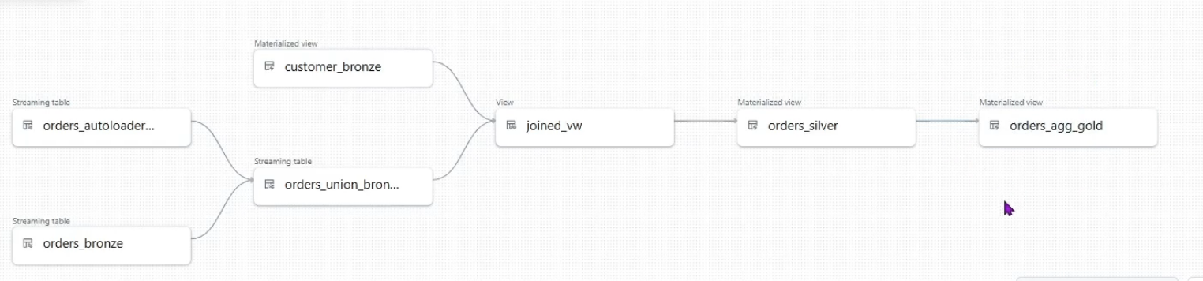

For the same pipeline we will use append flows to perform union of streaming and DLT table and then join with customers

%sql

create volume if not exists dev.etl.landing

%python

dbutils.fs.mkdirs("/Volumes/dev/etl/landing/files")

dbutils.fs.mkdirs("/Volumes/dev/etl/landing/autoloader/schemas")

import dlt

@dlt.table(

table_properties = {"quality":"bronze"},

comment = "order bronze table"

)

def orders_bronze():

df = spark.readStream.table("dev.bronze.orders_raw")

return df

@dlt.table(

table_properties = {"quality":"bronze"},

comment = "order autoloader table",

name="orders_autoloader_bronze"

)

def func():

df = (

spark.readStream.format("cloudFiles")

.option("cloudFiles.schemaHints","""o_orderkey long,

o_custkey long,

o_orderstatus string,

o_totalprice decimal(18,2),

o_orderdate date,

o_orderpriority string,

o_clerk string,

o_shippriority integer,

o_comment string""")

.option("cloudFiles.schemaLocation","/Volumes/dev/etl/landing/autoloader/schemas/1/")

.option("cloudFiles.format","CSV")

.option("pathGlobFilter","*.csv")

.option("cloudFiles.schemaEvolutionMode","none")

.load("/Volumes/dev/etl/landing/files")

)

return df

dlt.create_streaming_table("orders_union_bronze")

# Append Flow

@dlt.append_flow(

target="orders_union_bronze"

)

def order_delta_append():

df = spark.readStream.table("LIVE.orders_bronze")

return df

#ABove code will read data from orders_bronze table and append it to orders_union_bronze

# Append Flow

@dlt.append_flow(

target="orders_union_bronze"

)

def order_autoloader_append():

df = spark.readStream.table("LIVE.orders_autoloader_bronze")

return df

@dlt.table(

table_properties = {"quality":"bronze"},

comment = "order bronze table",

name='customer_bronze'

)

def cust_bronze():

df = spark.read.table("dev.bronze.customer_raw")

return df

@dlt.view(

comment = "joined view"

)

def joined_vw():

df_c = spark.read.table("LIVE.customer_bronze")

df_o = spark.read.table("LIVE.orders_autoloader_bronze")

df_join = df_o.join(df_c,how='left_outer',on=df_c.c_custkey==df_o.o_custkey)

return df_join

from pyspark.sql.functions import *

@dlt.table(

table_properties = {"quality":"silver"},

comment = "joined table",

name='joined_silver'

)

def joined_silver():

df = spark.read.table("LIVE.joined_vw").withColumn("__insert_date",current_timestamp())

return df

import dlt

@dlt.table(

table_properties = {"quality":"gold"}

)

def orders_aff_gold():

df = spark.read.table("LIVE.joined_silver")

df_final = df.groupBy("c_mktsegment").agg(count("o_orderkey").alias("count_orders"),

sum('o_totalprice').alias("sum_totalprice")).withColumn("__insert_date",current_timestamp())

return df_final

Pass Parameters in DLT tables:

Add multiple gold tables based on order status

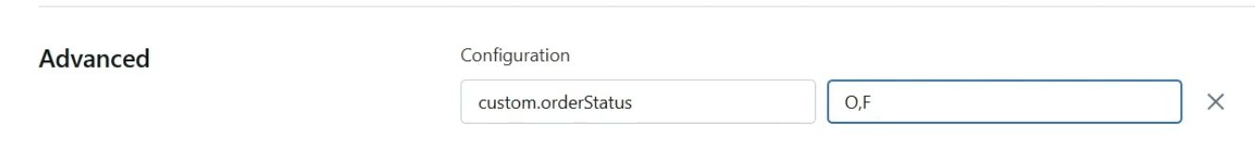

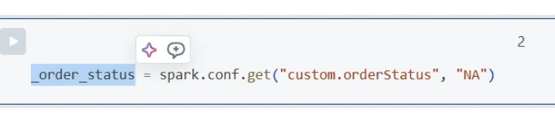

_order_status = spark.conf.get('custom.orderStatus','NA')

for i in _order_status.split(","):

import dlt

@dlt.table(

table_properties = {"quality":"gold"},

name=f'orders_agg_{i}_gold'

)

def orders_aff_gold():

df = spark.read.table("LIVE.joined_silver")

df_final = df.where(f"o_order_status = '{i}'").groupBy("c_mktsegment").agg(count("o_orderkey").alias("count_orders"),

sum('o_totalprice').alias("sum_totalprice")).withColumn("__insert_date",current_timestamp())

return df_final

Convert customer_bronze to SCD1 & SCD2:

%sql

alter table dev.bronze.customer_raw

add columns (

__src_action string,

__src_insert_dt timestamp

);

%sql

update dev.bronze.customer_raw

set __src_action = 'I',

__src_insert_dt = current_timestamp() - interval '3 days';

Change customer_bronze to streaming table for SCD to work

@dlt.view(

comment = "customer bronze view"

)

def customer_bronze_view():

df = spark.readStream.table("dev.bronze.customer_raw")

return df

SCD-1:

from pyspark.sql.functions import *

dlt.create_streaming_table("customer_scd1_bronze")

# SCD Type 1

dlt.apply_changes(

target="customer_scd1_bronze",

source="customer_bronze_view",

keys = ["c_custkey"],

stored_as_scd_type = 1,

apply_as_deletes= expr("__src_action = 'D'"),

apply_as_truncates= expr("__src_action = 'T'"),

sequence_by = '__src_insert_dt`'

)

SCD-2:

from pyspark.sql.functions import *

dlt.create_streaming_table("customer_scd2_bronze")

# SCD Type 2

dlt.apply_changes(

target="customer_scd2_bronze",

source="customer_bronze_view",

keys = ["c_custkey"],

stored_as_scd_type = 2,

except_column_list=["__src_action","__src_insert_dt"],

sequence_by = '__src_insert_dt`'

)

Data Quality in DLT:

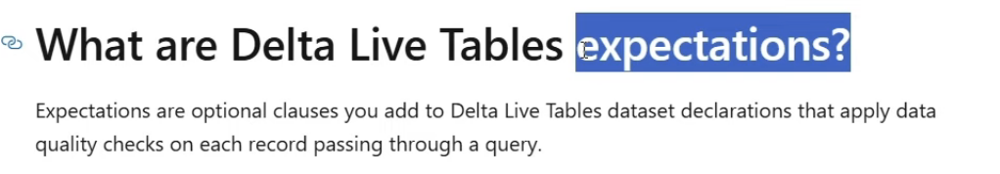

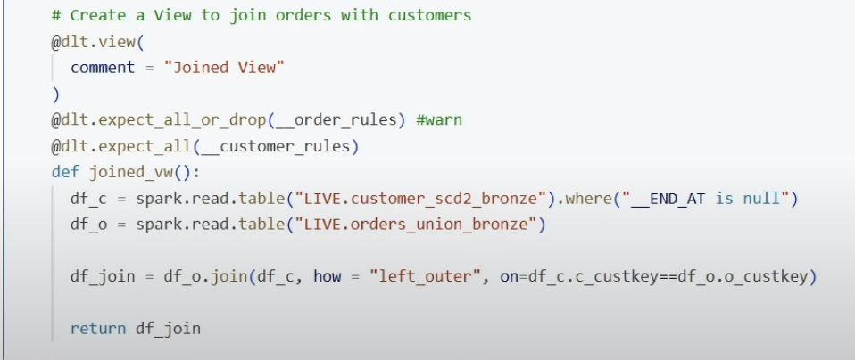

Truncate Load Table as source

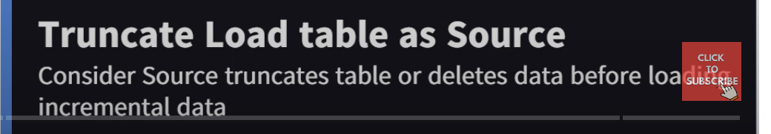

If my source table in truncated and load, then my DLT pipeline fails

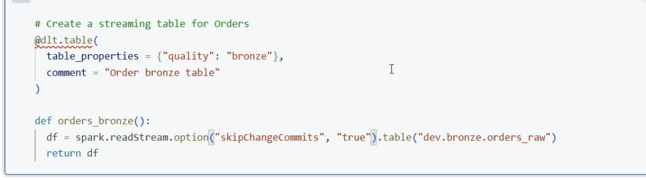

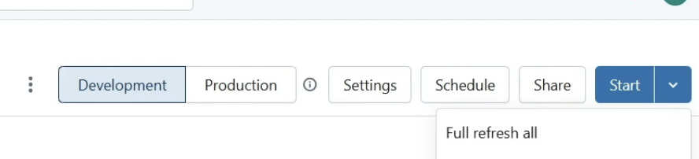

This will truncate and load table again, but this will also delete SCD2 tables as well to avoid that we can use

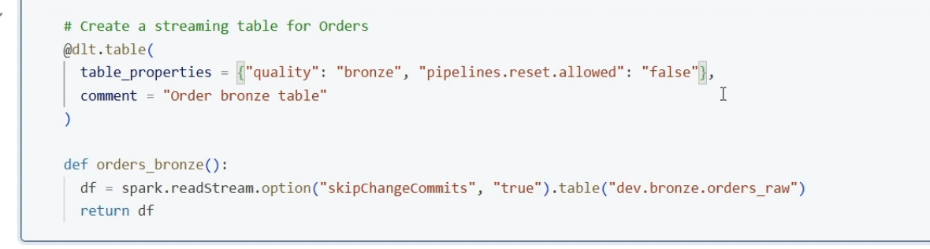

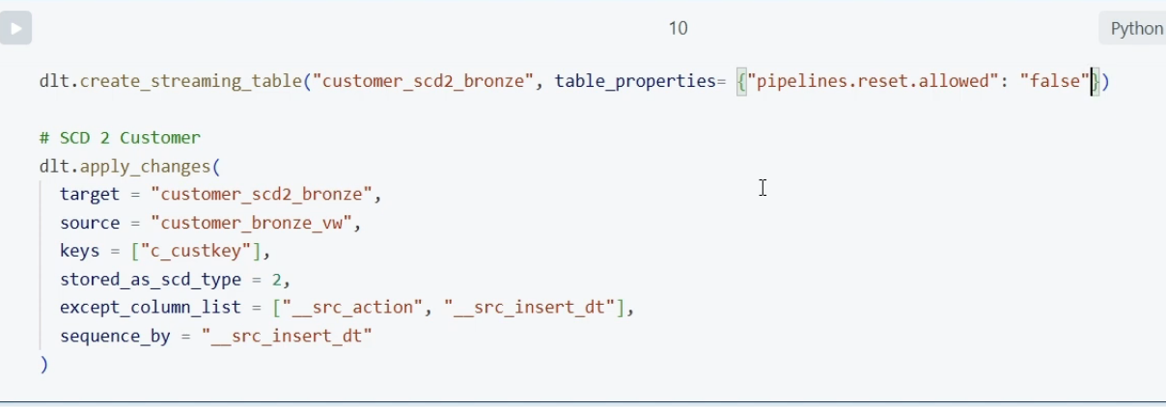

We can trigger DLT via workflows:

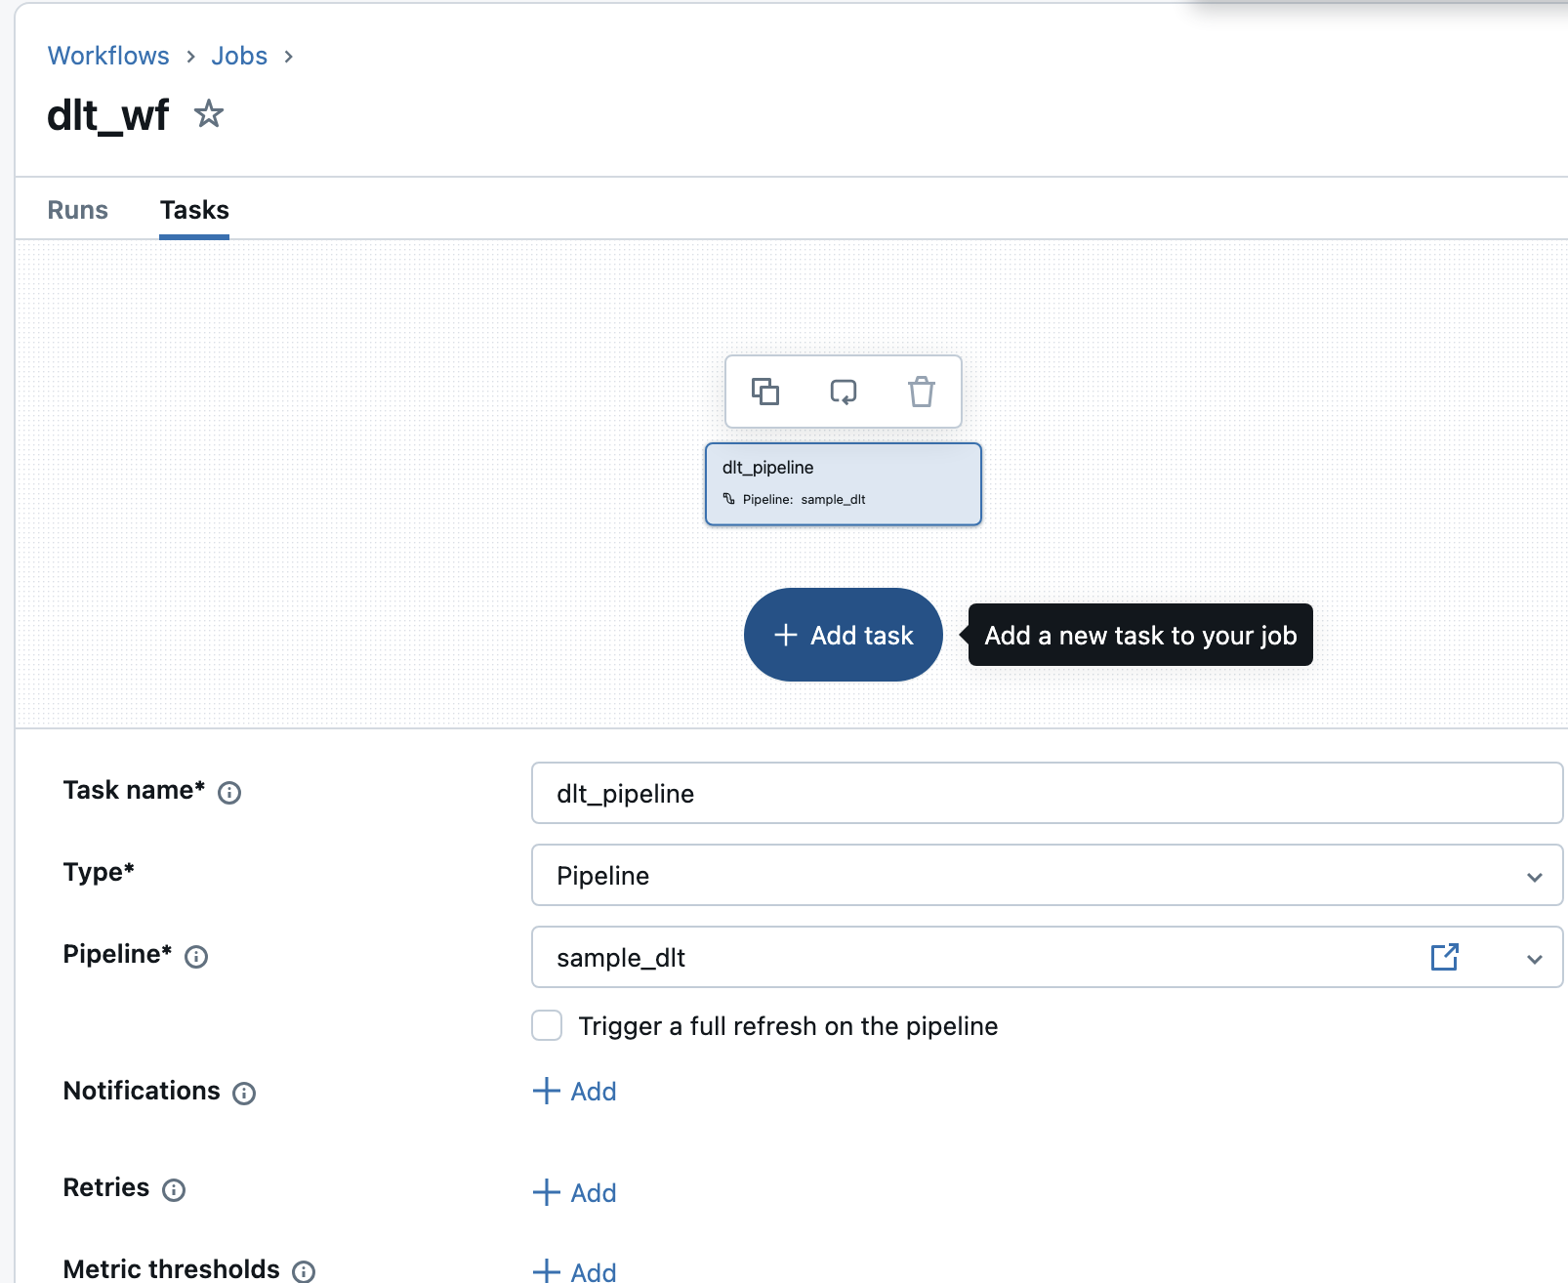

Secret Management:

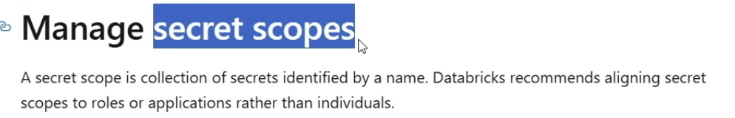

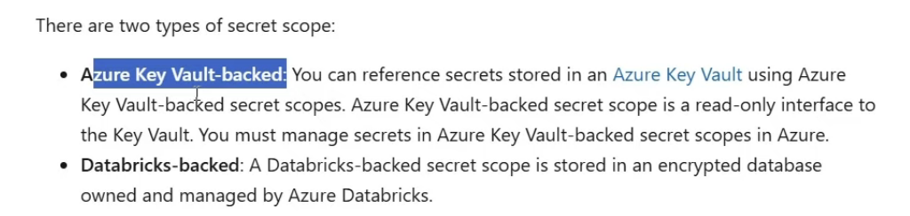

We need to create azure vault

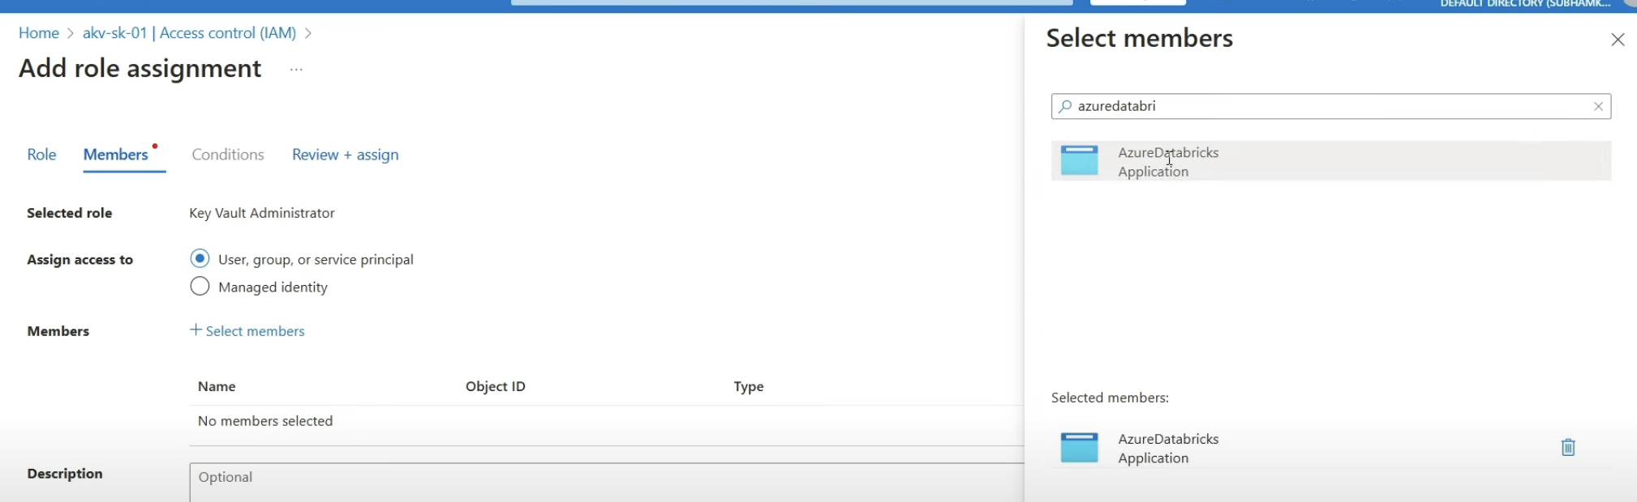

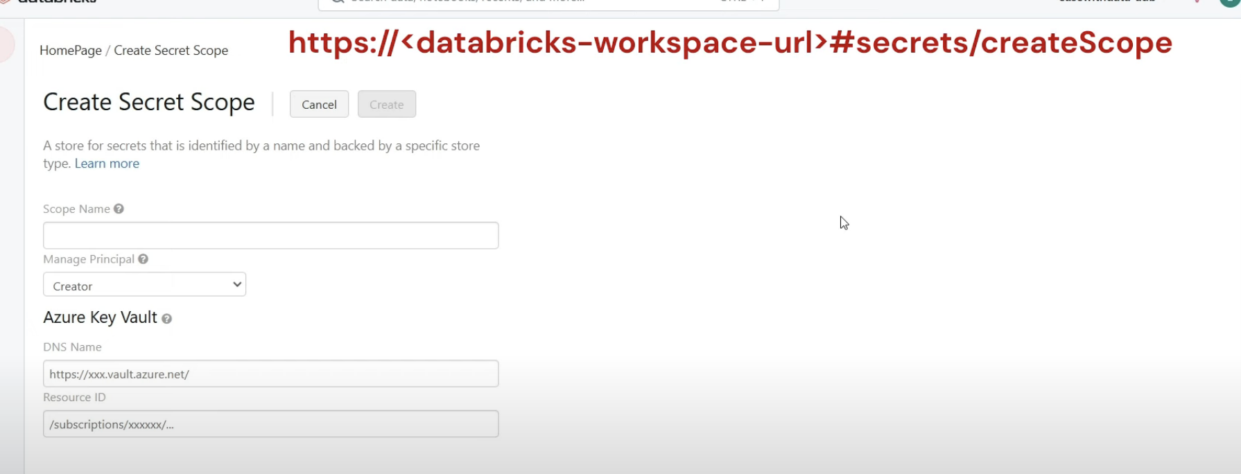

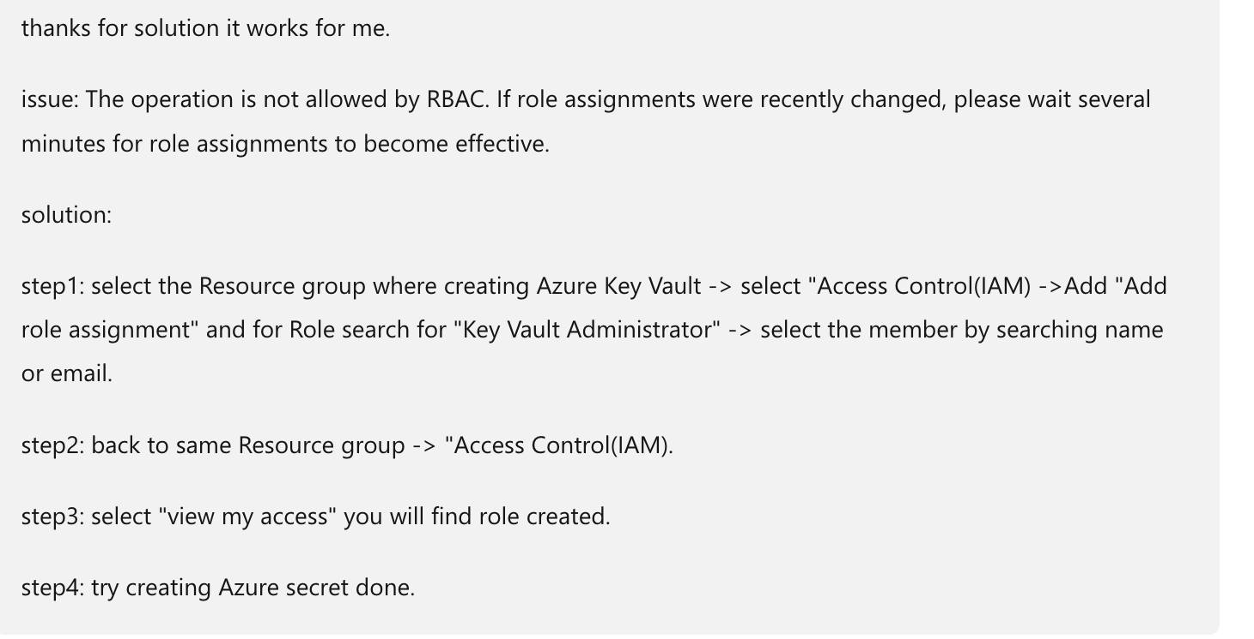

Databricks Backed secret scope:

We need to install databricks cli

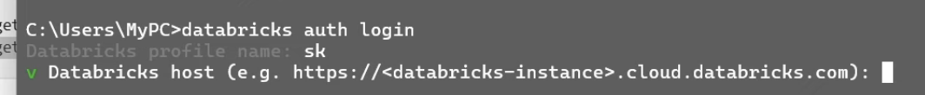

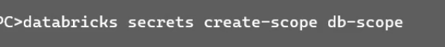



User Management:

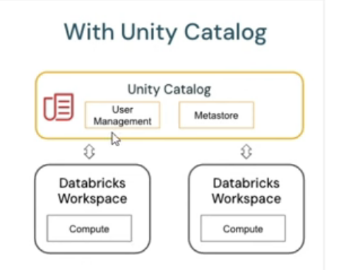

Create user in microsft entra id and go to account settings in databricks and add user, but this is manual process, we can automate databricks sync process using SCIM

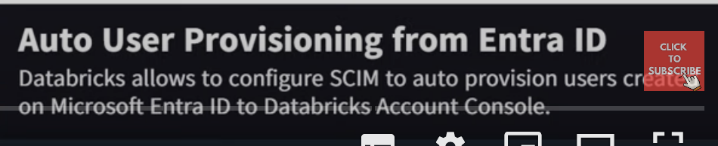

SCIM

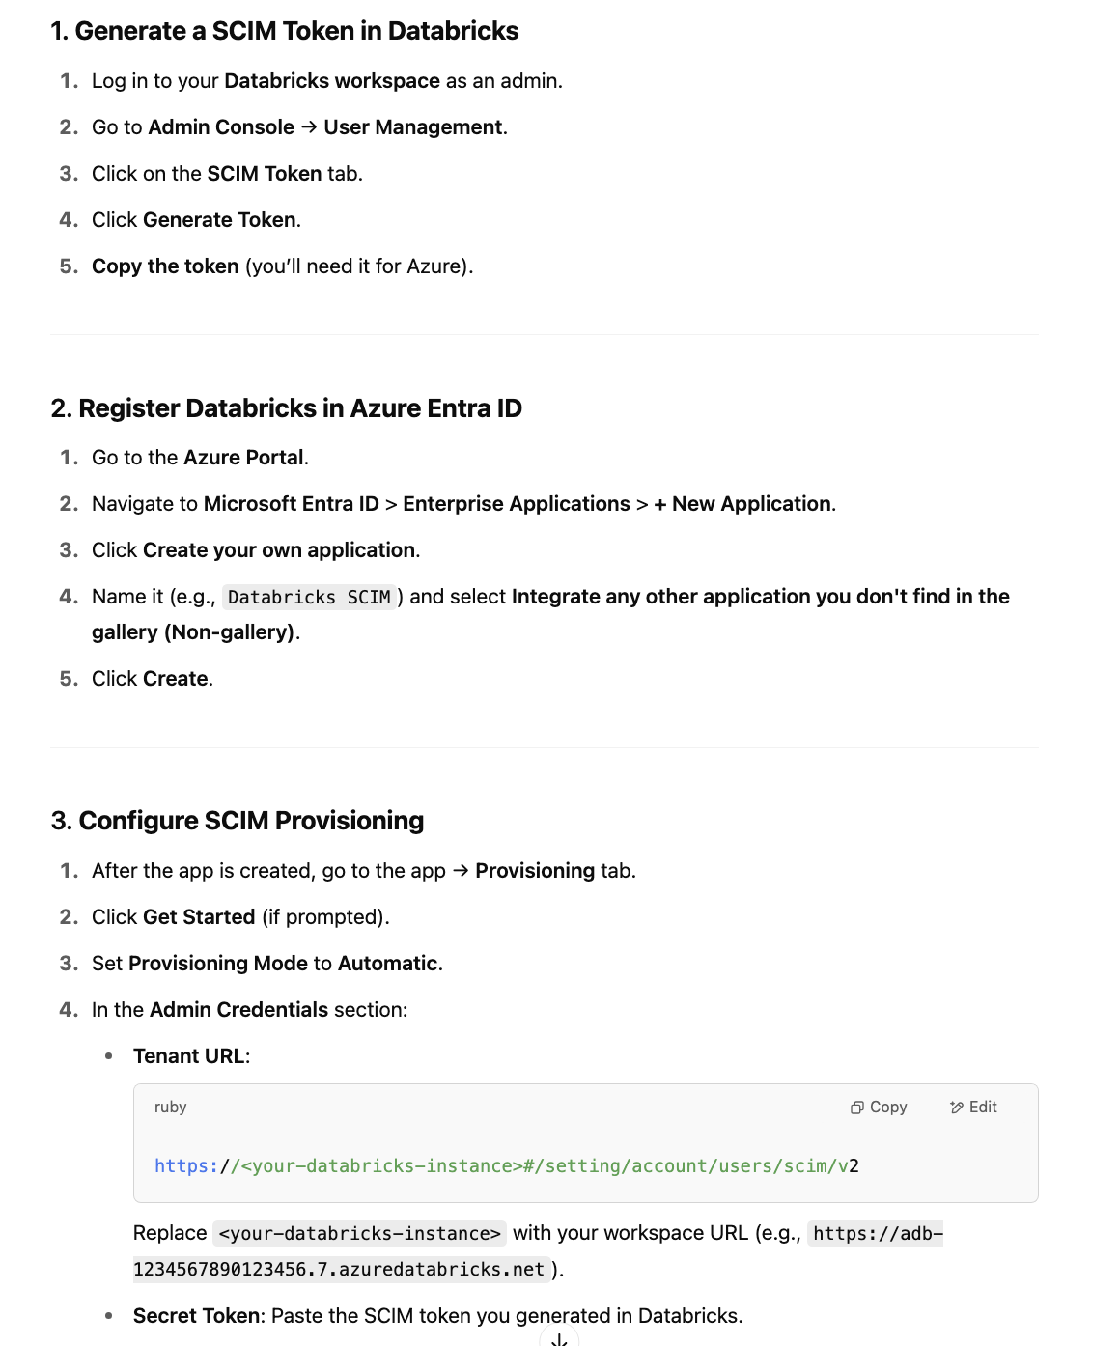

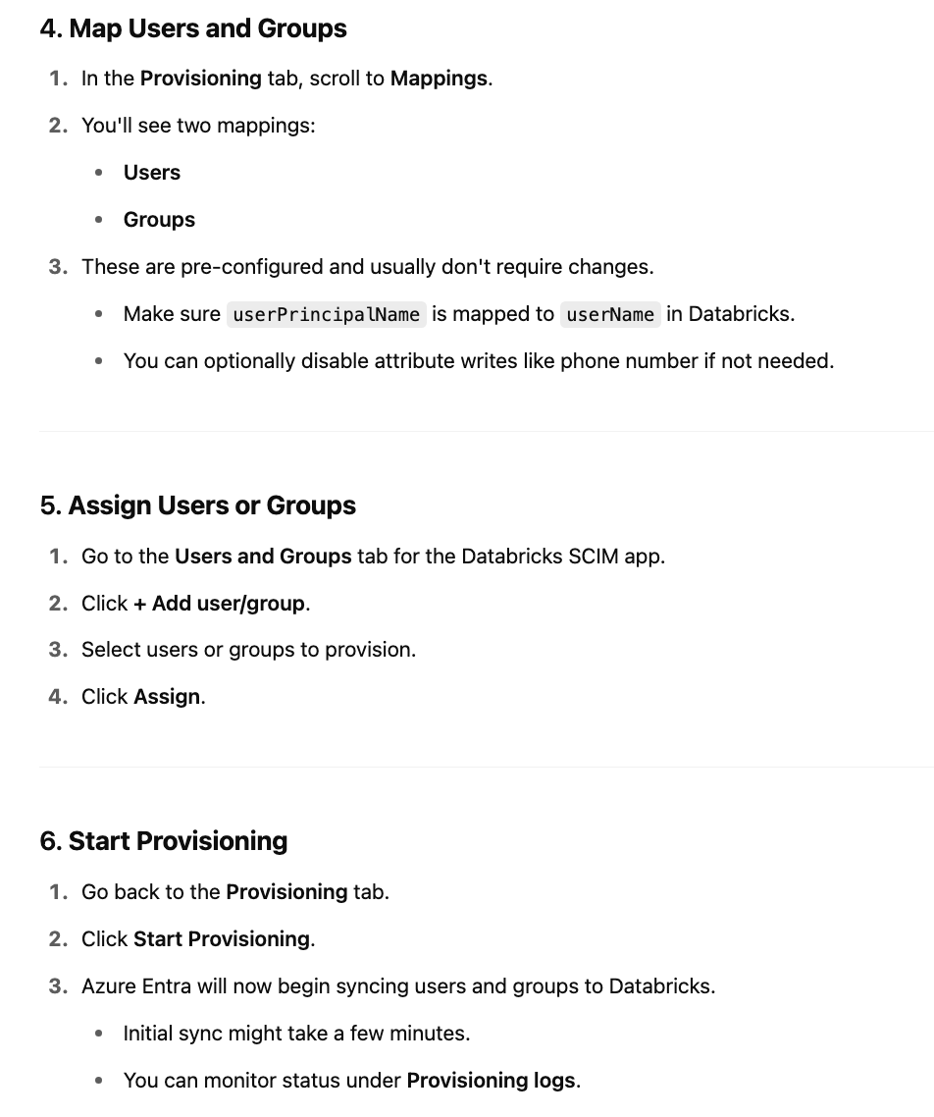

In order to add users to workspace:

1. First create group in databricks account portal and assign user to that group and then go to workspace and
2. 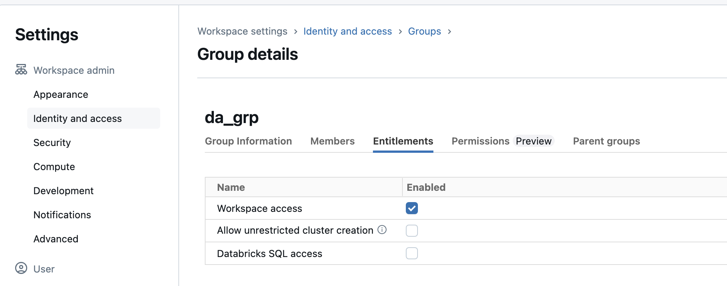

Service Principle:

1. We have data bricks
2. managed

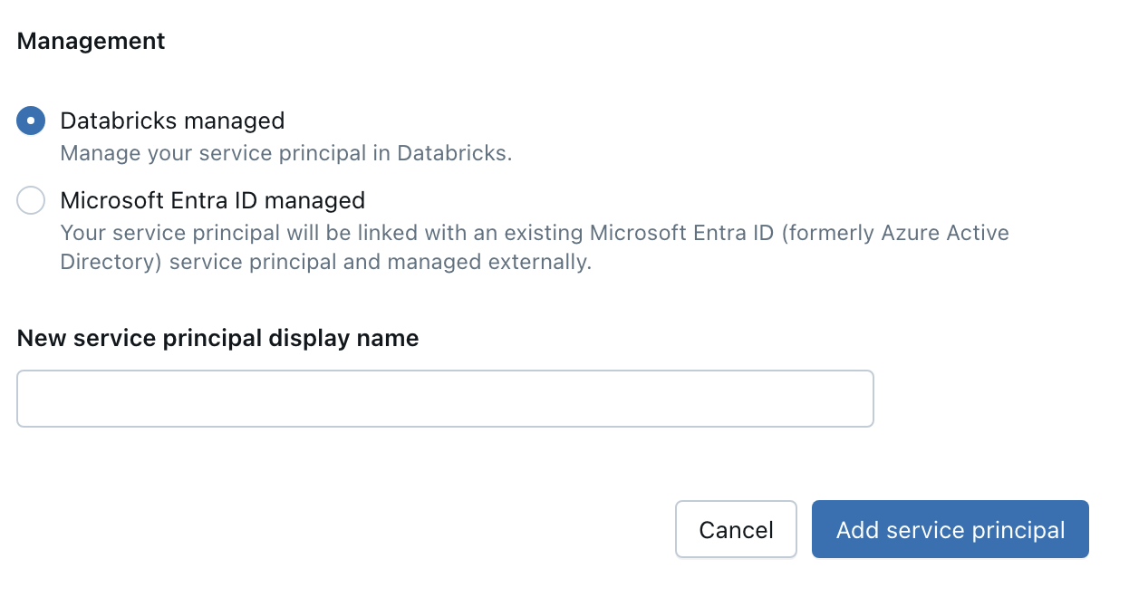

This is straight forward

1. We have Azure AD managed
2. 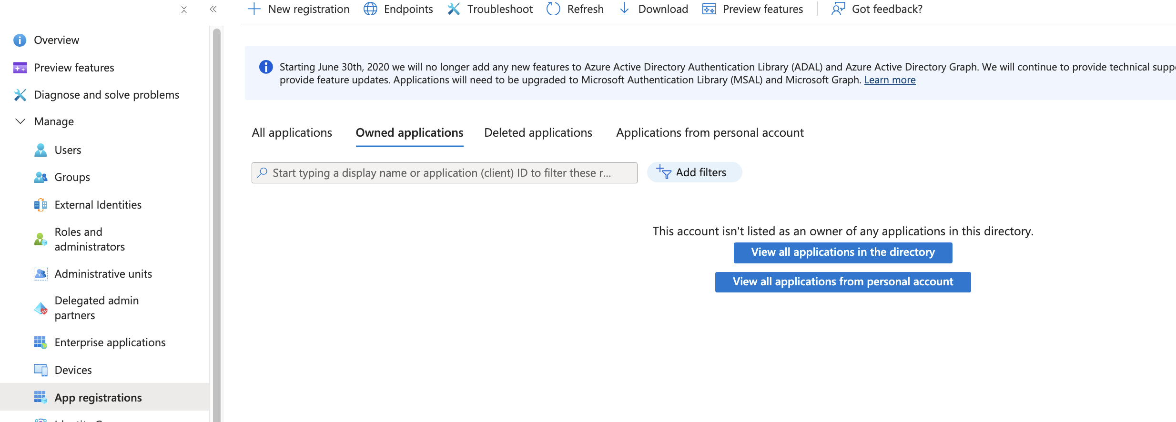

Add appid and appname in DB

Proving Access to Objects:

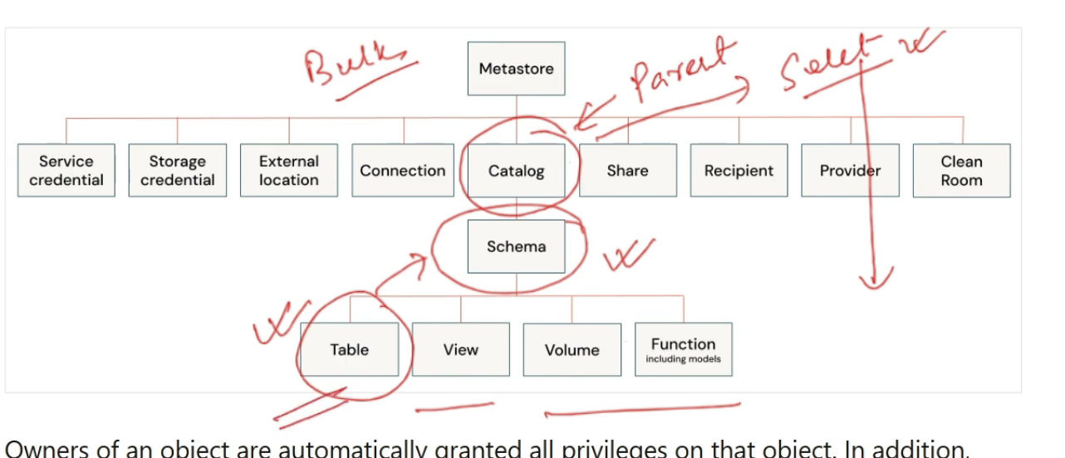

Add Metastore Admin:

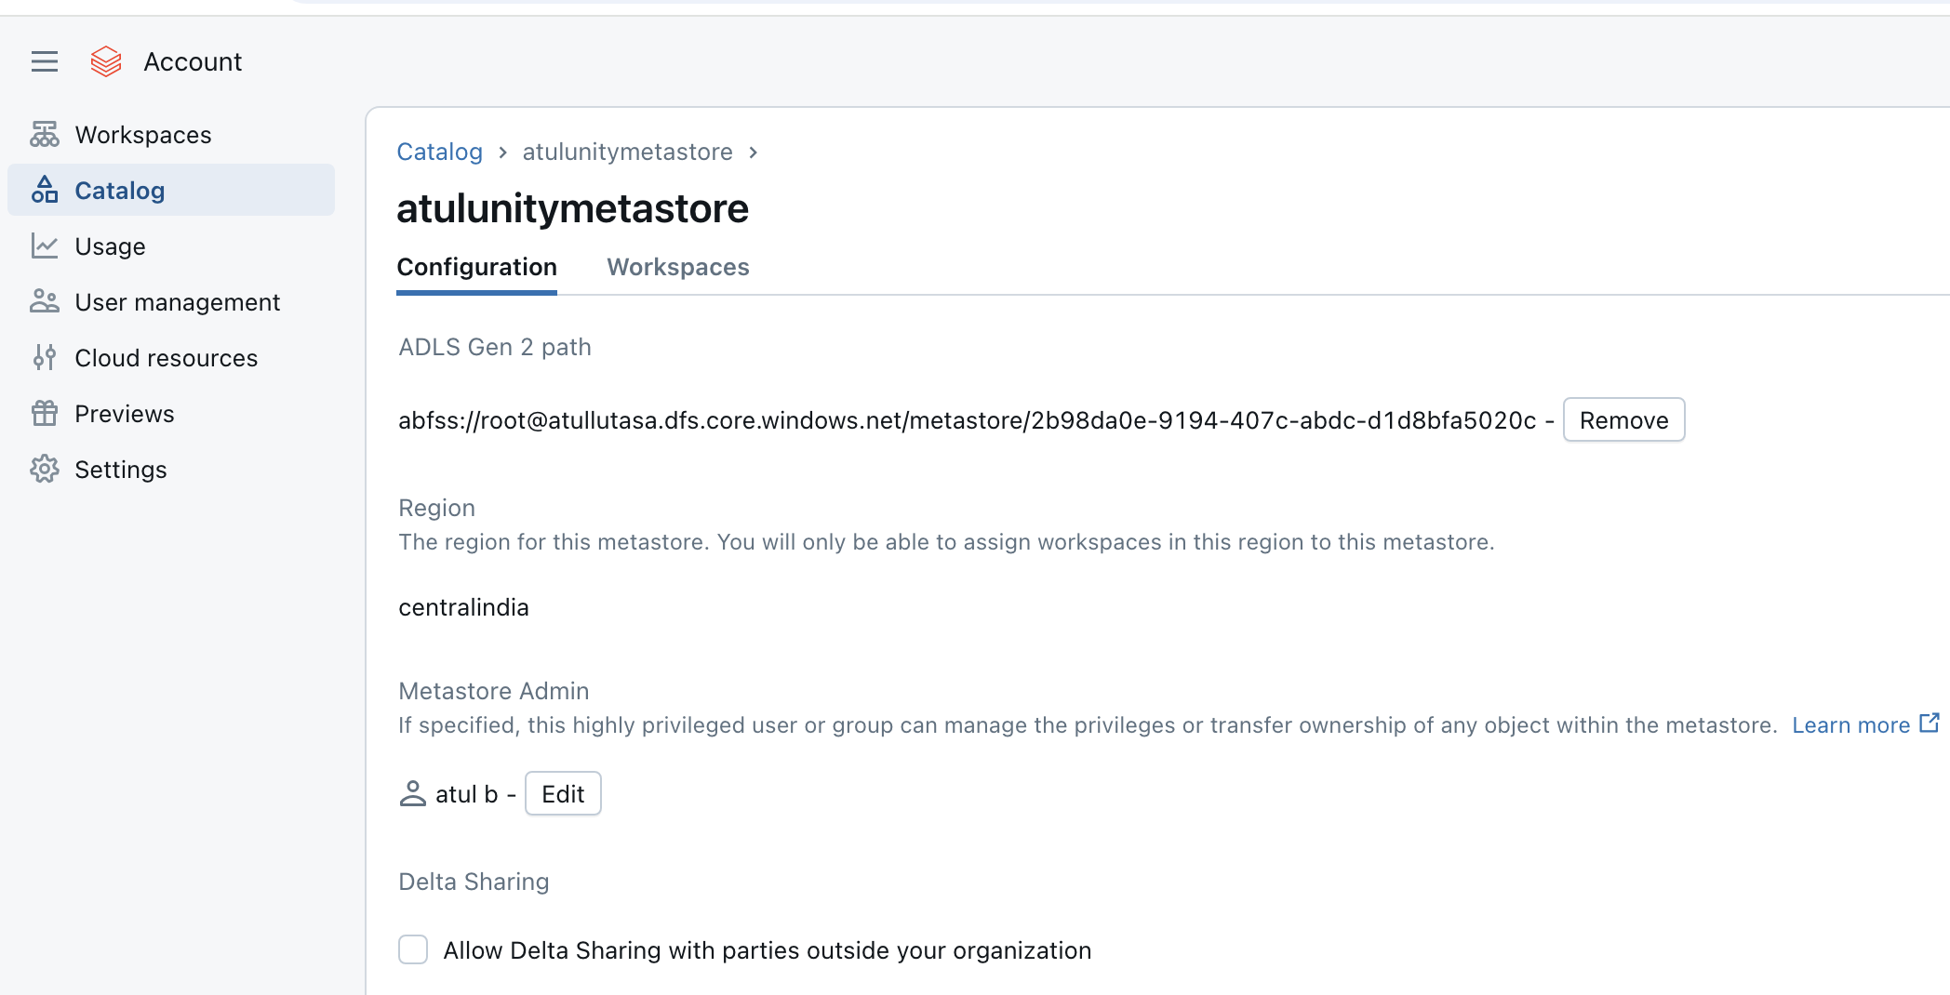

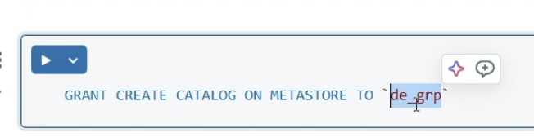

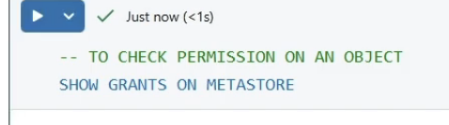

Fuctions:

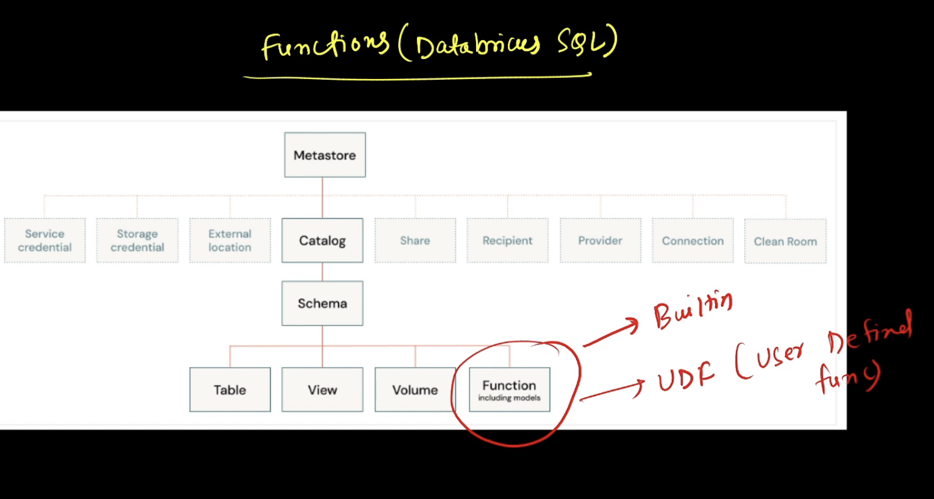

In UDF we have 2 types, scalar and table, in scalar we give 1 input n get 1 output, in table we give 1 input and get table

Pyspark udf is only applicable to session by Databricks function exists

In scalar output will be single scalar value like int, string or float, where as in tabular we get set of rows

create or replace function dev.bronze.tax_sql(sal double)

returns double

language sql

return sal*0.3

select *,dev.bronze.tax_sql(o_totalprice) from dev.bronze.orders_raw;

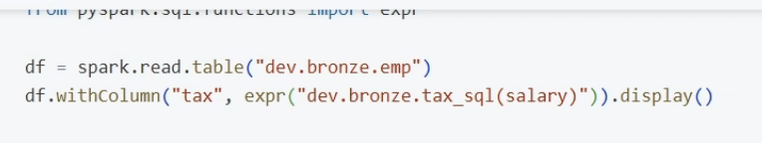

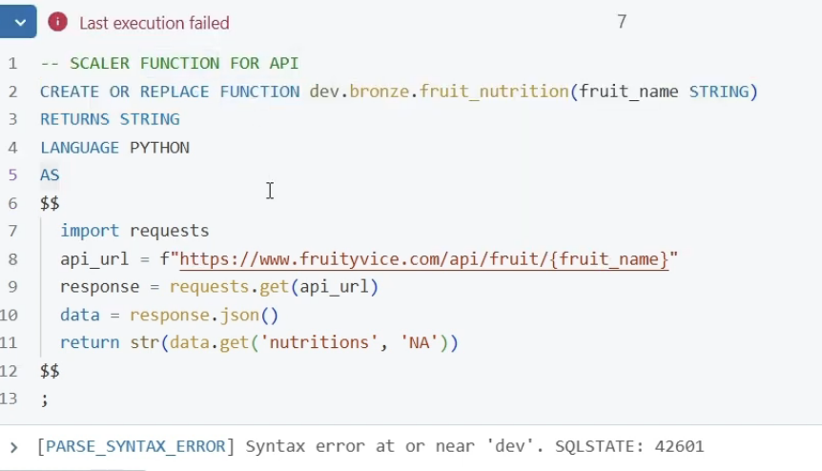

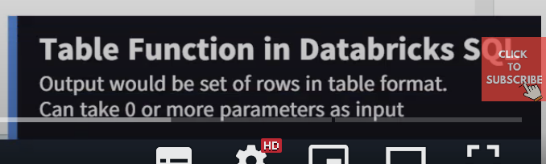

create or replace function dev.bronze.get_order_status(order_status string)

returns table (o_orderstatus string,o_custkey string)

language sql

return (

select o_orderstatus,o_custkey from dev.bronze.orders_raw where o_orderstatus = order_status

)

select * from dev.bronze.get_order_status('F');

Filter Sensitive Data:

create schema if not exists dev.metadata;

create table dev.metadata.allowed_mktsegments(

user_email string,

mktsegment string

)

insert into dev.metadata.allowed_mktsegments values

('atullutab_outlook.com#ext#@atullutaboutlook.onmicrosoft.com','BUILDING'),

('qa@atullutaboutlook.onmicrosoft.com','HOUSEHOLD')

Row Level Filter based on user:

create schema if not exists dev.metadata;

create table dev.metadata.allowed_mktsegments(

user_email string,

mktsegment string

)

insert into dev.metadata.allowed_mktsegments values

('atullutab_outlook.com#ext#@atullutaboutlook.onmicrosoft.com','BUILDING'),

('qa@atullutaboutlook.onmicrosoft.com','HOUSEHOLD')

create or replace function dev.metadata.is_allowed_mktsegment(mktsegment string)

returns boolean

language sql

return exists(

select * from dev.metadata.allowed_mktsegments a

where a.mktsegment = is_allowed_mktsegment.mktsegment

and a.user_email = current_user())

alter table dev.bronze.customer_raw set row filter dev.metadata.is_allowed_mktsegment on (c_mktsegment)

Column Level Masking:

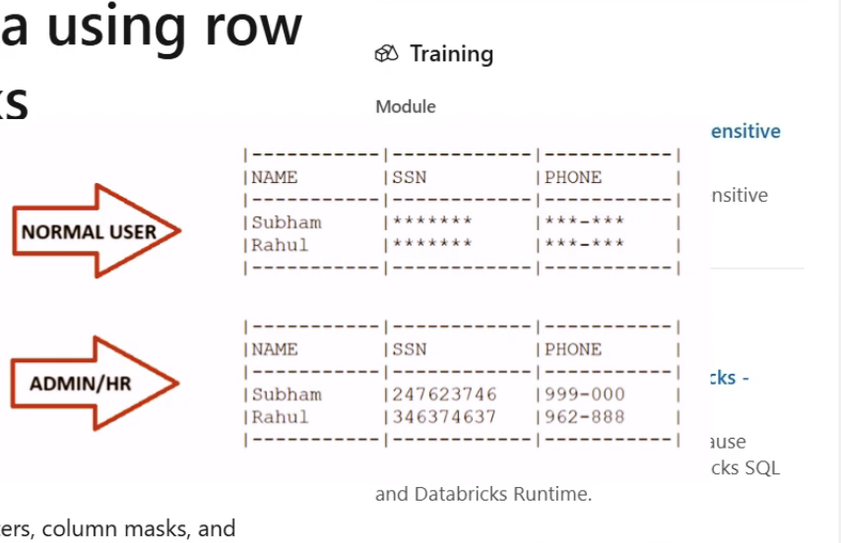

Here we want to hide phone no, we can do it in 2 ways:

1. We create custom metadata and group user to group
2. We use inbuilt function is_member

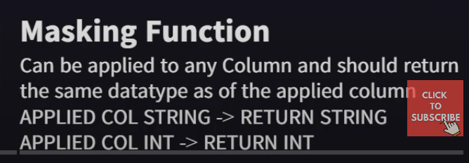

create table dev.metadata.user_groups(

user_email string,

groups string

);

insert into dev.metadata.user_groups values

('atullutab_outlook.com#ext#@atullutaboutlook.onmicrosoft.com','admin'),

('qa@atullutaboutlook.onmicrosoft.com','user')

select * from dev.metadata.user_groups;

create or replace function dev.metadata.phone_mask(col string)

returns string

language sql

return (

select case when grp ='admin' then phone_mask.col

else '****-****-****' end as masked_value from (

select max(groups) as grp from dev.metadata.user_groups

where where user_email = current_user()

))

alter table dev.bronze.customer_raw alter c_phone set mask dev.metadata.phone_mask

Method 2:

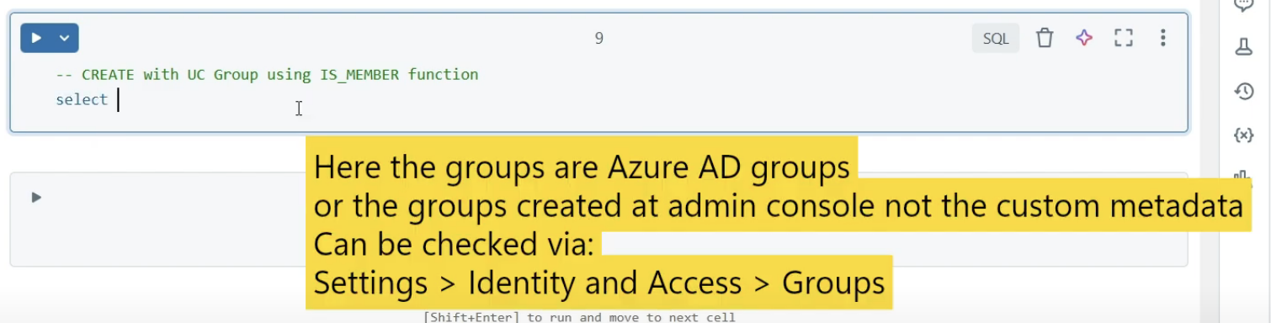

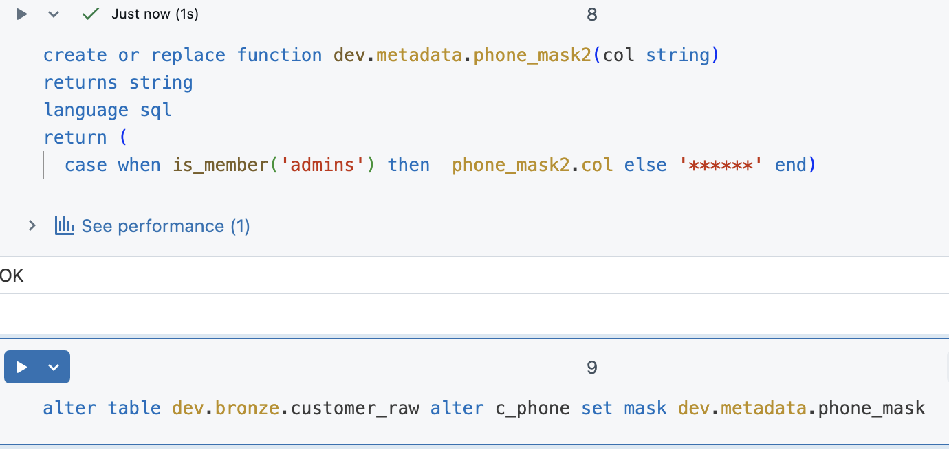

Workspace Catalog Binding:

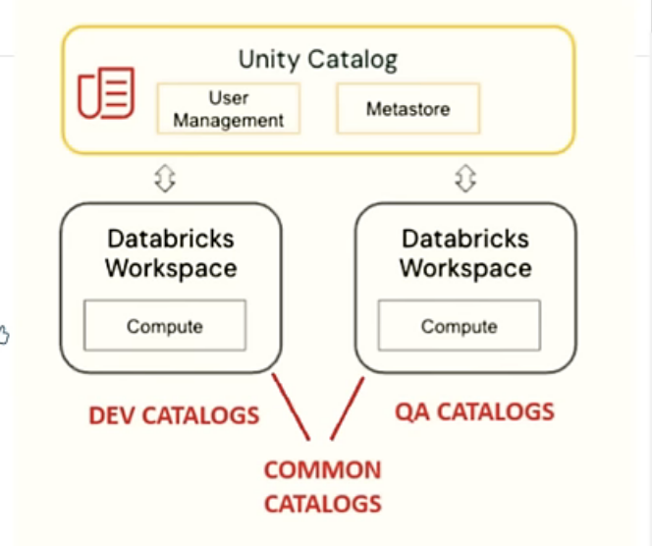

Restrict catalog to a workspace:

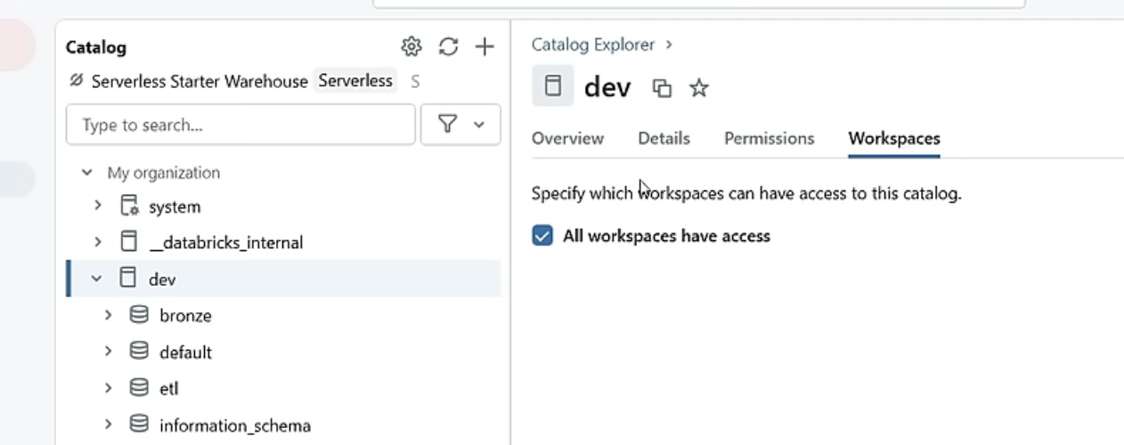

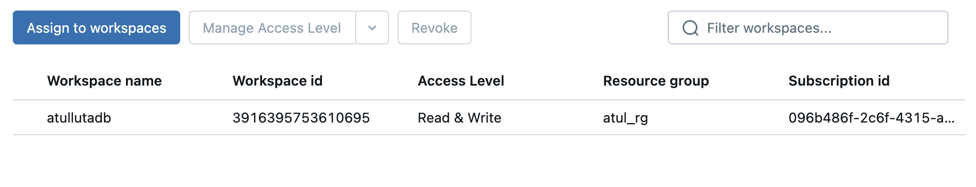

Only Admin will have access to catalog from multiple workspaces, if u want to assign to other users, u can add like this

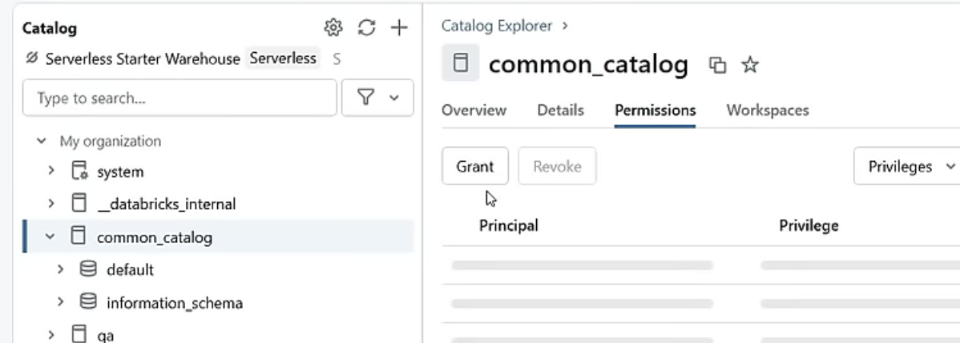

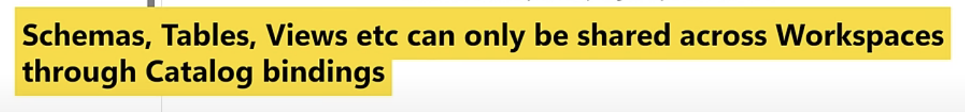

Delta Sharing:

It is read only share

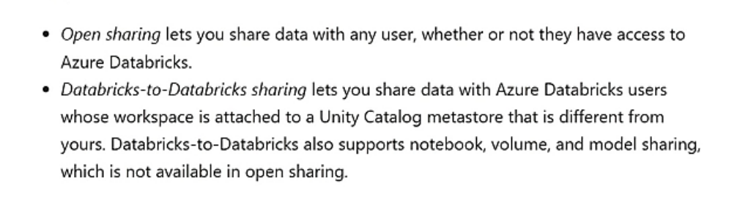

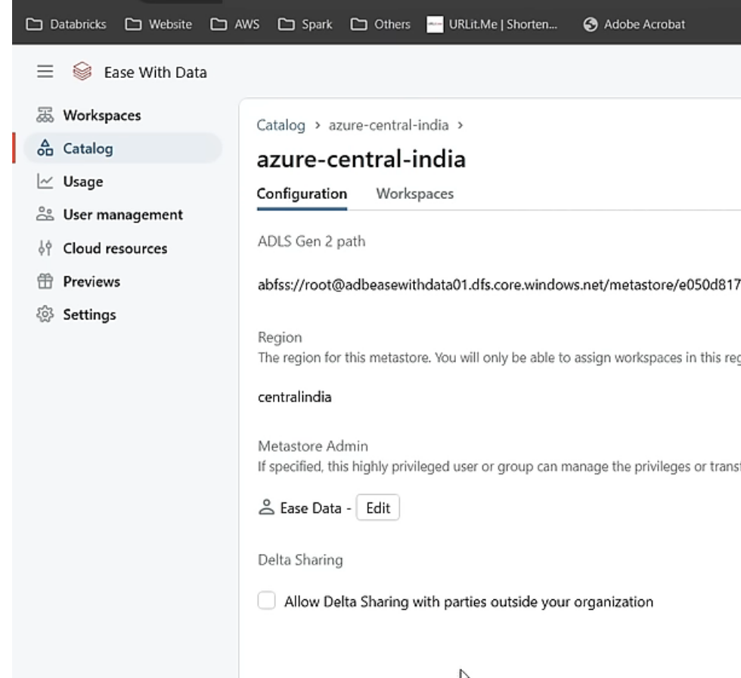

We need to have below access to work with delta sharing

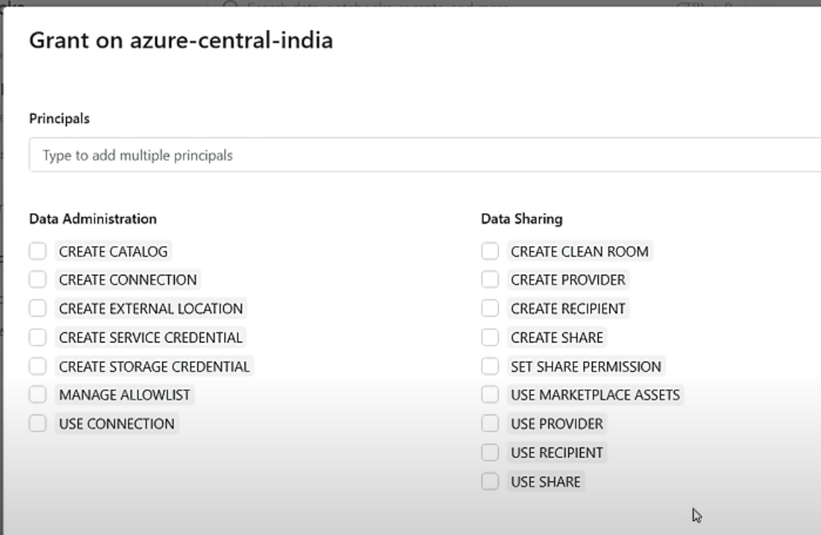

First from source account

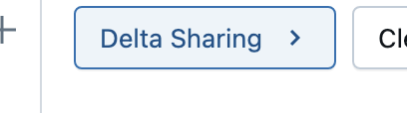

Create recipient

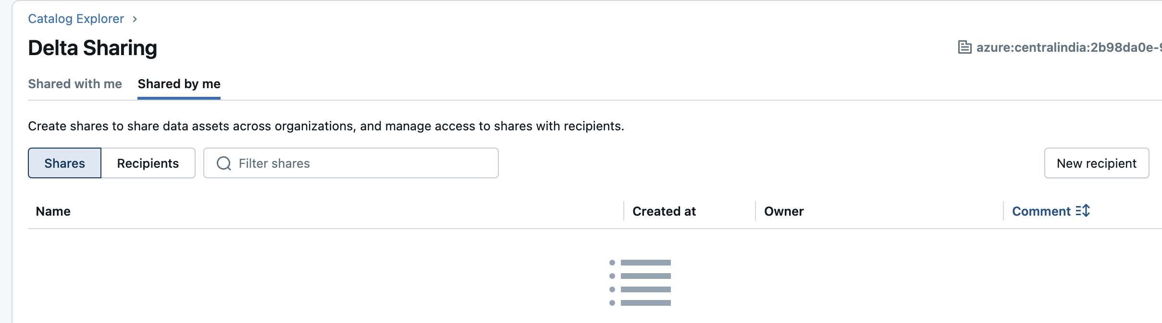

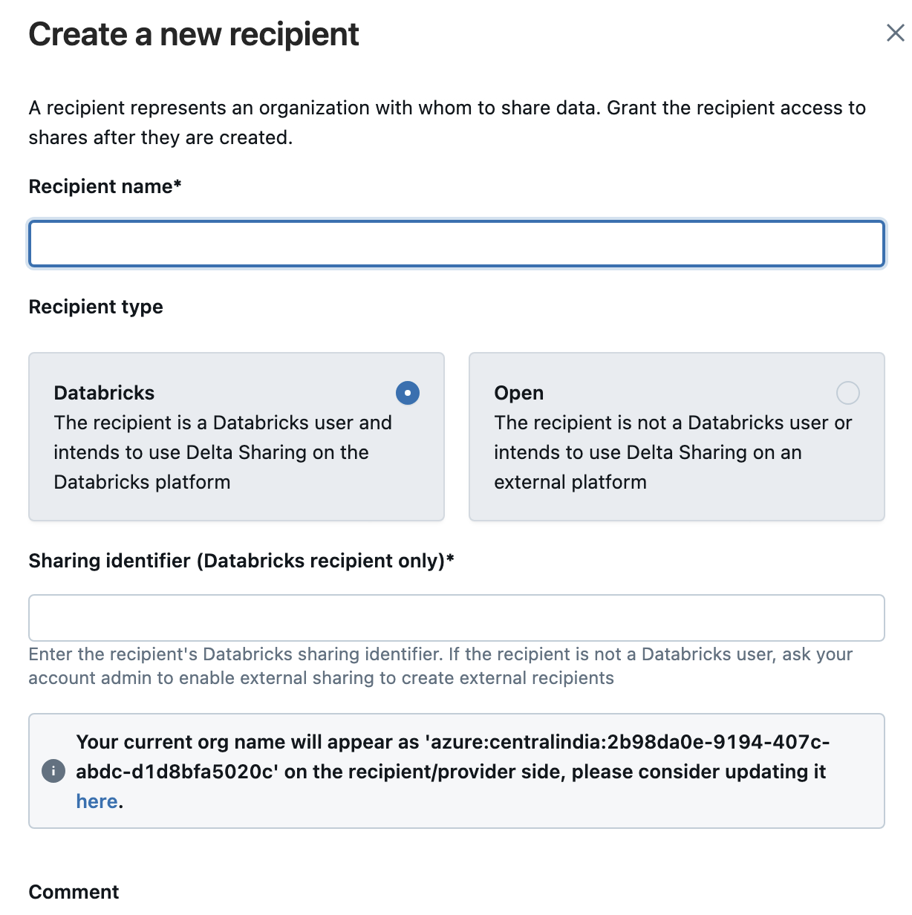

Value can be generated by

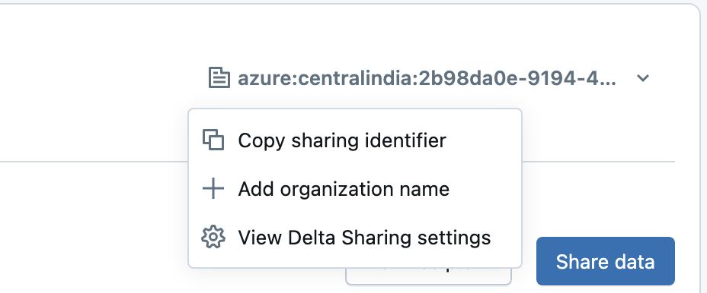

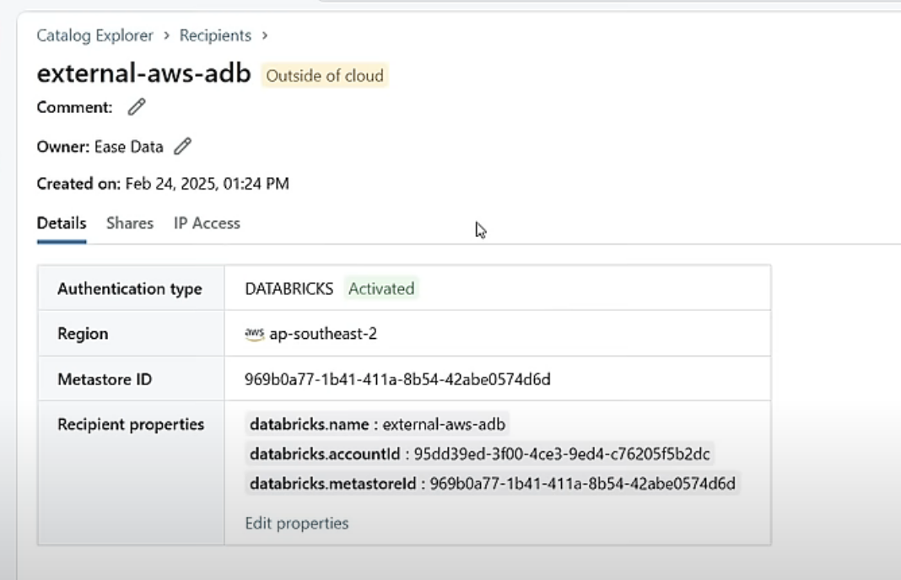

Recipient is created

Now click on

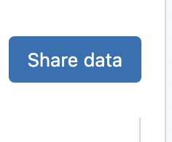

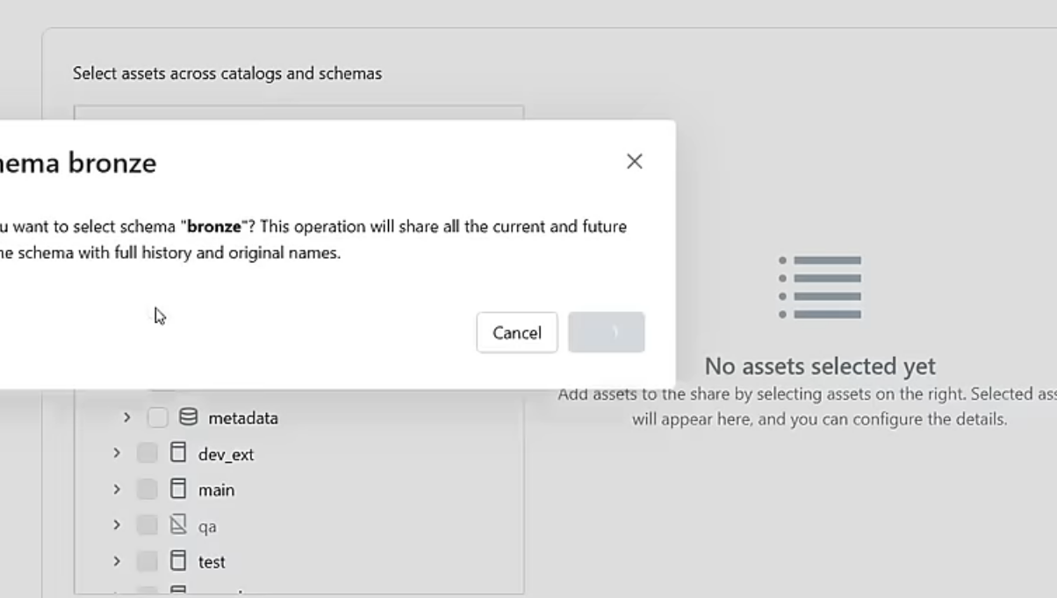

Select catalog and schema

Now on recipient go to

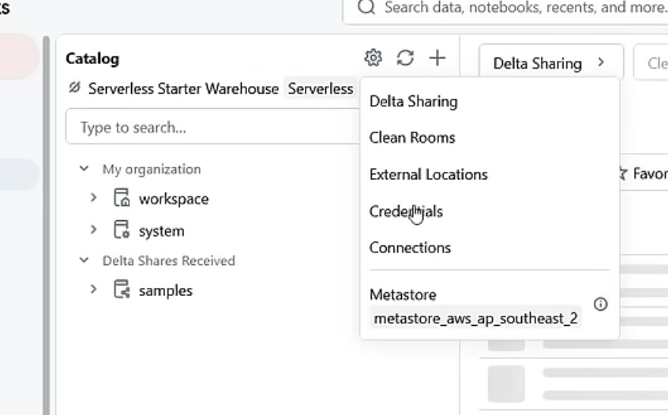

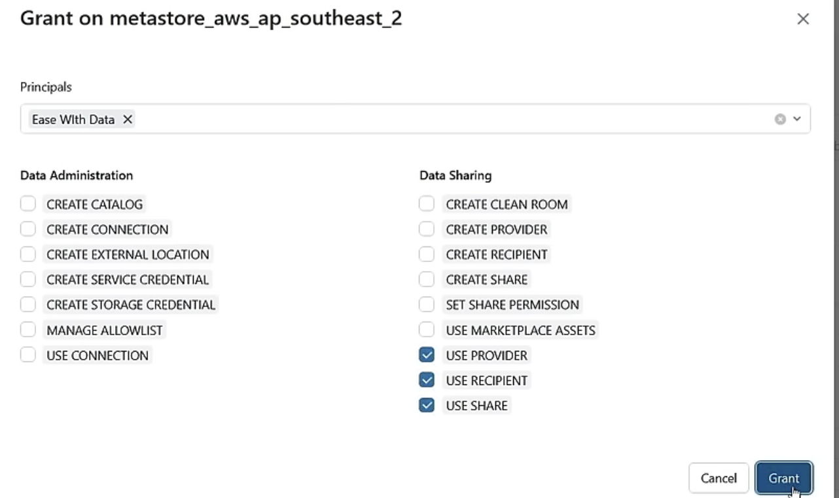

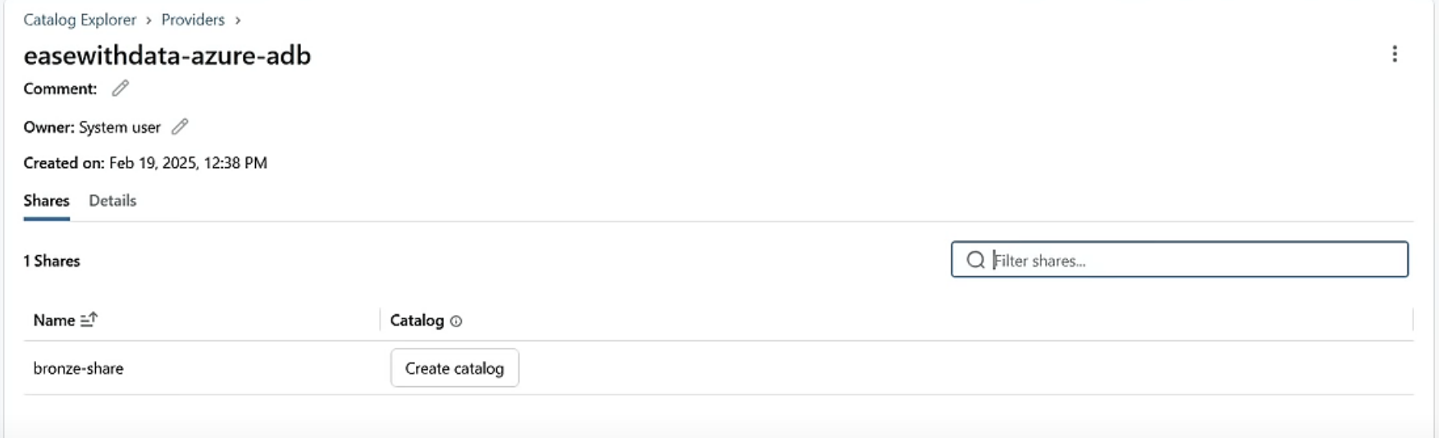

Serverless:

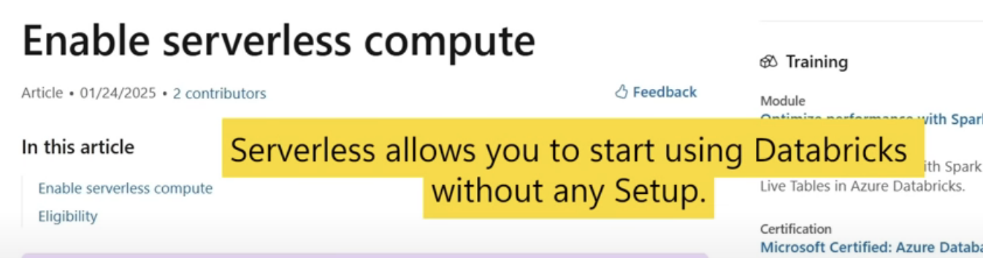

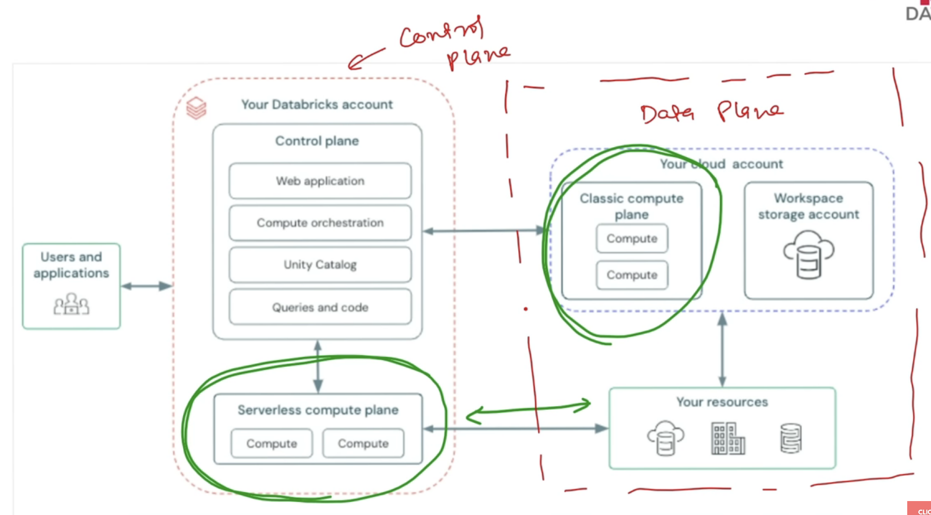

In serverless, compute resources are in control plane

Enable serverless:

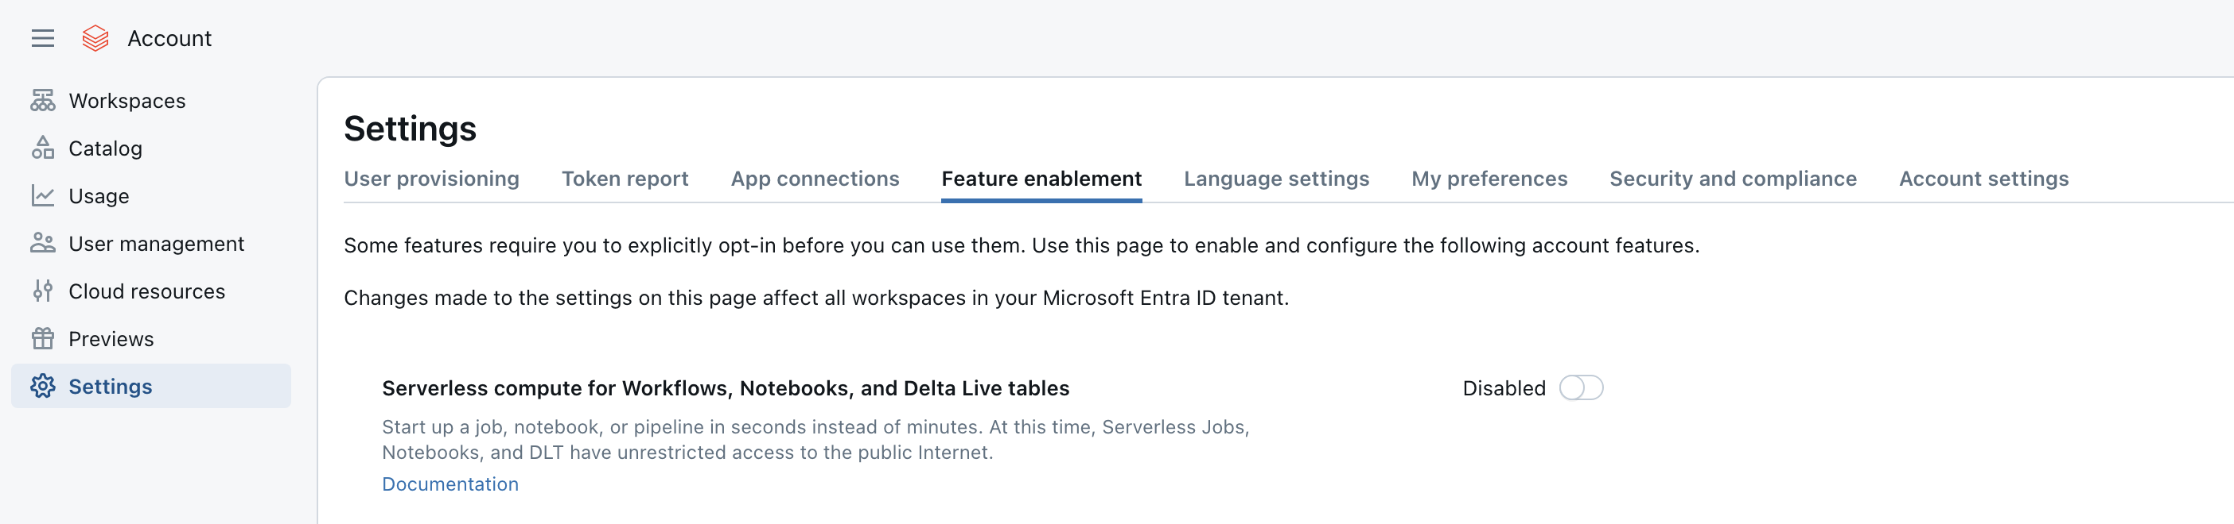

Serverless supports sql & python

We can use for notebook, workspace, dlt pipeline

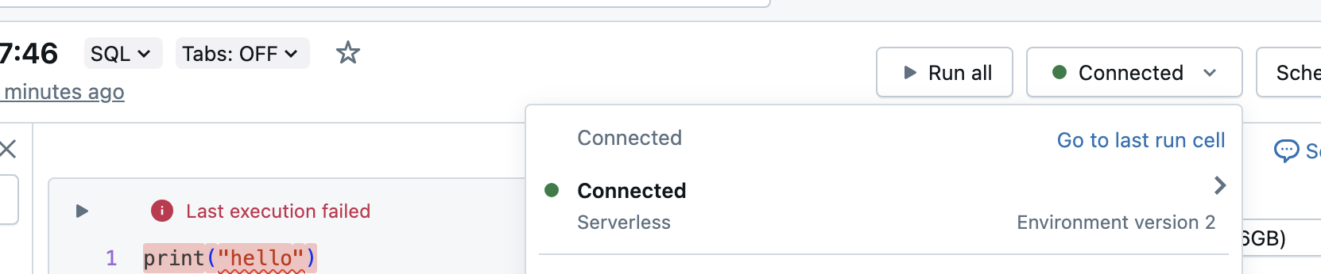

SQL Warehouses:

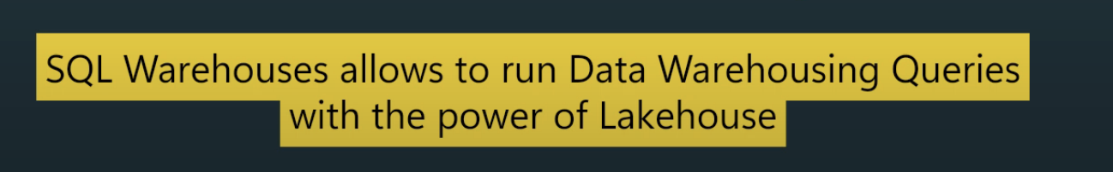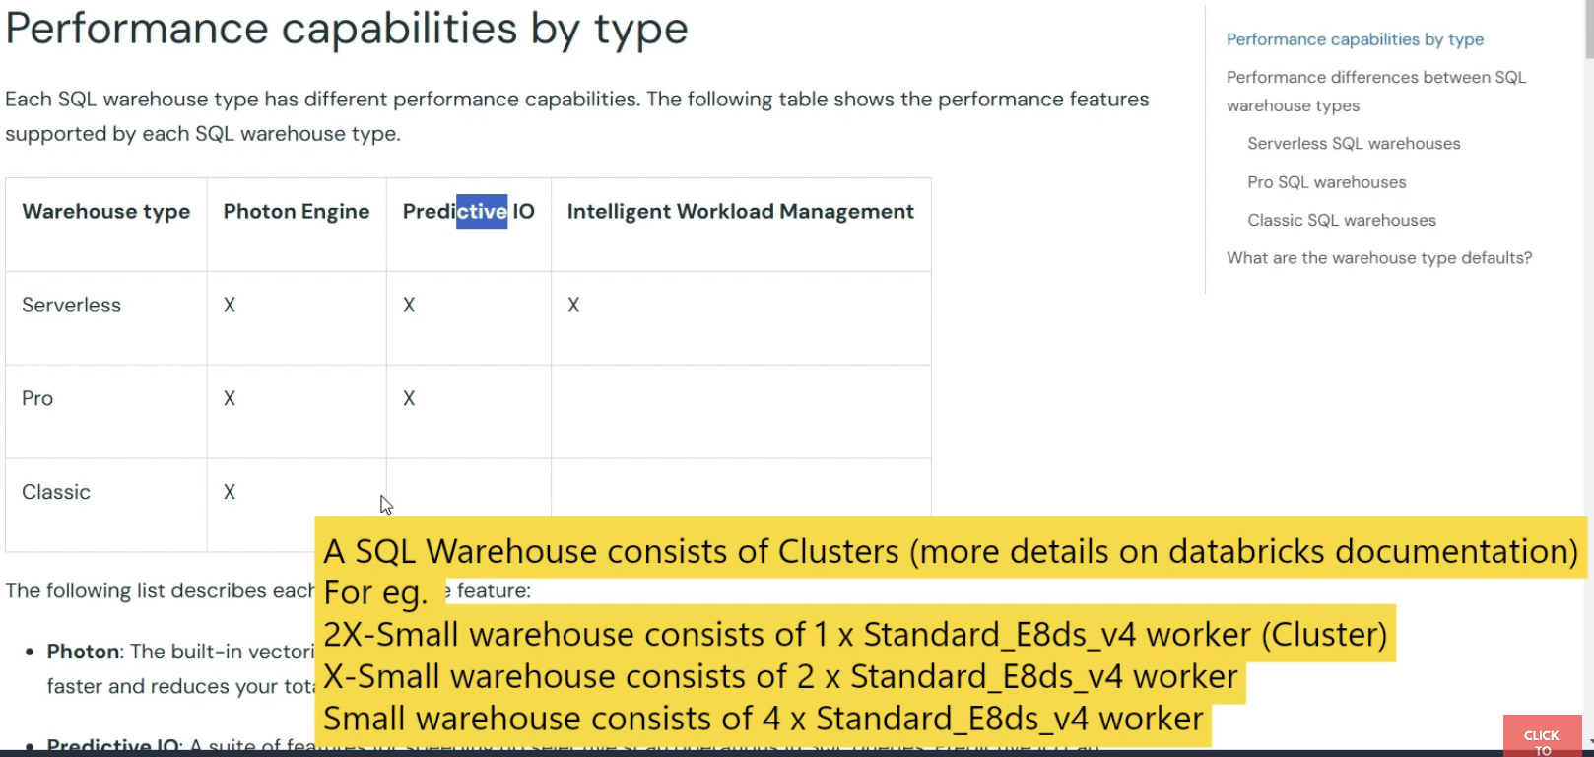

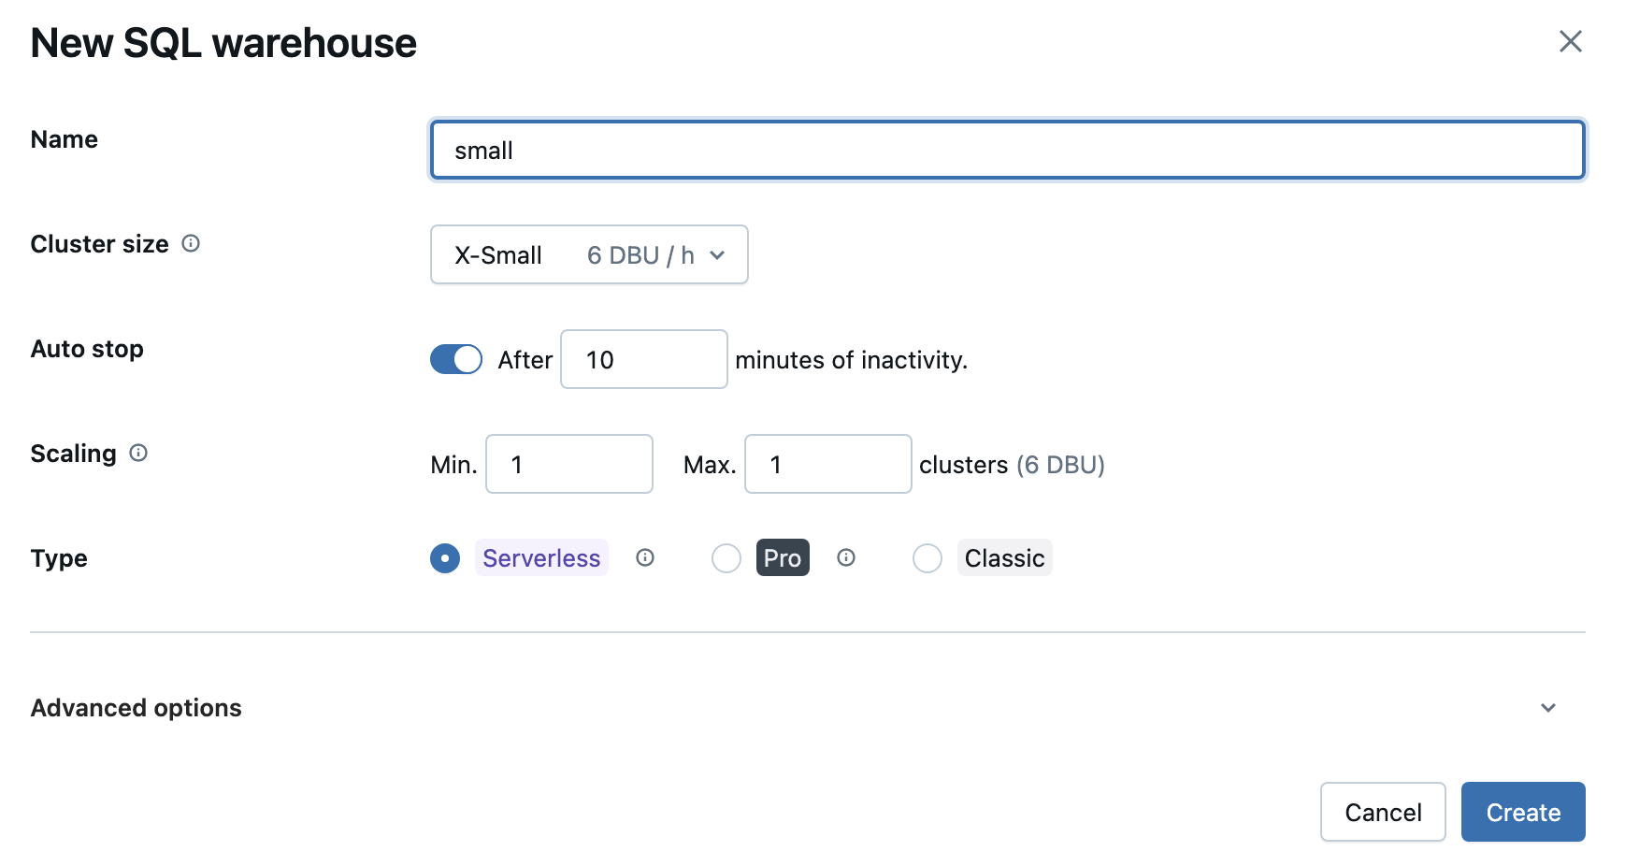

Streaming Table & Materialized view using DB SQL:

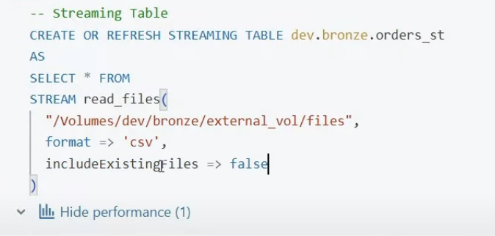

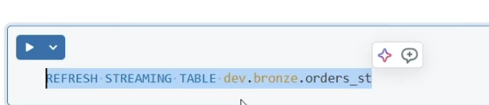

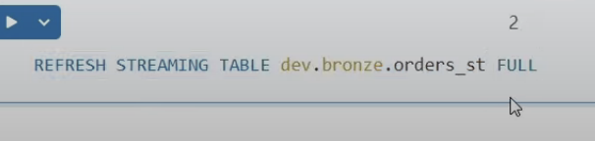

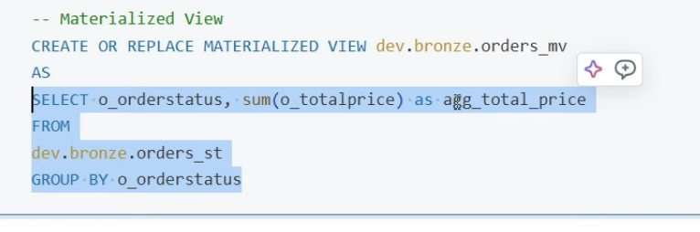

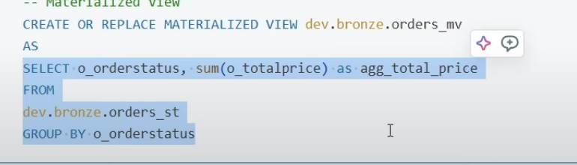

Materialized view before:

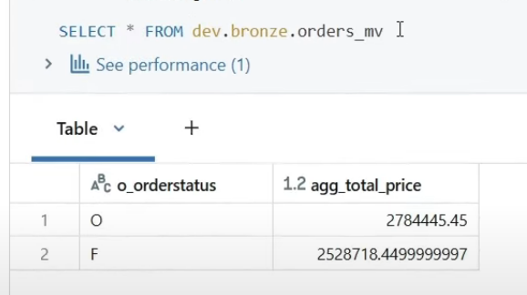

Materialized view After:

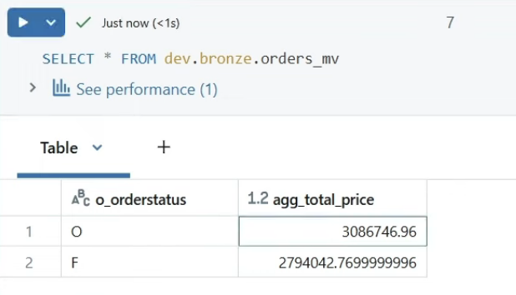

Materialized view also process data incrementally

Scheule query:

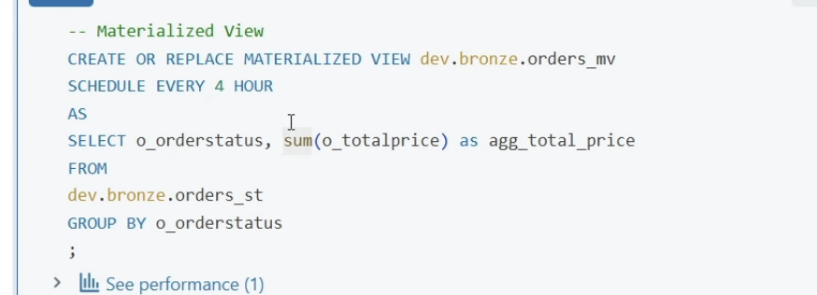

Lakehouse Federation:

